**Prof.V.B.Shah Institute of Management & R.V.Patel College of Commerce (Eng.Med.) & V.L.Shah College of Commerce (Guj.Med.) &**

**Sutex Bank College of Computer Applications & Science, Amroli**

**(Accredited ‘B’ (CGPA 2.55) by NAAC Dec.-2009)**

**VEER NARMAD SOUTH GUJARAT UNIVERSITY, SURAT**



**PROJECT REPORT ON**

**EVENT MANAGEMENT SYSTEM**

**AS A PARTIAL REQUIREMENT FOR THE DEGREE OF**

**BACHELOR OF COMPUTER APPLICATION (B.C.A.)**

|  |  |  |
| --- | --- | --- |
| **SUBMITTED BY:** |  | **GUIDED BY:** |
| **Paghadal Maulikkumar Haribhai** | **521** | **Asst. Prof. Mansi A. Shah** |
| **Parmar Yashkumar Kishorbhai** | **529** |  |
| **Patthar Parth Maganbhai** | **539** |  |



Certificate

This is to certify that the project titled **“ Event Management For College”** is the bonafide work carried out by **Paghadal Maulikkumar Haribhai (521),Parmar Yashkumar Kishorbhai (529),Patthar Parth Maganbhai (539),** students of TYBCA Sem-VI of Sutex Bank College of Computer Applications and Science, Amroli, (Surat) affiliated to Veer Narmad South Gujarat University. He/she has successfully completed his/her project work in partial fulfillment of the requirements for the award of the degree of **"Bachelor of Computer Application"** during the academic year **2019-2020**. And that the project has not formed the basis for the award previously of any other degree, diploma, fellowship or any other similar title.

**_______________________________ _______________________________**

## Asst. Prof. Mansi A. Shah Dr. Mukesh Goyani

Project Guide In-charge Principal

Date:

Place: **Amroli, Surat.**

### ACKNOWLEDGEMENT

Our Self Mr. Paghadal Maulikkumar H. & Mr. Parmar Yashkumar K. & Mr. Patthar Parth M. Have opportunity to Express our knowledge. We would like to express our gratitude to all those who gave us the possibility to complete our project Event Management for college (Evento).

Success is such a comprehensive project cannot achieve single-handed. It is team effort that sails the ship to the coast. So, we would like to Express our sincere thanks to all the dignitaries who were involved in making this project the great joy and turning it our into successful piece of work

Asst. Prof. Mansi A. Shah – Our professor and Project Co-ordinates has been very proudent to us threw out the college studies. They are the person who has giving this direction to our work and the shape to our Imagination. We Express our regard to them from the core of our hearts.

We also like to thanks our all the professor who are always Ready to give best Guide and Special thanks to Asst. Prof. Dr. Viral B. Polishwala. He is the person behind the idea of this project and give Solution whenever needed.

We would also like to acknowledge all the friends and Colleagues, team member for the help and Encouragement By them for time to time. The Constant support and encouragement of my friend is deeply appreciating. The project indeed gave challenging and Exhilarating experience in designing and developing the required System.

From,

Paghadal Maulikkumar H. Parmar Yashkumar K. Patthar Parth M.

INDEX

|  |  |
| --- | --- |
| **Chapter** | **Page No.** |
| 1. **Introduction**    1. Project description    2. Project Profile 2. **Environment Description**    1. Hardware and Software Requirements    2. Technologies Used 3. **System Analysis and Planning**    1. Existing System and its Drawbacks    2. Feasibility Study    3. Requirement Gathering and Analysis 4. **Proposed System**    1. Scope    2. Project modules    3. Module vise objectives/functionalities Constraints    4. Expected Advantages 5. **Detail Planning**    1. Data Flow Diagram / UML    2. Process Specification / Activity Flow Diagram    3. Data Dictionary    4. Entity-Relationship Diagram / Class Diagram 6. **System Design**    1. Database Design    2. Directory Structure    3. Input Design    4. Output Design 7. **Software Testing** 8. **Limitations and Future Scope of Enhancements References** | **1**  **5**  **13**  **18**  **23**  **62**  **117**  **134** |
|  |  |

# Introduction

* 1. Project Description
  2. Project Profile
  3. **Project Description**

**Event management**, which is Developed for Handling various kind of events. This project is developed for Co-Ordinator to manage events, Student to participant in event and one Admin (Super-Admin) who can manage the both Co-Ordinators and Students.

The Event management is an extensive and powerful script written in PHP and Laravel 6. It gives the platform to manage events online. Co-Ordinator can create their event according to requirement through this website. Admin can manage all his/her Co-Ordinators and also check their activity.

### Features

* + Projects are categorized into event categories for convenient browsing.
  + Front page displays the Institute/college list and events according to selected Institute/College.
  + Events can create and manage by Co-Ordinators.
  + Students can explore various available events of their Institute/College before Log-in into system.
  + Password Retrieval System for Co-Ordinator and Admin
  + Co-Ordinator as well as admin can manage notice.
  + Result declaration feature for Co-Ordinator to declare the result of event.
  + System admin handles all the institute/college admins who are using the system.
    1. Student Panel Features: -
       - Login
       - Participant / cancel event registration.
       - View all activities.
       - Profile update.
       - Searching winner list.
       - Receive notice.
    2. Co-Ordinator Panel Features: -
       - Login
       - Profile update
       - Change password
       - Create & manage event
       - Give rank to participated candidates
       - View event status
       - Send / receive notice
    3. Admin Panel Features: -
       - Login
       - Profile update
       - Change password
       - Confirm/Reject a delete event request
       - Manage student records
       - Manage Co-Ordinators
       - Check Co-Ordinator’s log
       - Send / receive notice
       - View event status
       - Backup Facility
    4. System Admin Panel Features: -
       - Login
       - Profile Update
       - Change Password
       - Create Notice
       - Manage College data
  1. **Project Profile**

|  |  |
| --- | --- |
| Project Details | |
| **Project Title:** | Evento |
|  | |
| **Front-End:** | HTML5, CSS3, Laravel (PHP  framework) |
|  | |
| **Back-End:** | MySQL |
|  | |
| **Browser:** | All Browser Supported |
|  | |
| **Technology:** | JavaScript, jQuery, Ajax |
|  | |
| **Guided by:** | Ass. Prof. Mansi Shah |
|  | |
| **Platform:** | PHP 6.0.0 above |
|  | |
| **Tools Used For:** | Ms-Office 2019, draw.io, XAMPP server |
|  | |
| **Submitted To:** | Sutex Bank College of Computer Applications & Science Amroli, Surat |
|  | |
| **Developed By:** | Paghdal Maulikkumar Haribhai Parmar Yashkumar Kishorbhai  Patthar Parth Maganbhai |

# Environment Description

* 1. Hardware and Software Requirements
  2. Technologies Used
  3. **Hardware and Software Requirements**

The efficient hardware and software configuration require to run the system is as suggest below. The configuration suggested is for better performance. Same functionality or **higher configuration will always better.**

### *Client Side :

* + - Internet Enabled Device with Web-browser

### *Server Side :

* Node.js - 14.16.1
* MongoDB Database

### *Development Side :

* + - **Processor** : Intel Core i3 7th Generation
    - **O.S**.: Windows 10
    - **Memory**: 4.00 GB (8.00 GB Recommended)
    - **Hard**-**Disk**: 1.00 TB
    - **Web-Browser**: Google Chrome

(Recommended)

## Technologies Used

### *PHP



* PHP stands for: Hypertext Pre-processor**.** The product was Product was originally named Personal Home Page Tools. PHP is a server-side scripting language, which can be embedded in HTML or used as standalone binary. Sometimes it’s also called as open source.
* PHP is a real programming language. In PHP you can define functions to your heart’s content just by typing a name and definition. As we talk about the scalability two different things in this context.

### *Laravel



* Laravel is a powerful PHP framework with a very small footprint, built for developer’s who need a simple and elegant toolkit to create full-featured web applications.
* Laravel is an open source rapid development web application framework, for use in building dynamic web sites with PHP. The first public version of Laravel was released on August 23,2016, and the latest stable version Laravel 6 was released September 3,2019.

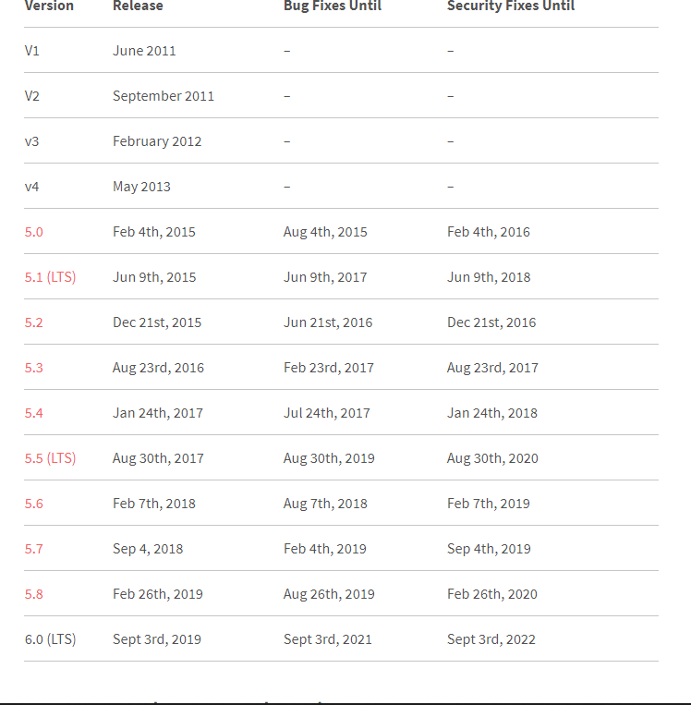

* Laravel is loosely based on the popular Model-View-Controller development pattern. While controller classes are a necessary part of development under Laravel, models and views are optional.

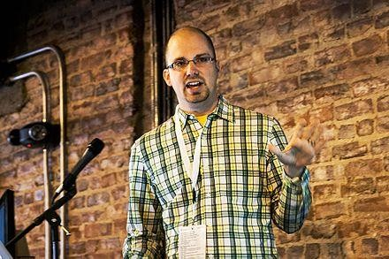

* Taylor Otwell created Laravel as an attempt to provide a more advanced alternative to the CodeIgniter framework, which did not provide certain features such as built-in support for user authentication and authorization. Laravel’s first beta release was made available on June 9, 2011, localization, models, views, sessions, routing and other mechanisms.

##### Laravel Features: -

* Provide a modular [packaging system](https://en.wikipedia.org/wiki/Application-level_package_manager) since the release of Laravel 3, with bundled features already available for easy addition to applications.
* Eloquent ORM ([object-relational mapping](https://en.wikipedia.org/wiki/Object-relational_mapping)) is an advanced PHP implementation of the [active record pattern](https://en.wikipedia.org/wiki/Active_record_pattern).
* More direct database access alternative to the Eloquent ORM. Instead of requiring [SQL queries](https://en.wikipedia.org/wiki/SQL_query) to be written directly, Laravel's query builder provides a set of classes and [methods](https://en.wikipedia.org/wiki/Method_(computer_programming)) capable of building queries programmatically.
* Blade [templating engine](https://en.wikipedia.org/wiki/Web_template_system) combines one or more templates with a [data](https://en.wikipedia.org/wiki/Data_model) [model](https://en.wikipedia.org/wiki/Data_model) to produce resulting views, doing that by transpiring the templates into cached PHP code for improved performance. Blade also provides a set of its own [control structures](https://en.wikipedia.org/wiki/Control_structure) such as [conditional](https://en.wikipedia.org/wiki/Conditional_(computer_programming)) [statements](https://en.wikipedia.org/wiki/Conditional_(computer_programming)) and [loops](https://en.wikipedia.org/wiki/Loop_(computing)), which are internally mapped to their PHP counterparts. Furthermore, Laravel services may be called from Blade templates.
* [Unit testing](https://en.wikipedia.org/wiki/Unit_test) is provided as an integral part of Laravel, which itself contains unit tests that detect and prevent [regressions](https://en.wikipedia.org/wiki/Software_regression) in the framework. Unit tests can be run through the provided artisan [command-line utility](https://en.wikipedia.org/wiki/Command-line_utility).
* Automatic pagination simplifies the task of implementing pagination, replacing the usual manual implementation approaches with automated methods integrated into Laravel.

### *JavaScript: -



* JavaScript is a programming language that can be included on web pages to make them more interactive. You can use it to check or modify the

content of forms, change images, open new windows and write dynamic page content. You can even use it with CSS to make DHTML (Dynamic Hypertext Markup Language). This allows you to make parts of your web pages appear or disappear or move around on the page.

##### JavaScript Feature

* + JavaScript is more flexible language.
  + JavaScript make possible all type of validation and security.
  + JavaScript has set of function.

### *Ajax: -



##### Ajax Features

Ajax is associated with many more other development tools like.

* + HTML
  + JavaScript
  + CSS
* Ajax is a group of interrelated web development techniques used on the client-side to create asynchronous web application. With Ajax, web application can send data to, and retrieve data from, a server asynchronously (in the background) without interfering with the display and behavior of the existing page. Data is usually retrieved using the XML Http Request object. Despite the name, the use of XML is not needed (JSON is often used instead), and the requests do not need to be asynchronous.
* Ajax is not a single technology, but a group of technologies. HTML and CSS can be used in combination to mark up and style information. The DOM is accessed with JavaScript to dynamically display, and to allow the user to interact with the information presented. JavaScript and the XML Http Request object provide a method for exchanging data asynchronously between browser and server to avoided full page reloads.

### *Xampp Server: -

* Stands for "Windows, Apache, MySQL, and PHP." XAMPP is a variation of LAMP for Windows systems and is often installed as a software bundle (Apache, MySQL, and PHP). It is often used for web development and internal testing, but may also be used to serve live websites.
* The most important part of the XAMPP package is Apache (or "Apache HTTP Server") which is used run the web server within Windows. By running a local Apache web server on a Windows machine, a web developer can test webpages in a web browser without publishing them live on the Internet.

### *CSS 3: -



##### What is CSS?

* CSS stands for Cascading Style Sheets
* CSS describes how HTML elements are to be displayed on screen or in other media.
* CSS saves a lot of work. It can control the layout of multiple web pages all at once
* External stylesheets are stored in CSS files

##### CSS Features

CSS has three types:

##### Internal cascading style sheet:

In which code of style is embedded into html source Code.

##### External cascading style sheet:

In which code is kept external file.

##### Inline cascading style sheet:

In which tag of style is embedded into html tag code

# System Analysis and Planning

* 1. Existing System and its Drawbacks
  2. Feasibility Study
  3. Requirement Gathering and Analysis
  4. **Existing System and its Drawbacks**

The main goal of our system is to reduce the drawbacks of existing system like on desk event registration.

In the existing system there is one or two person who is responsible of managing all events from beginning to announcement of result.

Thus, we can say it takes more man power because a person is working behind all the functions of an event like to do registration of students, paper-work, managing event or changes in event etc.

### Following are some drawbacks of existing system

#### Time consuming set up and maintenance: -

On desk registration centre consists delay process, and more human empowerment. Absence of Co-Ordinator makes event registration process time consuming.

#### Delay process: -

Sometimes Students are not aware of event in their institute or Sometimes Co-Ordinators can’t able to do registration of student because of their problems, so the process becomes lengthy.

#### Not easy to maintain & update Event: -

It is not easy to maintain events after some update or changes.

Ex. Students need to get notify when event location is change or any kind of update.

#### Not Consist Students Response: -

Some system doesn’t consist the student side feedback or sometimes it becomes complex when event has tons of candidates and getting feedback from them.

#### Status of Particular event:

On desk registration system can not track the participation ratio and current status like how many students from first year has participated and how many students from particular stream has participated yet. However, it needs time for calculation to know the particular numbers.

## Feasibility Study

All projects are feasible, provided that unlimited resources and infinite time are available. However, in real world that can sound like dream. Especially computer-based systems are likely to be bounded by limited resources as well as time. Feasibility & risk is related in many ways. If the risk is great then feasibility of producing quality software is reduced.

### *Technical Feasibility

This project does require that much of higher & advanced technology. It’s requires database Interaction and it requires to be accessed via web or internet. This can be easily done. It must be developed within the four months of period excluding the time period for the testing and validation, verification. Thus, it seems that the project is technically feasible to do.

### *Economic Feasibility

In This project, we will require to not purchasing much of the tools like web cameras to take the photograph of a person or shut Video of that person, but as it will be web-enabled we do not have any extra cost of setting up a network. This is also feasible economically.

### *Operational Feasibility

The web application can be beneficial only if it satisfies the organization requirement; in such a way that resource utilization & optimum outcome is justified. A web application should not only be robust but should also be able to work Simultaneously with other systems. Operational feasibility means that web application should not affect any existing system during the development phase or even in the implementation phase

### *Management Feasibility

Management feasibility ratio and aspect of management News. Here all level of management rise of related basic feasibility and gives their decision for all those feasibilities to use or not is not comes in basic feasibility of system, bus how the requirement of that all, after that all manager.

### *Time Feasibility

Time feasibility describes the time cost for converting the existing system to web application. As a for completion. This System is Develop under the time period of just four months so we can say that this system is time Feasible.

## Requirement Gathering and Analysis

Gathering requirements for the project is the most important part of the software development.

There are two main reasons for specifying requirements.

* + 1. It guides design and decision-making processes towards a correct solution.
    2. Provides a basis of testing the implemented solution is correct.

Every successful system passes through requirement gathering because without any requirement the development process is like adding bugs in empty system.

Requirement gathering and analysis makes the whole picture of the system and because of that we can identify the features, the modules, the functionality of the system.

##### What type of activities are included?

* How to manage all events?
* What type of category should be included?
* How to manage login and logout process?
* How to know how many Co-Ordinator are added and how they manage the events under direction of Admin?
* How to manage all activities linked with each other?
* How to manage the bunch of data of a particular Institute.
* How many members are going to use this website?
* What is the knowledge level of the member and how does it maintain the ordering criteria?

We analyzed our gathered information and we have decided our system should have following functionalities.

* + **Common models**
    - Login
    - Forget Password (Co-Ordinator / Admin)
    - Change Password (Co-Ordinator / Admin)
    - Winners List Filter
    - View Event Information
    - View Candidates List

### Module 1

**Student**

* + Log in
  + Explore events
  + Manage profile
  + View activity
  + View participated event
  + Feedback
  + View winners list
  + View event information
  + View notice and attachment

### Module 2

**Co-Ordinator**

* + Log in
  + View all events
  + View running events
  + Manage events
  + Manage profile
  + Manage notice
  + Declare result

### Module 3

**Admin (Super-admin)**

* + Login
  + View all events
  + Manage coordinators
  + Manage students
  + Manage notice
  + Manage profile
  + Manage event & student reports
  + View logs

### Module 4

**Admin (System-admin)**

* + Login
  + Manage Institutes/Colleges
  + Manage Subscriptions
  + Manage Notice
  + Manage Profile
  + Manage Requests

# Proposed System

* + - * 1. Scope
        2. Project modules
        3. Module vise objectives/functionalities Constraints
        4. Expected Advantages
  1. **Scope**

We believe with the help of our web application colleges/institutes are able to manage their events easily. The system provides best interface and functionality to the user. Following are the scope of our system.

* To provide user friendly interface
* To reduce the manpower and time behind managing events and activities
* To provide best functionality and features to manage the event
* To provide facility like email-authentication to the users
* To provide backup facility and report generate facility to the admin
* To provide every updates of event using email and notify to the student
* To provide managing facility to the system admin to manage all institute /colleges
* To provide best security features to the users

## Project modules

#### Student

* + 1. Co-Ordinator

#### Admin (Super-Admin)

* + 1. System Admin

## Module wise objectives/functionalities Constraints

### Student

* + - * Student can select their institute/college & insert their enrollment number to login in student panel.
      * Student can view poster of upcoming events
      * Student can explore the events and view event information
      * Student can participate in solo or team event
      * Team event contains team name and team members
      * Student can view winners list and filter the winners
      * Student can view notice and download attachment
      * Student can manage their profile
      * Student can give rate (feedback) to the particular participated event

### Co-Ordinator

* + - * Co-Ordinator can create & manage their event
      * Co-Ordinator can announce the result of their event
      * Co-Ordinator view participated candidates and event information
      * Co-Ordinator can update the event partially when students have already participated
      * Co-Ordinator can request admin to delete particular event
      * Co-Ordinator can send notice to students
      * Co-Ordinator can manage their profile and view their activity
      * Co-Ordinator can change password

### Admin (Super-Admin)

* + - * Admin can create Co-Ordinator for particular category
      * Admin can manage all the category of his/her institute/college
      * Admin can view information and participated candidates of all event
      * Admin can view announced result by Co-Ordinator
      * Admin can update announced result of particular finished event within 24 hours
      * Admin can declare result if result is not declared or missed by Co-Ordinator.
      * Admin can add students through excel sheet or add individual student and manage them
      * Admin can view activity of their co-ordinator
      * Admin can create report of particular event and view particular

student’s record

* + - * Admin can send notice to co-ordinator and students and also receive from system admin
      * Admin can filter the winners list with various options
      * Admin can manage their profile and view their activity
      * Admin can change password

### System Admin

* + - * System Admin can manage Admin (Super-Admin) of all institute/college
      * System Admin can accept/reject the subscription request
      * System admin can send notice to institute/college
      * System admin can manage their profile
      * System admin can change password

## Expected Advantages

#### Easy to use

The system is easy to use for every user such as student, co- ordinator, admin and system-admin.

Easily manage their work with amazing features like announcing result using drag-drop, sending notice, tracking participation ratio using charts, Notify for every update in event etc.

#### User friendly interface

The interface of every panel is minimal and user friendly. Every panel like student, co-ordinator, admin and system-admin is fully responsive and run in most of browser such as Google chrome, Mozilla Firefox, Opera etc.

#### Easy to manage

It is easy to manage every activity and events for admin and co- ordinator. Not for only admin and co-ordinator but also student can manage their participation in event.

Ex. Students can also cancel participation of event. Admin and Co- Ordinator can view the participation ratio of particular year student or particular class students.

#### Report generating feature

Admin can generate report of particular event and students.

Ex. Admin can view particular event’s winners, Event list between two date, Event of particular co-ordinator, Event of particular category or gender etc.

In students report, Admin can view the details such as how many times particular student was won in an event, how many times particular student took a part in an event etc.

#### Security

The system is secured itself because of functionality and features of Laravel 6. Not only security of Laravel 6 but we have done encryption and decryption of Ids when it passes data from one page to another.

Ex. URL encryption-decryption

#### Reduce time & manpower

On desk registration system has many drawbacks like difficulty in managing events, difficulty in registration, time consuming and it takes lots of manpower.

In this system, all the task is done through online with the help of internet and various functionality of system.

Ex. Create and manage event through the system, Students can participate in event through the system etc.

# Detail Planning

* 1. Data Flow Diagram / UML
  2. Process Specification / Activity Flow Diagram
  3. Data Dictionary
  4. Entity-Relationship Diagram / Class Diagram
  5. **Data Flow Diagram / UML**

A data flow diagram (DFD) illustrates how data is processed by a system in terms of inputs and Outputs. As its name indicates its focus is on the flow of information, where data comes from, where it goes and how it gets stored.

### Strict landing page policy:

* A data flow diagram needs to be simple because user has to go through it, understand suggest correction or changes.
* External entity
* Data flow
* Process
* Data stores

### Symbols used in DFD:

* + 1. **Process: -**
       - Flow of data is transformed.
       - A Process represents some amount of work u
       - sing behavior of data.
       - Transformation of data from one form to another.
       - A circle represents a process.
       - The area of the circle is divided into two parts.
       - The process number is written in the top portion and process name is written the bottom portion.
       - E.g. verify credits, update inventory file, etc.

### External Entity: -

* A source or destination of data which is external to the system.
* As the name suggest it line outside the context of the system. It represented by solid squares.
* The people/department that will be giving the data and/or receiving information.
* It can be referred to as external entities as they do not accomplish any word done by the system.
* The data coming in and the report produced are referred as the input and Output of the system respectively.

### Data Flow: -

* Line is packet of data. it may be of form of documentation, letter etc.
* A data flow portrays an interface among different components in the flow diagram. It represents the data of the data as it flows through a system. An arrow represents it.
* The arrow head point in the direction in which the data moves.

### Data Stores: -

* Any stores data but no reference to the physical method of storing.
* If there is a logical requirement for the data to be stored, it is held in a data store.
* A data store there for, is a repository of the data.

### Context Level DFD

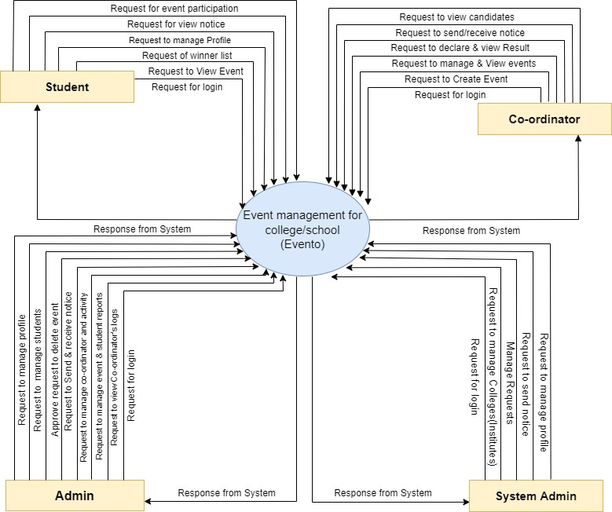

* **1st Level DFD Student**

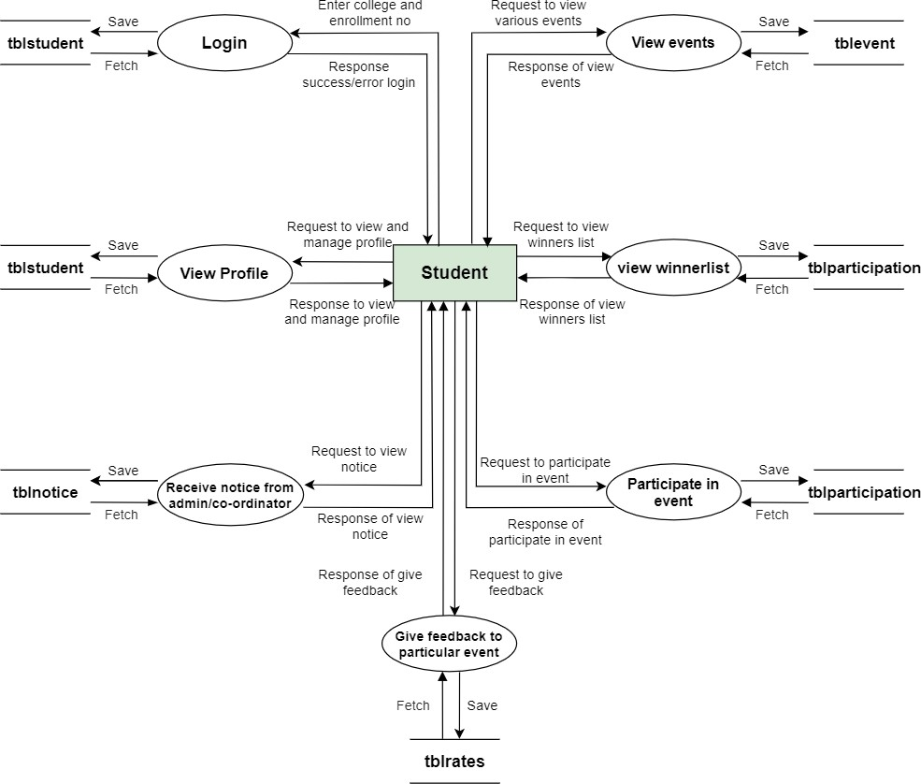

**1.0**

**4.0**

**2.0**

**5.0**

**3.0**

**6.0**

**7.0**

### 1st Level DFD Co-Ordinator

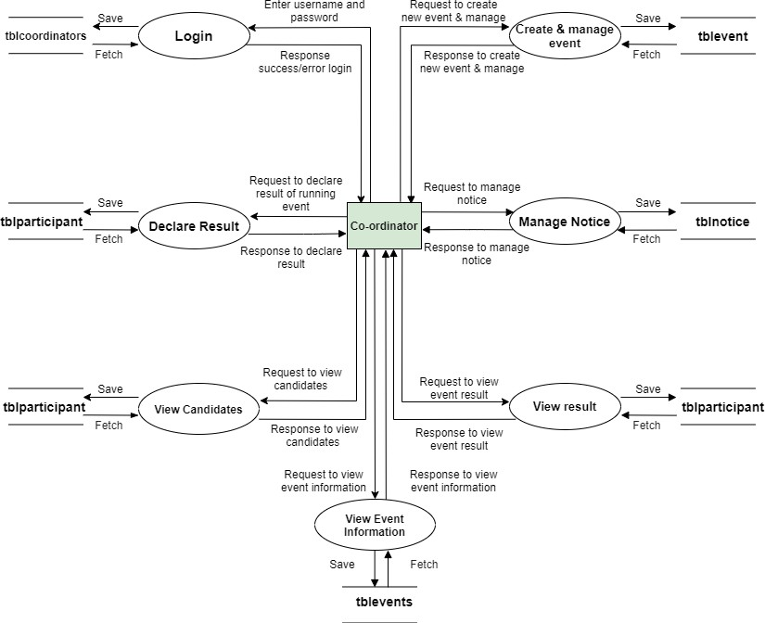

**8.0**

**11.0**

**9.0**

**12.0**

**10.0**

**13.0**

**14.0**

* **1st Level DFD Admin**

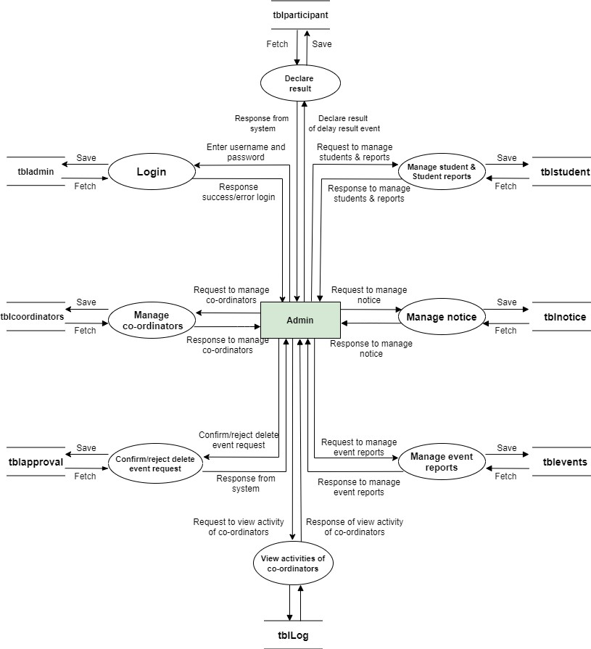

**18.0**

**15.0**

**19.0**

**16.0**

**20.0**

**17.0**

**21.0**

**22.0**

### 1st Level DFD System Admin

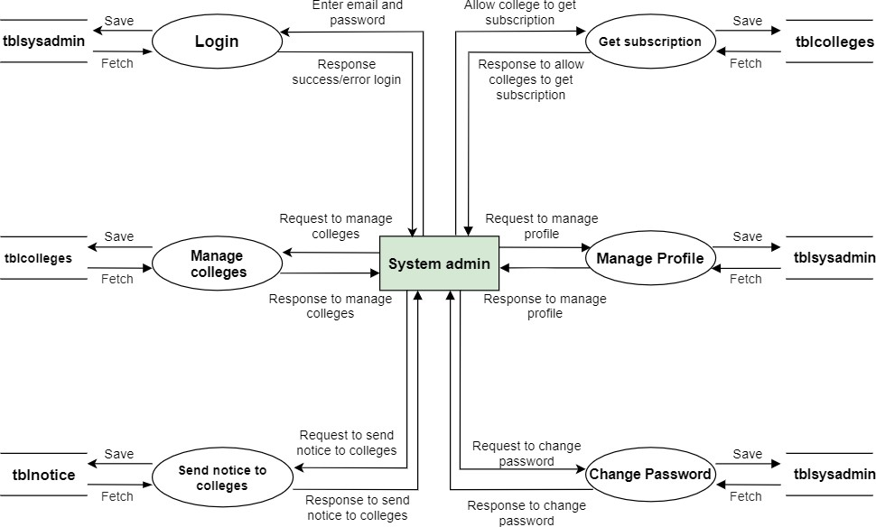

**23.0**

**26.0**

**27.0**

**24.0**

**28.0**

**25.0**

* **2nd level DFD Student**

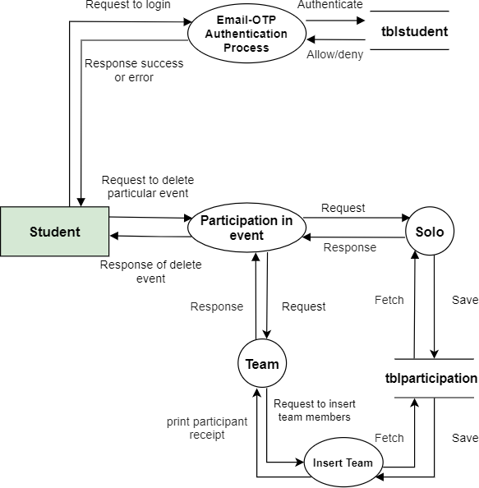

**1.1**

**1.2**

**1.2.2**

**1.2.1**

**1.2.3**

### 2nd level DFD Co-Ordinator

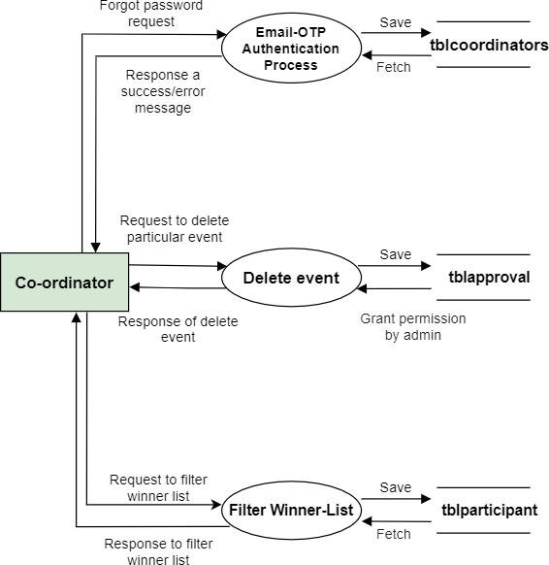

**2.1**

**2.2**

**2.3**

* **2nd level DFD Admin**

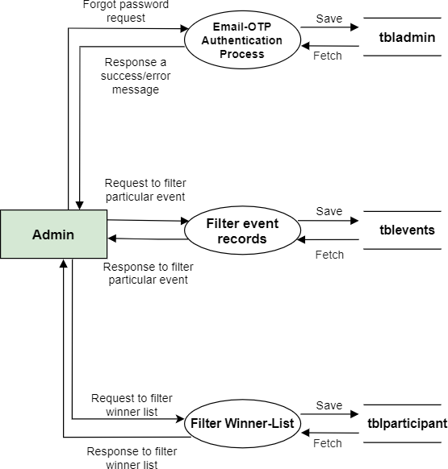

**3.1**

**3.2**

**3.3**

* **2nd level DFD System-Admin**

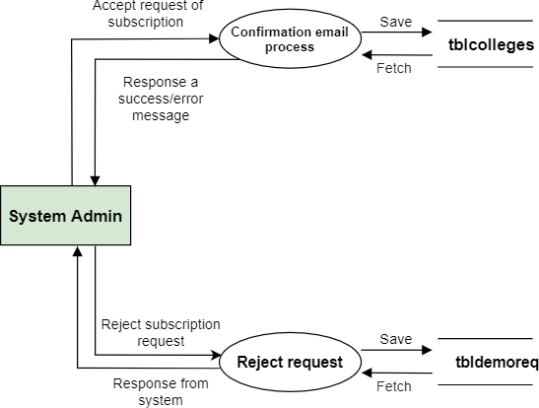

**4.1**

**4.2**

## Process Specification

### Student login

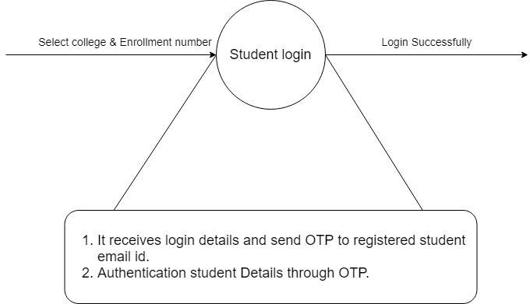

**1.0**

* **Participant**

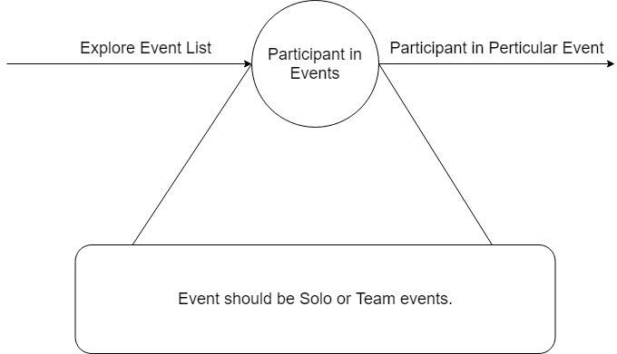

**2.0**

### Feedback

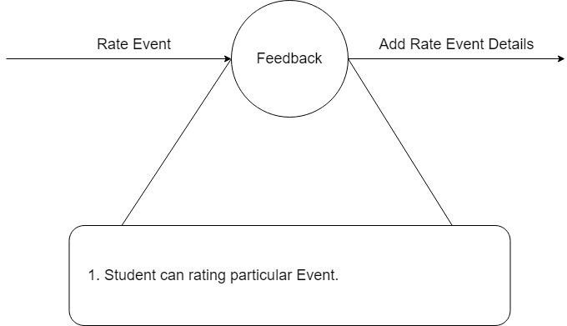

**3.0**

* **Student Activities**

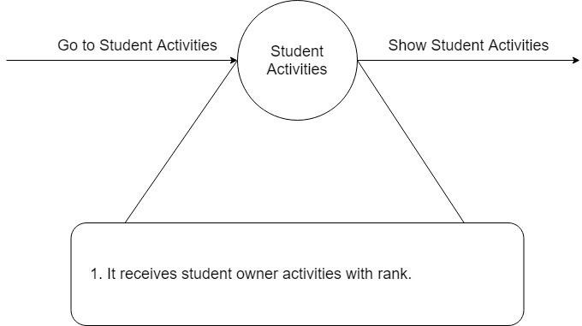

**4.0**

### Student Profile

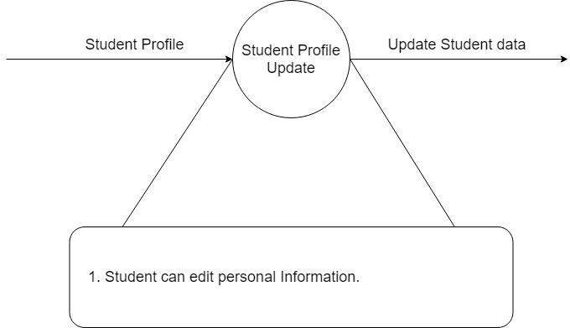

**5.0**

* **Notice**

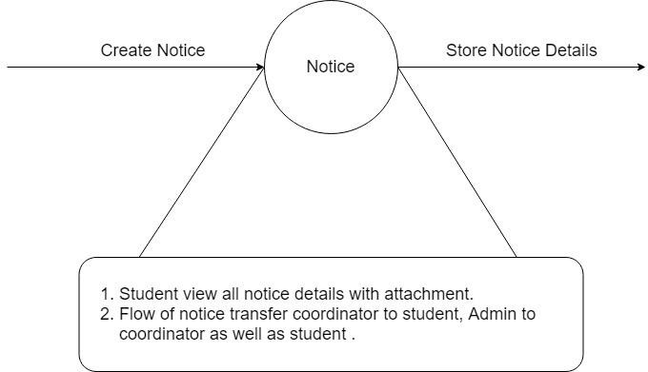

**6.0**

### Co-Ordinator Login

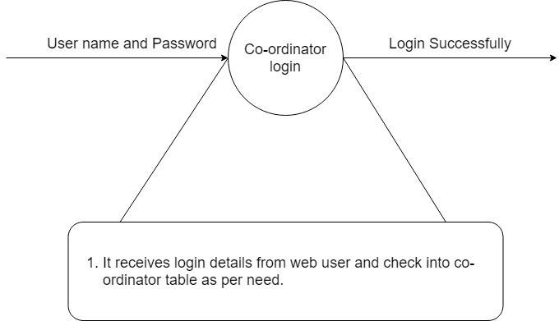

**7.0**

* **Co-Ordinator Profile**

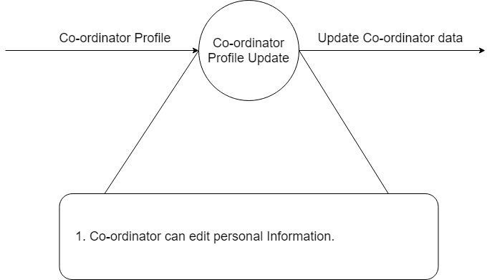

**8.0**

### Co-Ordinator Change Password

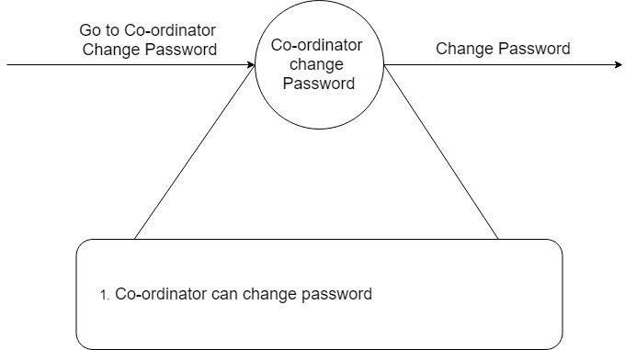

**9.0**

* **Create Event**

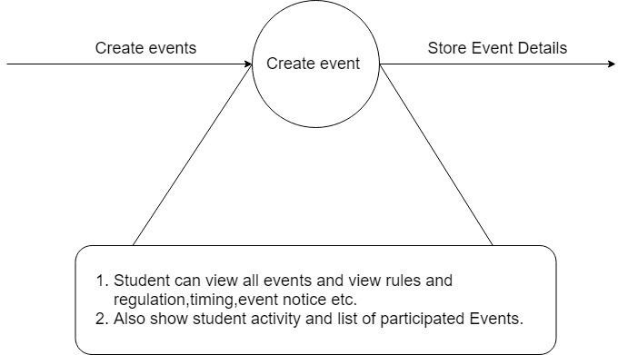

**10.0**

### Delete Event

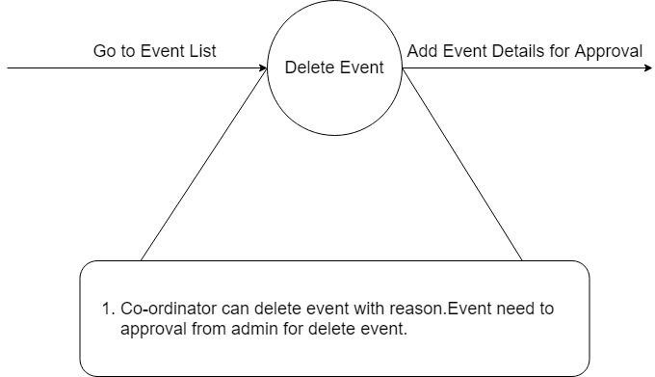

**11.0**

* **Modify Event**

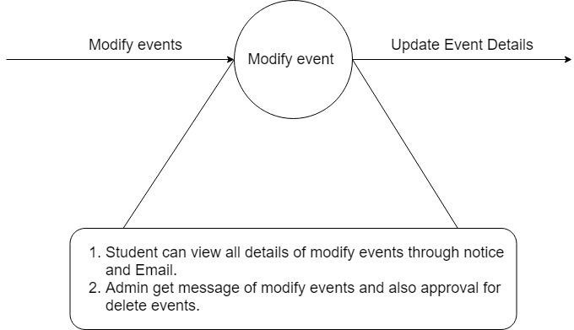

**12.0**

### Announce Result

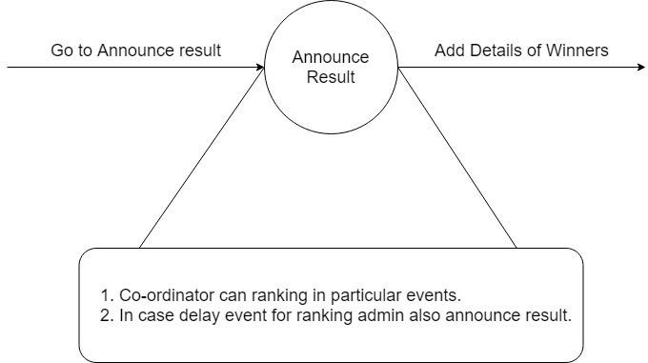

**13.0**

* **Winner List**

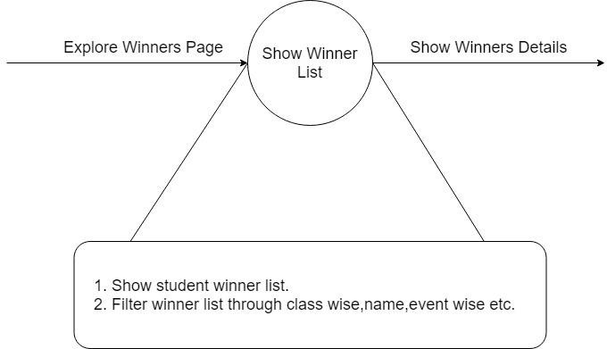

**14.0**

* **Event Details**

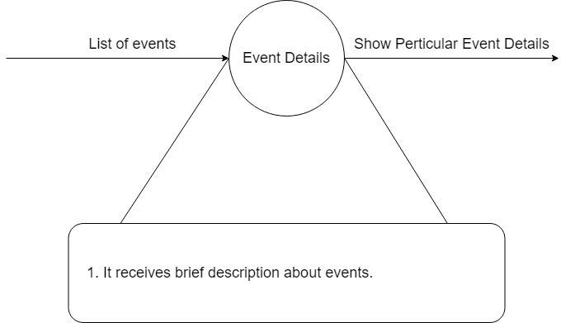

**15.0**

### Admin login

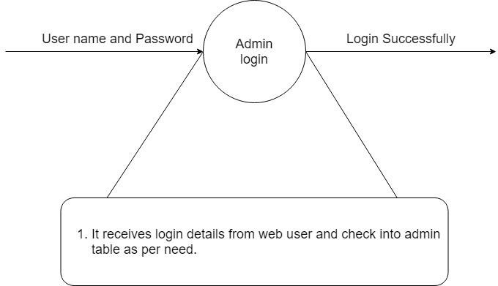

**16.0**

* **Admin Password**

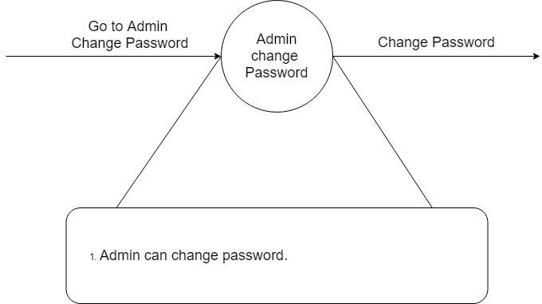

**17.0**

### Manage Student

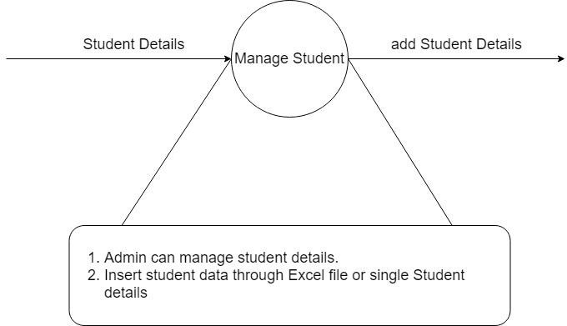

**18.0**

* **Co-Ordinator logs**

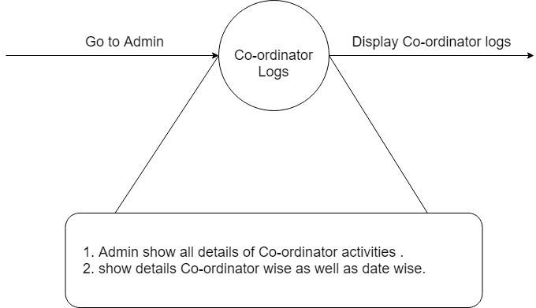

**19.0**

### Manage Co-Ordinator

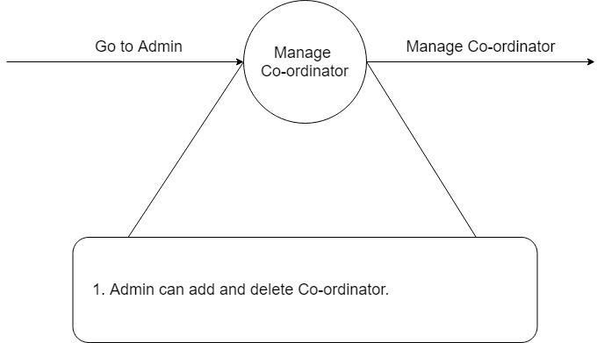

**20.0**

* **Manage College**

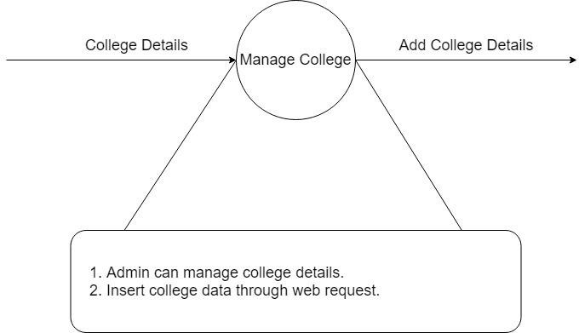

**21.0**

## Data Dictionary

### tbladmin

|  |  |  |  |  |  |  |
| --- | --- | --- | --- | --- | --- | --- |
| **Data Type:** | **Data Name** | **Alias** | **Description** | **Character istic** | **How Used** | **Where used** |
| **Int (5)** | admin_id | aid | Stores unique id for admin | Only numbers allowed | Output | Access admin Details |
| **Varchar (7)** | College_cod e | clgcode | Stores code of college | Only character allowed | Output | Access Admin Details |
| **Text** | Admin_nam e | name | Stores admin name | Only character allowed | Input and Output | Display name of admin |
| **Text** | email | email | Stores admin email | Only Allow email Expression | Input and Output | Display Admin email |
| **Int (10)** | mobile | Mobile | Stores admin mobile | Only allow mobile Expression | Output | Display admin mobile |
| **Text** | Password | Pass | Stores admin password | Only allow 6 to 13 character | Input | Login, Change password |
| **Int (5)** | Last_notice | Last_n oti | stores last notice value | Default 0 | Input and Output | Store the last seen notice  number |
| **Text** | Profile picture | Profilep ic | Store profile pic path | Not null allowed | Output | Display Profile picture |

1. **Tblapproval**

|  |  |  |  |  |  |  |
| --- | --- | --- | --- | --- | --- | --- |
| **Data Type:** | **Data Name** | **Alias** | **Description** | **Character istic** | **How Used** | **Where used** |
| **Int (5)** | approval_id | apid | Stores unique id for requested delete events | Only numbers allowed | Output | Access details of requested delete  events |
| **Int (5)** | Event_id | Eid | Stores id of event | Only number allowed | Output | Access details of requested delete  events |
| **Text** | Reason | reason | Stores reason for requested delete events | Not null allowed | Input and Output | Display reason of requested delete  events |
| **Int (5)** | Co- ordinator id | cid | Stores co- ordinator id | Only number allowed | Output | Display co- ordinator  details |

### tblcategory

|  |  |  |  |  |  |  |  |
| --- | --- | --- | --- | --- | --- | --- | --- |
| **Data Type:** | **Data Name** | **Alias** | **Descripti on** | | **Character istic** | **How Used** | **Where used** |
| **Text** | Category_id | Category_id | | Stores category id | Not null allowed | Input/ Output | Access category details |

|  |  |  |  |  |  |  |
| --- | --- | --- | --- | --- | --- | --- |
| **Text** | Category_n ame | Category_n ame | Stores category name | Not null allowed | Output | Display category name |
| **Text** | College_cod e | Clgcode | Stores code of college | Not null allowed | Input and Output | Access category details |
| **Varchar (1)** | Status | Status | Stores status of category | Not null allowed | Input and Output | Display Status of category |
| **Text** | Category_pi cture | Cat_pic | Stores category picture | Not null allowed | Output | Display category picture |

1. **tblcolleges**

|  |  |  |  |  |  |  |
| --- | --- | --- | --- | --- | --- | --- |
| **Data Type:** | **Data Name** | **Alias** | **Descripti on** | **Character istic** | **How Used** | **Where used** |
| **Varchar (7)** | College_cod e | Clgcode | Stores code of college | Not null allowed | Input/ Output | Access category details |
| **Text** | College_na me | clgname | Stores college name | Not null allowed | Output | Display college name |
| **Text** | Address | address | Stores college address | Not null allowed | Output | Access college address |

|  |  |  |  |  |  |  |
| --- | --- | --- | --- | --- | --- | --- |
| **Text** | City_name | city | Stores city name of college | Not null allowed | Output | Display City of college |
| **Text** | status | status | Stores college status | Status should be active or  inactive | Input/ Output | Display status of college |

### tblcoordinaters

|  |  |  |  |  |  |  |
| --- | --- | --- | --- | --- | --- | --- |
| **Data Type:** | **Data Name** | **Alias** | **Descripti on** | **Character istic** | **How Used** | **Where used** |
| **Int (5)** | Co- ordinators id | cid | Stores co- ordinator  s id | Uniq/not null | Output | Access co- ordinators details |
| **Varchar (7)** | College code | clgcode | Stores college code | Not null allowed | Input and Output | Access college details |
| **Text** | Co- ordinators name | cname | Stores co- ordinator  s name | Only characters allowed | Input and Output | Access co- ordinators name |
| **Int (10)** | Mobile number | mobile | Stores co- ordinatot s mobile  number | Only allow mobile Expression | Input and Output | Access co- ordinators mobile number |
| **Text** | Password | password | Stores co- ordinator s  password | Not null | Output | Access co- ordinators account |

1. **tbldemoreq**

|  |  |  |  |  |  |  |
| --- | --- | --- | --- | --- | --- | --- |
| **Data Type:** | **Data Name** | **Alias** | **Descripti on** | **Character istic** | **How Used** | **Where used** |
| **Int (5)** | Demo_requ est_id | did | Store id for demo request  of college | Uniq/not null | Output | Access Demo request |
| **Text** | Admin_nam e | Aname | Store admin name of college | Not null allowed/on ly character  allowed | Input and Output | Access college admin name |
| **Text** | email | email | Stores college admin  email | Only email Expression allowed | Input and Output | Access college admin  email |
| **Text** | Institute_na me | iname | Stores institute name | Not null | Input and Output | Access institute name |
| **Int (10)** | Contact_nu mber | contact | Store college mobile number | Not null/mobil e Expression  allowed | Output | Access college mobile number |
| **Text** | City | City | Store college city | Not null | Input and Output | Access college city |
| **Text** | Address | address | Store college address | Not null | Input | Access college address |
| **Text** | Massage | msg | Send msg with demo request | Allow null | Input | Receive massage from college  admin |

### tblevents

|  |  |  |  |  |  |  |
| --- | --- | --- | --- | --- | --- | --- |
| **Data Type:** | **Data Name** | **Alias** | **Descripti on** | **Character istic** | **How Used** | **Where used** |
| **Int (5)** | Event id | eid | Store event id | Uniq/not null | Output | Access event informatio  n |
| **Text** | Event name | ename | Store event name | Not null allowed | Input and Output | Access event name |
| **Text** | Category id | Cate_id | Store event category  id | Not null | Input and Output | Access category of the  event |
| **Text** | Event date | edate | Stores Event date | Only date Allow | Input and Output | Access Event date |
| **Text** | Enddate | enddate | Store event end date | Only date allow | Input and Output | Access event end date |
| **Text** | Time | time | Store event time | Not null/time | Input and Output | Access event starting  time |
| **Date** | Registration start date | Reg_start_d ate | Store start date of registrati  on | Date | Input  /Outp ut | Access registratio n start date |
| **Date** | Registration end date | Reg_end_d ate | Store end date of registrati  on | Date | Input  /Outp ut | Access registratio n end  date |

|  |  |  |  |  |  |  |
| --- | --- | --- | --- | --- | --- | --- |
| **Text** | College_cod e | Clgcode | Store college code | Only character allowed | Input/ Output | Access college details |
| **Text** | Gender_allo w | gallow | Store the allowed gender for event | Only male/fema le allowed | Input/ Output | Access the allowed gender for  events |
| **Text** | Event for | efor | Store the class allowed for event | Class name allowed only | Input/ Output | Access the allowed class for  event |
| **Text** | Event type | e_type | Store the event type | Solo/team allowed only | Input/ Output | Access the type of event |
| **Int (2)** | Team size | tsize | Store the team size for event | Allow null/only number | Input/ Output | Access the team size |
| **Int (3)** | Maximum team | maxteam | Store the maximu m team allow for participati  on | Only number | Input/ Output | Access the maximum team allowed |
| **Text** | Place | place | Store the event location | Not null | Output | Access the place of the  event |
| **Varchar (3)** | Allow different class | Alw_dif_cla ss | Specify that different class student allow or  not | Yes/no allow | Output | Specify different class allow or not |

|  |  |  |  |  |  |  |
| --- | --- | --- | --- | --- | --- | --- |
| **Varchar (3)** | Allow different division | Alw_dif_div | Specify that different division student allow or  not | Yes/no allow | Output | Specify different division allow or not |
| **Text** | Rules | rules | Specify the extra rules of the  events | Allow null | Output | Display extra rules for the events |
| **Text** | Banner | banner | Specify the the banner name of  event | Allow null | Output | Access banner name or display  banner |
| **Int (5)** | Co- ordinators id | cid | Specify the event co- ordinator | Not null/intege r | Input  /Outp ut | Access the co- ordinators informatio  n |

1. **tbllog**

|  |  |  |  |  |  |  |
| --- | --- | --- | --- | --- | --- | --- |
| **Data Type:** | **Data Name** | **Alias** | **Descripti on** | **Character istic** | **How Used** | **Where used** |
| **Int (7)** | Log id | Lid | Store log id | Uniq/not null | Input/ Output | Access log informatio n |
| **Int (5)** | User id | Uid | Store id of the user | Not null/intege r | Input and Output | Access user details |

|  |  |  |  |  |  |  |
| --- | --- | --- | --- | --- | --- | --- |
| **Text** | User type | Utype | Store user type | Not null/admin  /co-  ordinators | Input and Output | Access the type of the  user |
| **Text** | Action on | action_on | Store the field on which the action  perform | Not null | Input and Output | Access field name on which action  perform |
| **Text** | Action type | action_type | Store the type of action | Not null | Input and Output | Access action type |
| **Text** | Description | desrc | Store descrepti on of the  action | Not null | Input and Output | Display action descriptio  n |
| **Text** | Time | time | Store time of action  occur | Time | Input  /Outp ut | Display the action time |
| **Text** | Ip address | ip_add | Store the client ip address from where action  occur | Only ip addesss allow/not null | Output | Display the ip address |

### tblnotice

|  |  |  |  |  |  |  |
| --- | --- | --- | --- | --- | --- | --- |
| **Data Type:** | **Data Name** | **Alias** | **Descripti on** | **Character istic** | **How Used** | **Where used** |
| **Int (6)** | Notice id | nid | Store the notice id | Uniq/not null | Input/ Output | Access notice details |

|  |  |  |  |  |  |  |
| --- | --- | --- | --- | --- | --- | --- |
| **Text** | Topic | topic | Store the topic of the notice | Not null | Output | Display the notice topic |
| **Text** | Massage | message | Store the message of the  notice | Not null | Output | Display the notice message |
| **Text** | Sender | sender | Store the sender name | Not null/only character | Output | Display the name of the notice  sender |
| **Text** | Receiver | receiver | Store the receivers type | Not null/stude nt/co- ordinator/  admin | Input/ Output | access the receiver type |
| **Date** | Notice date | ndate | Store the date of notice send | Not null/only date | Output | Display the sending date of  notice |
| **Time** | Notice time | ntime | Store the time of the notice  send | Not null/Time | Output | Display time of notice  sending |
| **Text** | Attachment | Attachment | Store the file attached with  notice | Allow null | Output | Display or access the attached files |
| **Text** | College code | Clgcode | Store the college code | Not null/only character | Input/ Output | Access the college  details |

1. **tblparticipant**

|  |  |  |  |  |  |  |
| --- | --- | --- | --- | --- | --- | --- |
| **Data Type:** | **Data Name** | **Alias** | **Descripti on** | **Characte ristic** | **How Used** | **Where used** |
| **Int (5)** | Participant id | Pid | Store the id of the participant | Uniq/not null | Input/ Output | Access the participant informatio  n |
| **Int (5)** | Event id | Eid | Store id of the event | Not null/integ er | Input and Output | Access event details |
| **Text** | Team name | tname | Store team name | Allow null | Output | Display the name of the  team |
| **Varchar (15)** | Student enrolment number | Senrl | Store the enrolment number of the  students | Not null | Input and Output | Access the student informatio n |
| **Varchar (7)** | College code | Clgcode | Store college code | Not null/chara cter only | Input and Output | Access the college informatio  n |
| **Text** | Rank | rank | Store the rank of the participant | Not null/defau lt value p | Inputa nd Output | Access or display the participant  rank |
| **Date** | Registration date | Reg_date | Store the registratio n date | date | Output | Display registratio n date |

### tblrates

|  |  |  |  |  |  |  |
| --- | --- | --- | --- | --- | --- | --- |
| **Data Type:** | **Data Name** | **Alias** | **Descripti on** | **Character istic** | **How Used** | **Where used** |
| **Int (5)** | Rates id | rid | Store rates id | Uniq/not null | Input/ Output | Access rate informatio  n |
| **Int (5)** | Event id | Eid | Store event id | Not null/intege r | Input and Output | Access event informatio  n |
| **Varchar (15)** | Student enrolment number | Enrl | Store student enrolmen  t number | Not null | Input and Output | Access student informatio  n |
| **Int (1)** | Rate | rate | Store the rate value for  the event | Not null | Input and Output | Display or access the rates of  events |

1. **tblresult_delay**

|  |  |  |  |  |  |  |
| --- | --- | --- | --- | --- | --- | --- |
| **Data Type:** | **Data Name** | **Alias** | **Descripti on** | **Character istic** | **How Used** | **Where used** |
| **Int (5)** | Id | Id | Store the result delay  entry id | Uniq/not null | Input/ Output | Access the delay result  event |
| **Int (5)** | Event id | Eid | Store event id | Not null/intege r | Input and Output | Access event informatio  n |

|  |  |  |  |  |  |  |
| --- | --- | --- | --- | --- | --- | --- |
| **Int (5)** | Co- ordinatores id | cid | Store co- ordinator es id | Not null/intege r only | Input and Output | Access co- ordinatore s  informatio |

### tblstudent

|  |  |  |  |  |  |  |
| --- | --- | --- | --- | --- | --- | --- |
| **Data Type:** | **Data Name** | **Alias** | **Descripti on** | **Character istic** | **How Used** | **Where used** |
| **Varchar (15)** | Student enrolment number | senrl | Store enrolnum ber of the student | Uniq/not null | Input/ Output | Access the student infromatio  n |
| **Text** | Student name | sname | Store student name | Not null/charac ter only | Input and Output | Display student name |
| **Int (5)** | Student roll number | rno | Store student roll number | Not null/intege r only | Input and Output | Access or display student roll  number |
| **Text** | Student college code | clgcode | Store college code of  student | Not null | Input and Output | Access college details |
| **Date** | Student date of birth | dob | Store student date of  birth | Not null/date only | Output | Display student birth date |
| **Text** | Student Class | class | Store student class | Not null | Input/ Output | Display or access student  class |

|  |  |  |  |  |  |  |
| --- | --- | --- | --- | --- | --- | --- |
| **Int (5)** | Student Division | division | Store student division | Not null | Input/ Output | Display or access student  division |
| **Text** | Student email address | email | Store email address of  student | Email expression | Input/ Output | Display or access student email  address |
| **Int (10)** | Student_m obile | mobile | Store mobile number of  student | Mobile expression | Input/ Output | Store or display student mobile  number |
| **Text** | Student_ad dress | address | Store address of  student | Not null | Output | Display student address |
| **Varchar (6)** | Student_ge nder | gender | Store student gender | Not null/only male and  female | Output | Access or display student  gender |
| **Int (5)** | Last_notice | Last_noti | Store last notice id | Default 0 | Input/ Output | Access last notice id seen by student |

1. **tblsysadmin**

|  |  |  |  |  |  |  |
| --- | --- | --- | --- | --- | --- | --- |
| **Data Type:** | **Data Name** | **Alias** | **Descripti on** | **Character istic** | **How Used** | **Where used** |
| **Int (2)** | System_ad min_id | Sid | Store the system admin id | Uniq/not null | Input/ Output | Access the system admin  account |
| **Text** | System_na me | S_name | Store system admin  name | Not null/charac ter only | Output | Display system admin  name |
| **Text** | System_ad min_email | S_email | Store email address of system  admin | Email expression | Input and Output | Access or display system admin  email |
| **Int (10)** | System_ad min_mobile | s_mobile | Store system admin mobile number | Mobile expression | Input and Output | Access system email address mobile  number |
| **Text** | System_pof ile_picture | s_propic | Store system admin profile  picture | Allow null | Output | Display system admin picture |
| **Text** | System_ad min_passw ord | pass | Store system admin  password | Not null | Input/ Output | Access system admin  account |

* 1. **Entity-Relationship Diagram**

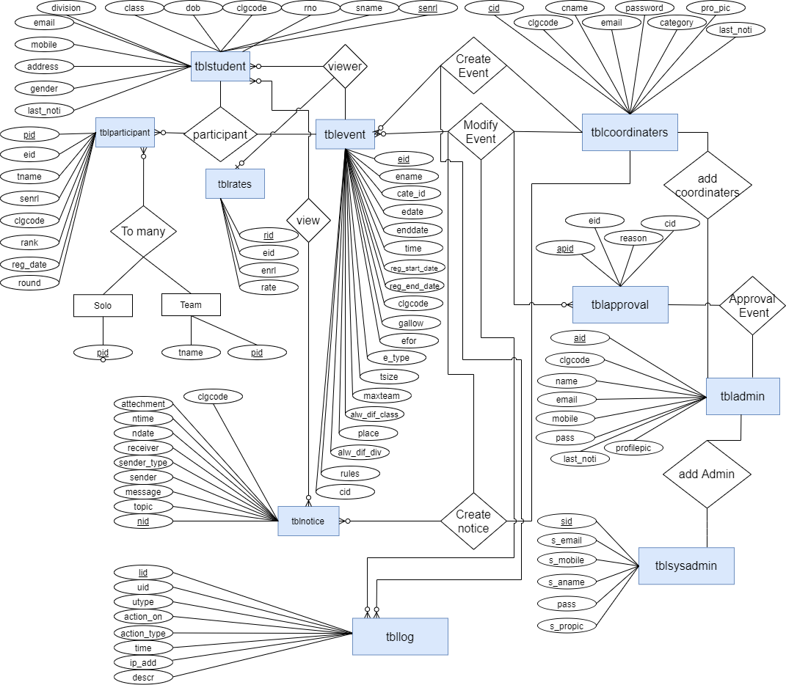

# System Design

* + 1. Database Design
    2. Directory Structure
    3. Input Design
    4. Output Design

## Database Design

### tbladmin

|  |  |  |  |  |  |
| --- | --- | --- | --- | --- | --- |
| No | column_name | Data_type | Size | Constraint | Description |
| 1 | aid | Integer | 11 | Primary key | This column contains Admin  id |
| 2 | clgcode | Varchar | 7 | - | This column contains College  Code |
| 3 | name | Text | - | - | This column  contains Admin Name |
| 4 | email | Text | - | - | This column contains Admin Email id/User  name |
| 5 | mobile | Varchar | 10 | - | This column contains Admin  Mobile Number |
| 6 | pass | Text | - | - | This column  contains Admin Password |
| 7 | last_noti | Integer | 11 | Default 0 | Access last  notice id seen by admin |
| 8 | profilepic | Text | - | - | This column contains Display  Profile picture of admin |

1. **tblapproval**

|  |  |  |  |  |  |
| --- | --- | --- | --- | --- | --- |
| No | column_name | Data_type | Size | Constraint | Description |
| 1 | apid | Integer | 30 | Primary key | This column  contains Approval Id |
| 2 | eid | Integer | 30 | Foreign key | This column contains Event id |
| 3 | reason | Text | - | - | This column  contains Reason for delete Event |
| 4 | cid | Integer | 10 | Foreign key | This column contains Co-  ordinaters id |

### tblcategory

|  |  |  |  |  |  |
| --- | --- | --- | --- | --- | --- |
| No | column_name | Data_type | Size | Constraint | Description |
| 1 | category_id | Text | - | - | This column contains Category id |
| 2 | category_name | Text | - | - | Display Category name |
| 3 | clgcode | Text | - | - | College code |
| 4 | status | Varchar | 1 | - | Category status Active/Inactive |
| 5 | cat_pic | Text |  | - | Display Category picture name |

1. **tblcolleges**

|  |  |  |  |  |  |
| --- | --- | --- | --- | --- | --- |
| No | column_name | Data_type | Size | Constraint | Description |
| 1 | clgcode | Text | - | - | This column contains College code |
| 2 | clgname | Text | - | - | This column contains College Name |
| 3 | address | Text | - | - | This column contains College Address |
| 4 | city | Text | - | - | This column contains College City |
| 5 | status | Text | - | - | This column contains College Status  Active / Inactive |
| 6 | start_date | Date | - | - | This column contains Subscription Starting  date |

### tblcoordinaters

|  |  |  |  |  |  |
| --- | --- | --- | --- | --- | --- |
| No | column_name | Data_type | Size | Constraint | Description |
| 1 | cid | Integer | 11 | Primary key | This column contains Co-ordinater id |
| 2 | clgcode | Varchar | 10 | - | This column contains College Code |
| 3 | cname | Text | - | - | This column contains Co-ordinater Name |
| 4 | email | Text | - | - | This column contains Co-ordinater Email id |
| 5 | mobile | Varchar | 10 | - | This column contains  Co-ordinater Mobile Number |

|  |  |  |  |  |  |
| --- | --- | --- | --- | --- | --- |
| 6 | password | Text | - | - | This column contains  Co-ordinater Password |
| 7 | cate_id | Text | - | - | This column contains Category Id |
| 8 | pro_pic | Text | - | - | This column Display  Profile picture of co- ordinator |
| 9 | last_noti | Integer | 10 | Default 0 | Access last notice id seen by co-ordinator |
| 10 | status | Varchar | 1 | - | This column contains  Co-ordinater Status Active / inactive |

1. **tbldemoreq**

|  |  |  |  |  |  |
| --- | --- | --- | --- | --- | --- |
| No | column_name | Data_type | Size | Constraint | Description |
| 1 | did | Integer | 11 | Primary key | This column contains Demo Request id |
| 2 | aname | Text | - | - | This column contains Admin Name |
| 3 | email | Text | - | - | This column contains Admin Email id /  Institute Email id |
| 4 | iname | Text | - | - | This column contains Institute Name |
| 5 | contact | Varchar | 10 | - | This column contains Admin/Institute  Contact Number |
| 6 | city | Text | - | - | This column contains Institute City |
| 7 | address | Text | - | - | This column contains Institute address |
| 8 | msg | Text | - | NULL | This column contains Message of admin’s  request |
| 9 | reqdate | Date | - | - | This column contains Request date |

### tblevents

|  |  |  |  |  |  |
| --- | --- | --- | --- | --- | --- |
| No | column_name | Data_type | Size | Constraint | Description |
| 1 | eid | Integer | 11 | Primary key | This column contains Event id |
| 2 | ename | Text | - | - | This column contains Event Name |
| 3 | cate_id | Text | - | - | This column contains |

|  |  |  |  |  |  |
| --- | --- | --- | --- | --- | --- |
|  |  |  |  |  | Category Id |
| 4 | edate | Date | - | - | This column contains Event Date |
| 5 | enddate | Date | - | - | This column contains Event Last Date |
| 6 | time | Time | - | - | This column contains Event timing |
| 7 | reg_start_date | Date | - | - | This column contains Registration start date |
| 8 | reg_end_date | Date | - | - | This column contains Registration end date |
| 9 | clgcode | Text | - | - | This column contains College code |
| 10 | gallow | Text | - | - | This column contains Gender type which is allow for that event  Ex. Both /Male /Female |
| 11 | efor | Text | - | - | This column contains Event For particular class Ex. Fybca, Tybca,  Fybba etc |
| 12 | e_type | Text | - | - | This column contains Event Type either Team or Solo |
| 13 | tsize | Integer | 11 | - | This column contains Team size |
| 14 | maxteam | Integer | 3 | - | This column contains Maximum team in Event |
| 15 | place | Text | - | - | This column contains Event place |
| 16 | alw_dif_class | Text | - | - | This column Allow/not allow Different class for event |
| 17 | alw_dif_div | Varchar | 4 | - | This column Allow/not  allow Different division for event |
| 18 | rules | Text | - | - | This column contains Event rules |
| 19 | banner | Text | - | NULL | This column contains  image or banner of particular event |
| 20 | cid | Integer | 11 | Foreign key | This column contains Co-ordinater id |

1. **tbllog**

|  |  |  |  |  |  |
| --- | --- | --- | --- | --- | --- |
| No | column_name | Data_type | Size | Constraint | Description |
| 1 | lid | Integer | 11 | Primary key | This column contains Log id |
| 2 | uid | Text | - | - | This column contains User id |
| 3 | utype | Text | - | - | This column contains User type |
| 4 | action_on | Text | - | - | This column contains name of the page in which action was  performed |
| 5 | action_type | Text | - | - | This column contains  action type Ex. insert, update, delete |
| 6 | descr | Text | - | - | This column contains Log Description |
| 7 | time | Text | - | - | This column contains Action time |
| 8 | ip_add | Text | - | - | This column contains IP address |

### tblnotice

|  |  |  |  |  |  |
| --- | --- | --- | --- | --- | --- |
| No | column_name | Data_type | Size | Constraint | Description |
| 1 | nid | Integer | 11 | Primary key | This column contains Notice id |
| 2 | topic | Text | - | - | This column contains Notice topic |
| 3 | message | Text | - | - | This column contains Notice message |
| 4 | sender | Text | - | - | This column contains Notice sender |
| 5 | sender_type | Text | - | - | This column contains Notice sender type |
| 6 | receiver | Text | - | - | This column contains Notice receiver |
| 7 | ndate | Date | - | - | This column contains Notice date |
| 8 | ntime | Text | - | - | This column contains Notice time |
| 9 | attechement | Text | - | NULL | This column contains Display Notice Attachment name |
| 10 | clgcode | Text | - | - | This column contains  College code |

1. **tblparticipant**

|  |  |  |  |  |  |
| --- | --- | --- | --- | --- | --- |
| No | column_name | Data_type | Size | Constraint | Description |
| 1 | pid | Integer | 11 | Primary key | This column contains Participant Id |
| 2 | eid | Text | - | Foreign key | This column contains Event Id |
| 3 | tname | Text | - | NULL | This column contains Team name |
| 4 | senrl | Text | - | - | This column contains Student Enrollment  Number |
| 5 | clgcode | Text | - | - | This column contains College code |
| 6 | rank | Text | - | - | This column contains rank of the participant |
| 7 | reg_date | date | - | - | This column contains Registration date |

### tblrates

|  |  |  |  |  |  |
| --- | --- | --- | --- | --- | --- |
| No | column_name | Data_type | Size | Constraint | Description |
| 1 | rid | Integer | 11 | Primary key | This column contains Rate id |
| 2 | eid | Text | - | Foreign key | This column contains Event id |
| 3 | enrl | Text | - | - | This column contains Student Enrollment  number |
| 4 | rate | Integer | 1 | - | This column contains Event rates |

1. **tblresult_delay**

|  |  |  |  |  |  |
| --- | --- | --- | --- | --- | --- |
| No | column_name | Data_type | Size | Constraint | Description |
| 1 | id | Integer | 11 | Primary key | This column contains Delay result id |
| 2 | eid | Text | - | Foreign key | This column contains Event id |
| 3 | cid | Text | - | Foreign key | This column contains Co-ordinater id |

### tblstudent

|  |  |  |  |  |  |
| --- | --- | --- | --- | --- | --- |
| No | column_name | Data_type | Size | Constraint | Description |
| 1 | senrl | Varchar | 15 | - | This column contains  Student’s Enrollment Number |
| 2 | sname | Text | - | - | This column contains Student’s name |
| 3 | rno | Integer | - | - | This column contains Roll number |
| 4 | clgcode | Text | - | - | This column contains College Code of particular college |
| 5 | dob | Date | - | - | This column contains Date of birth of student |
| 6 | class | Text | - | - | This column contains Student’s Class |
| 7 | division | Integer | 5 | - | This column contains Student’s Division |
| 8 | email | Text | - | - | This column contains Student’s Email id |
| 9 | mobile | Varchar | 10 | - | This column contains  Student’s Mobile Number |
| 10 | address | Text | - | - | This column contains Student’s address |
| 11 | gender | Varchar | 6 | - | This column contains Student’s Gender |
| 12 | last_noti | Integer | 6 | - | Access last notice id seen by student |

1. **tblsysadmin**

|  |  |  |  |  |  |
| --- | --- | --- | --- | --- | --- |
| No | column_name | Data_type | Size | Constraint | Description |
| 1 | sid | Integer | 11 | Primary Key | This column contains  Unique id of System admin |
| 2 | s_aname | Text | - | - | This column contains Name of System admin |
| 3 | s_email | Text | - | - | This column contains  System admin’s email id |
| 4 | s_mobile | Varchar | 10 | - | This column contains  System admin’s Mobile number |
| 5 | s_propic | Text | - | - | This column Display system admin’s profile picture (contains image  of system admin) |
| 6 | pass | Text | - | - | This column contains  System admin’s password |

## Directory Structure

##### root/

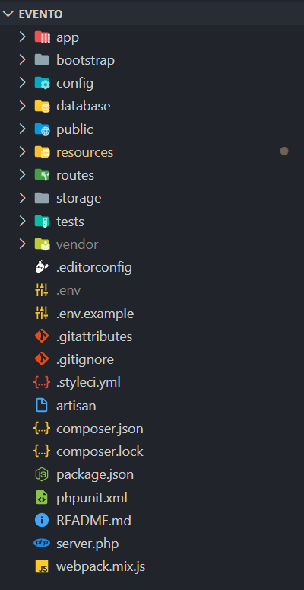

* **root/app/**

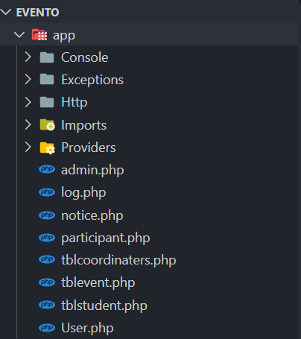

##### root/app/Http/

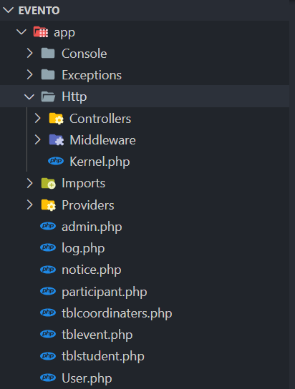

* **root/app/Http/Controllers/**

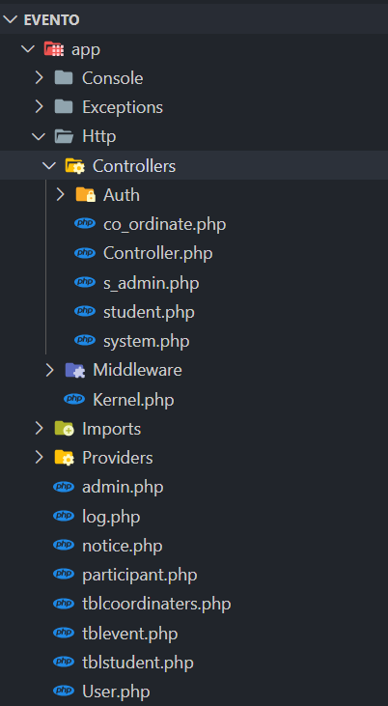

##### root/app/Http/Middleware/

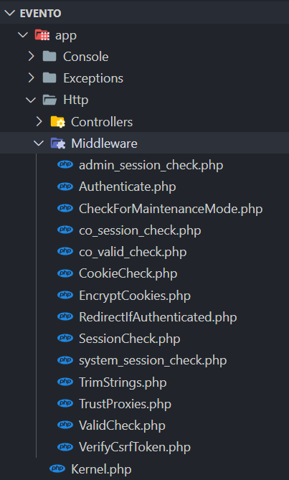

* **root/public/**

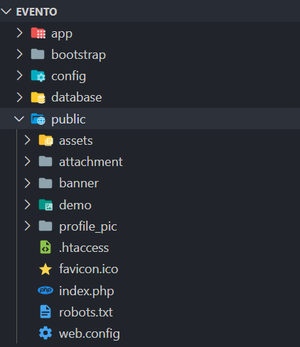

##### root/public/assets/

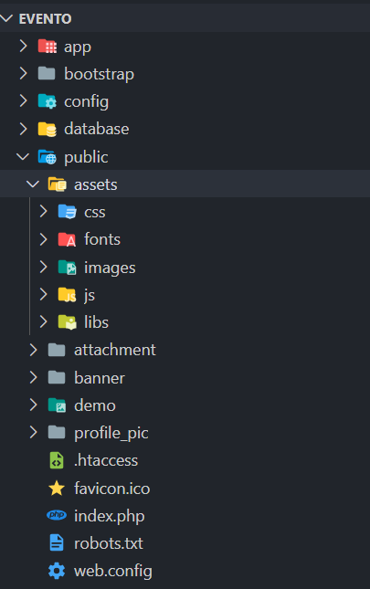

* **root/resources /**

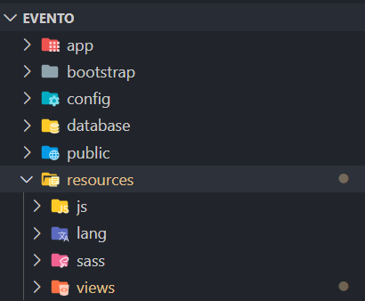

##### root/resources/views/

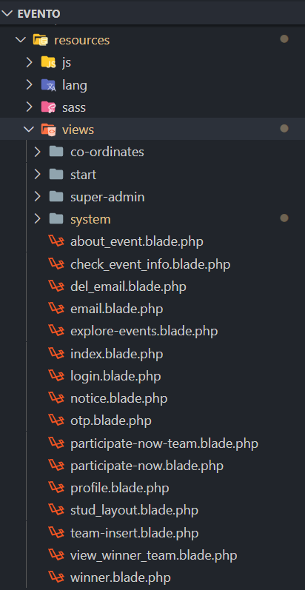

* **root/resources/views/Co-ordinates/**

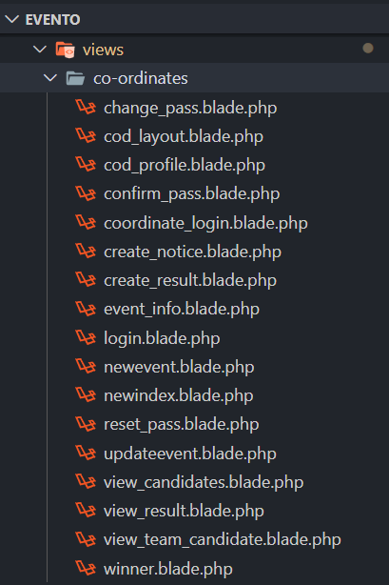

##### root/resources/views/start/

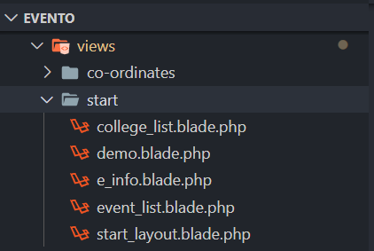

* **root/resources/views/super-admin/**

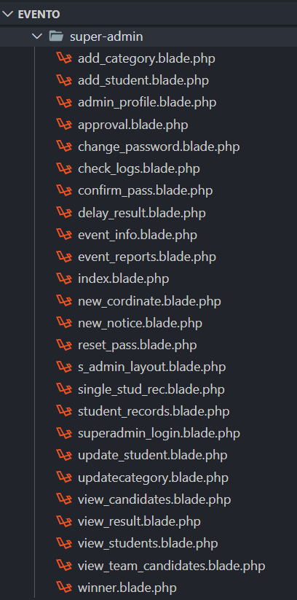

##### root/resources/views/system

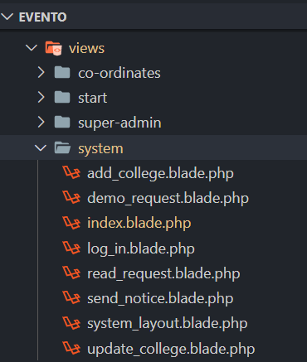

* **root/routes/**

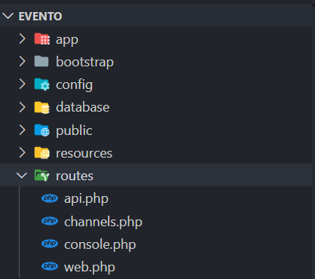

## Input design

### Admin side input design

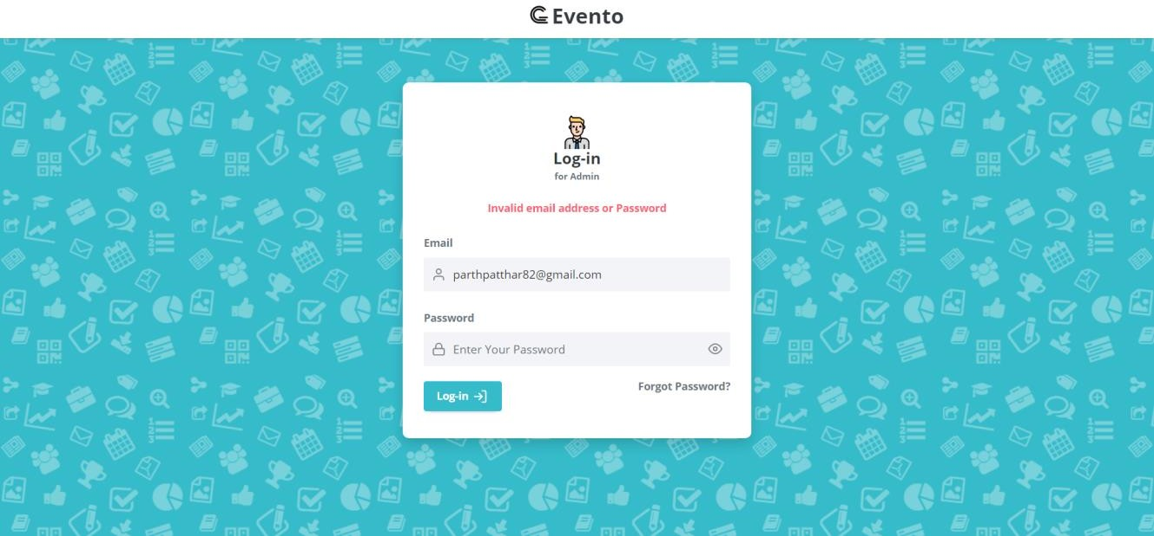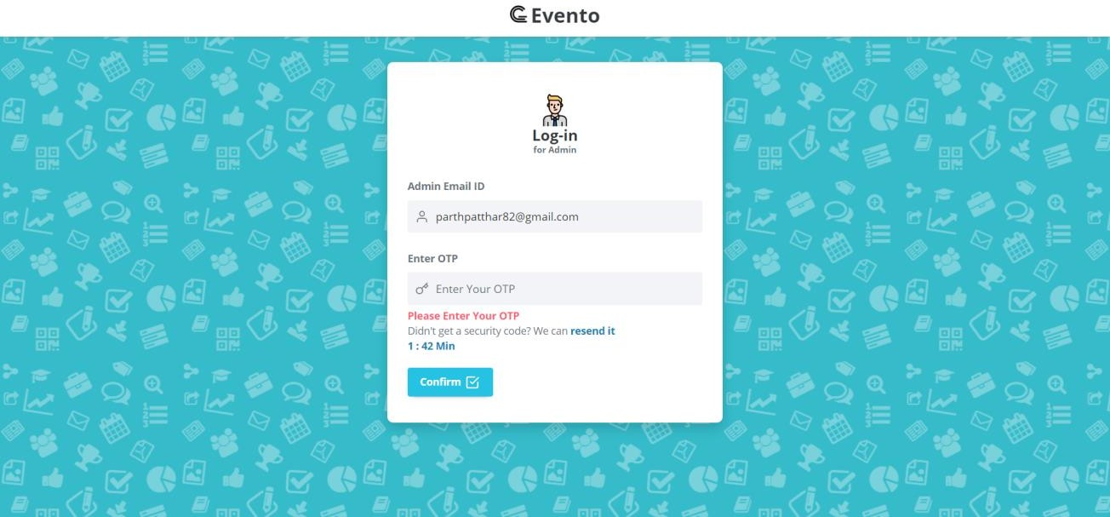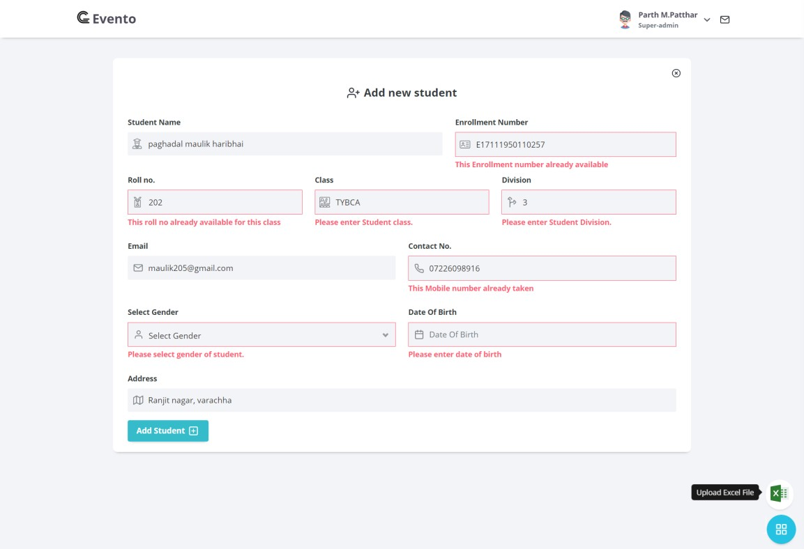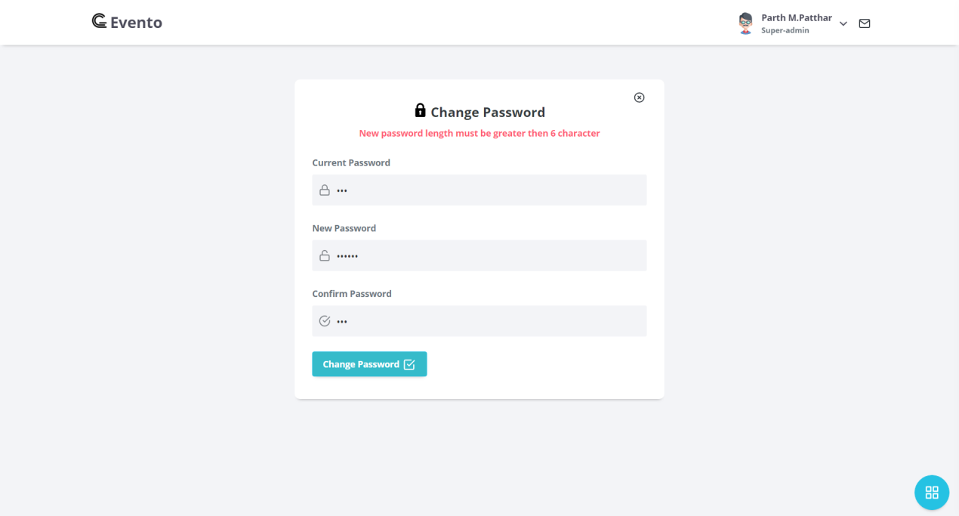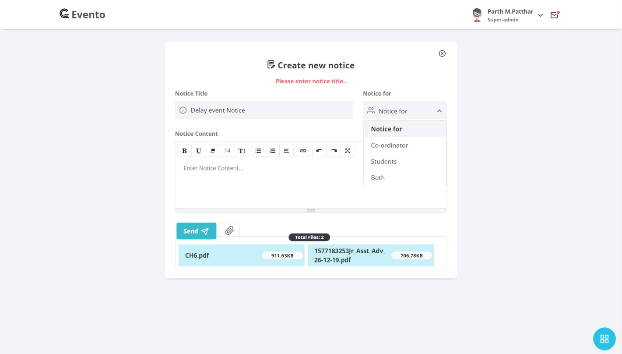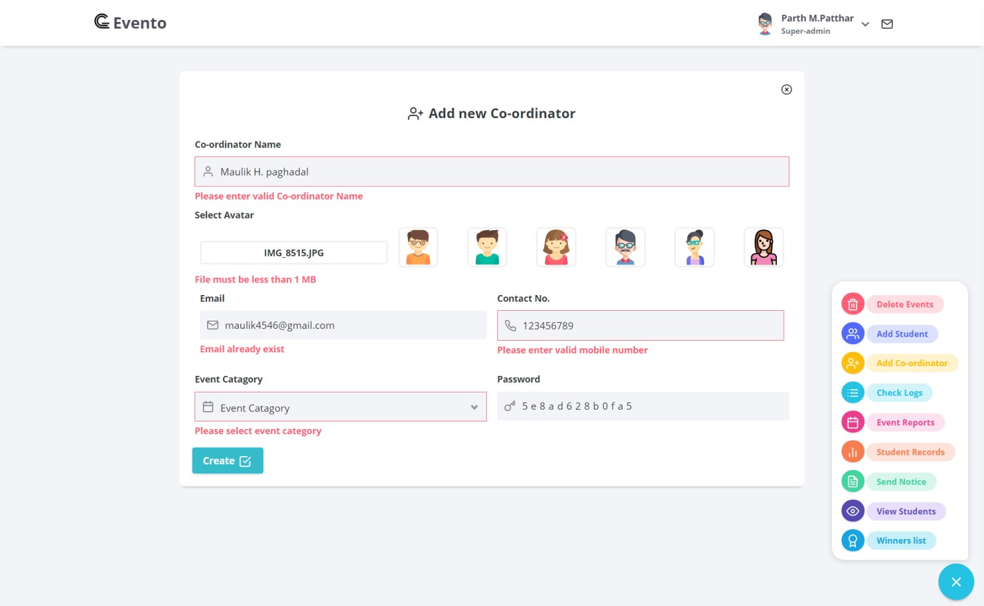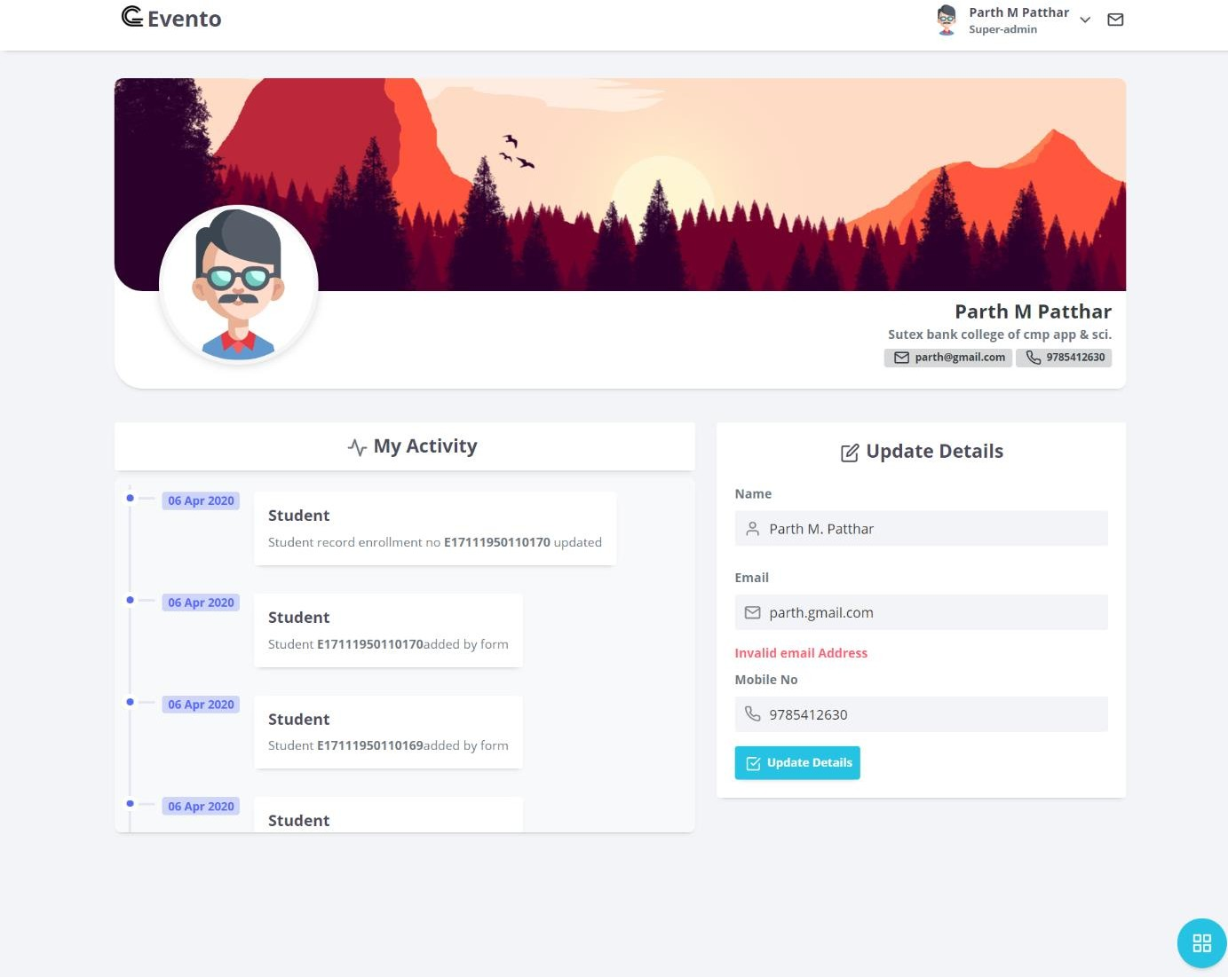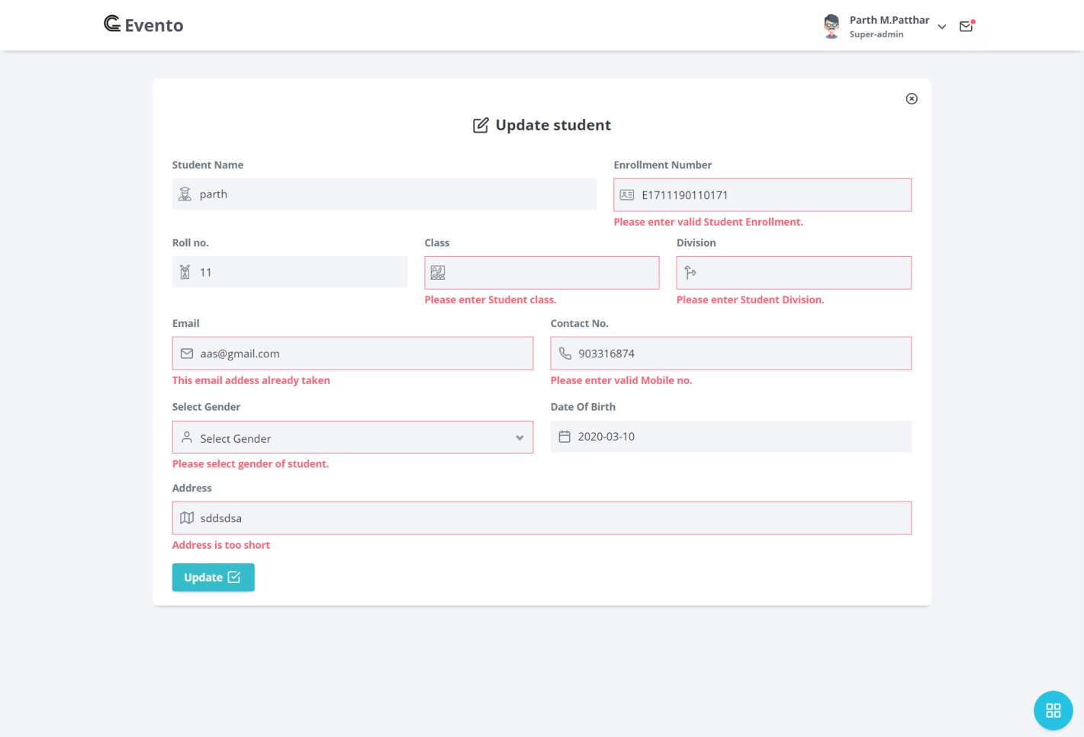

* **Co-ordinator side input design**

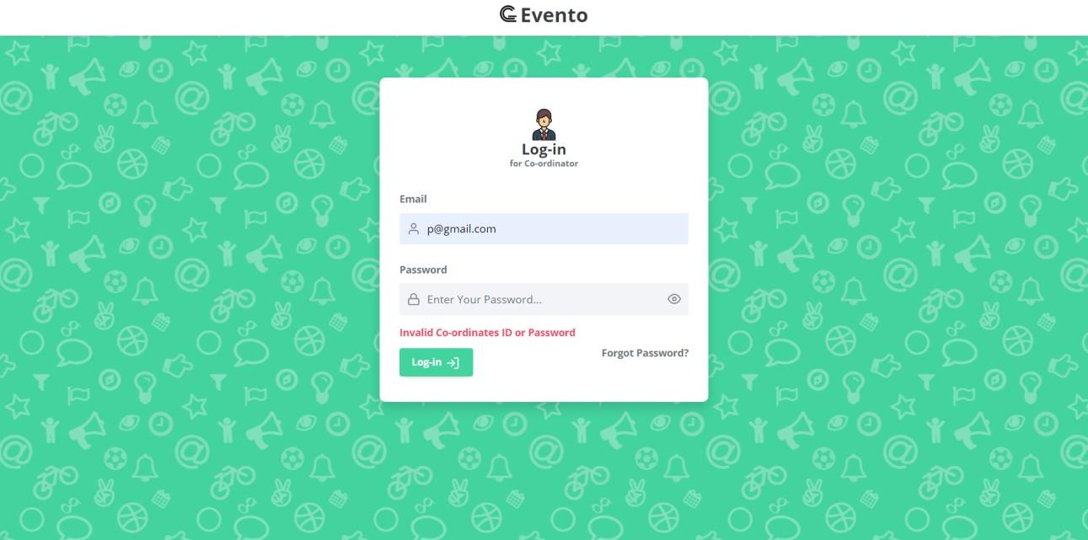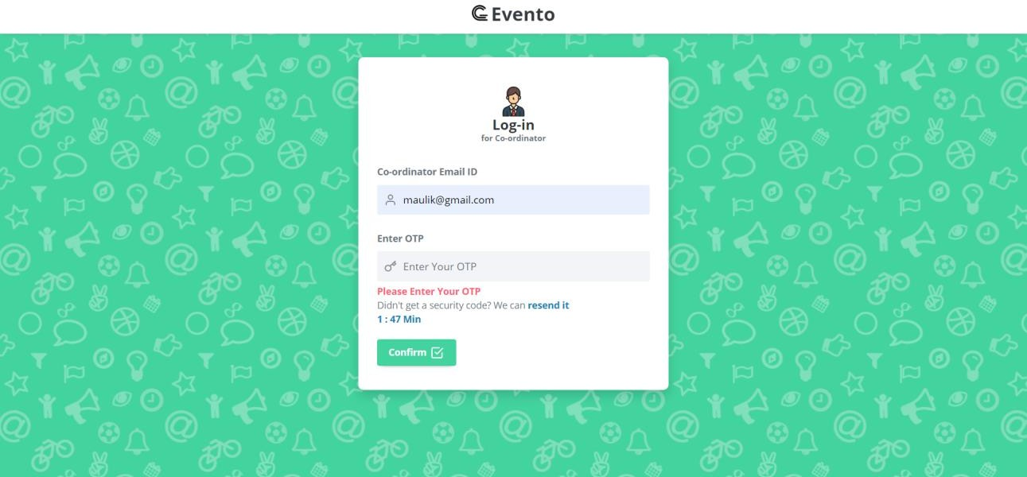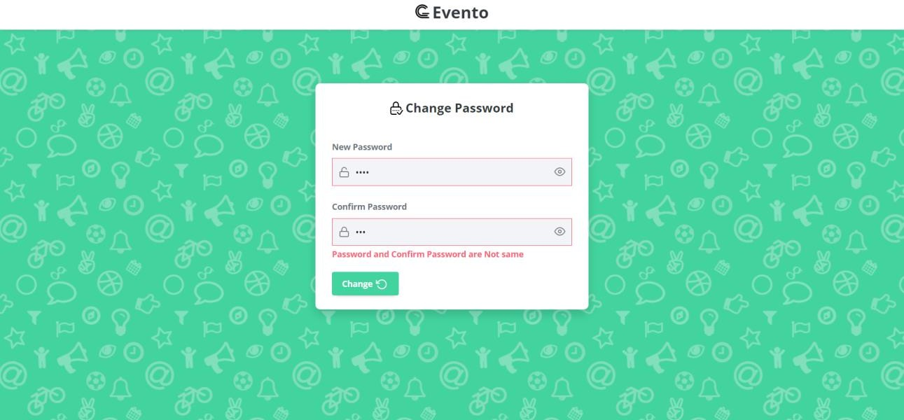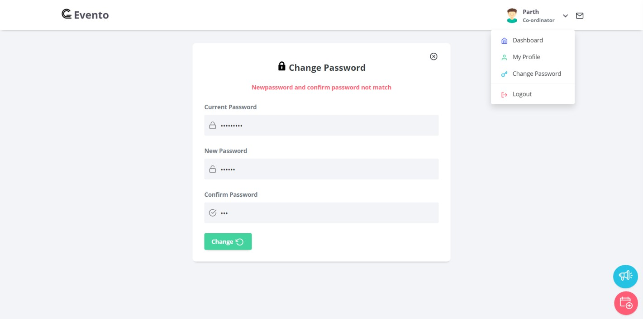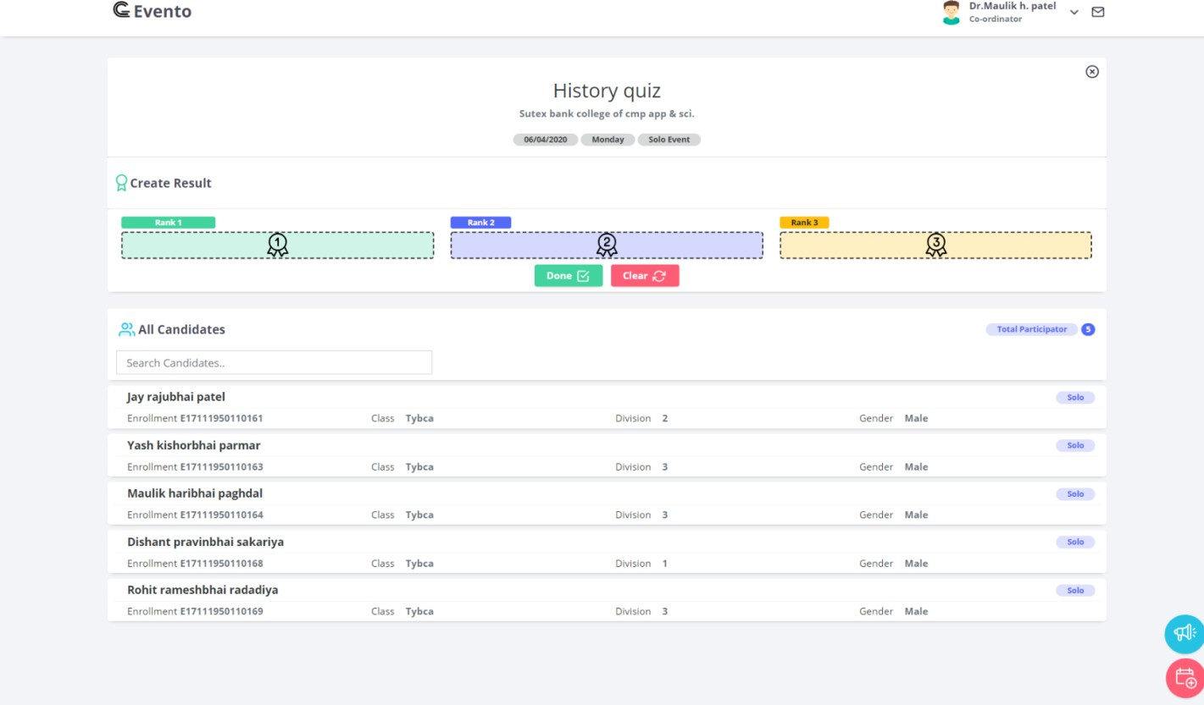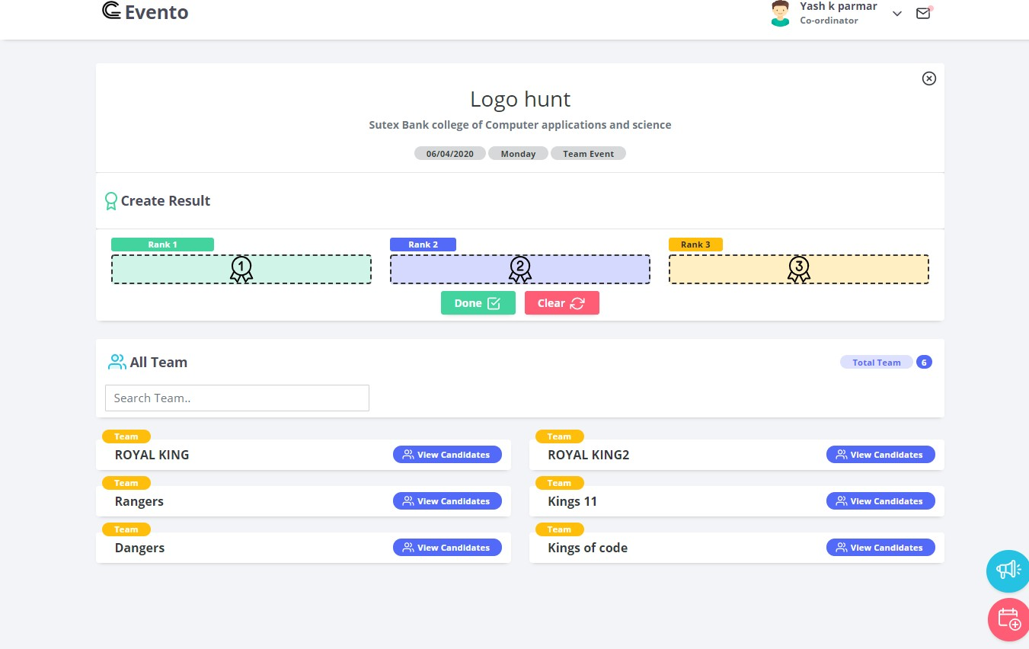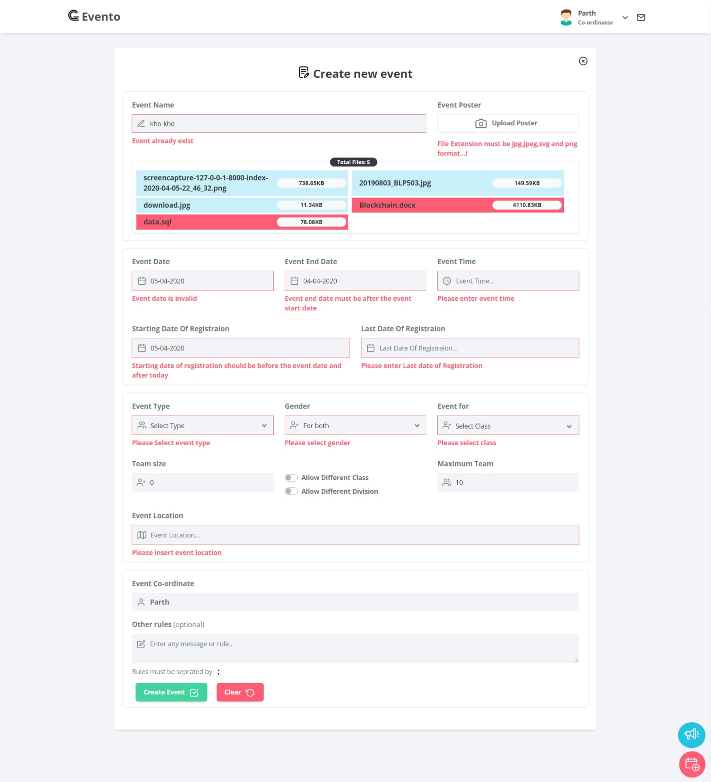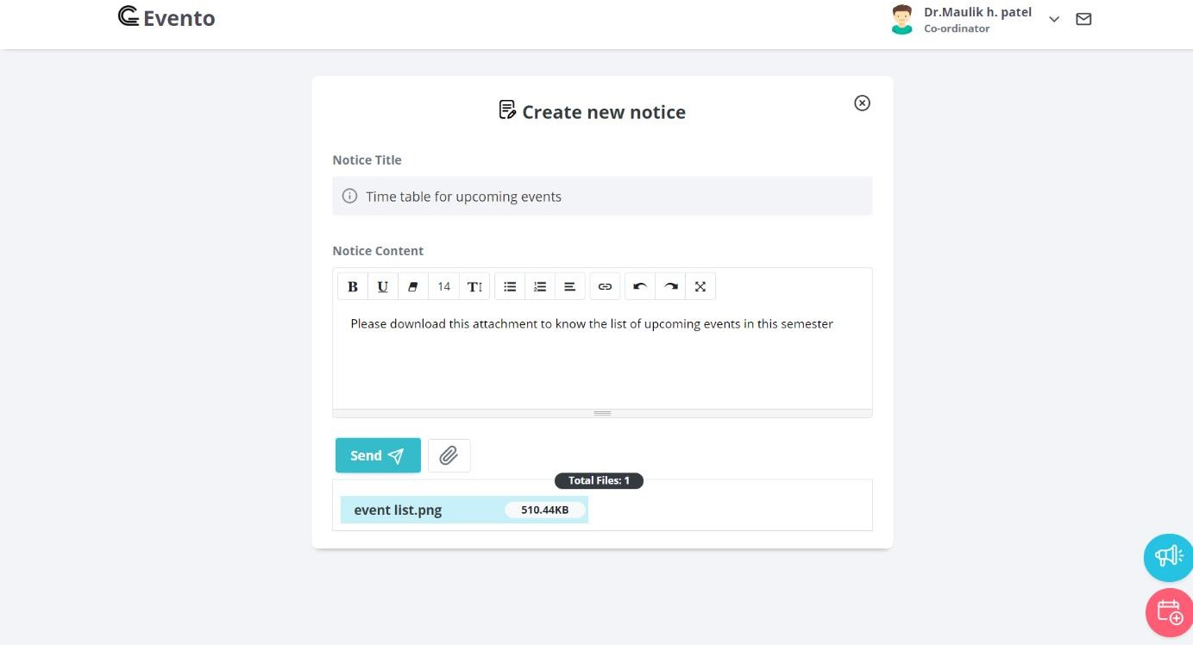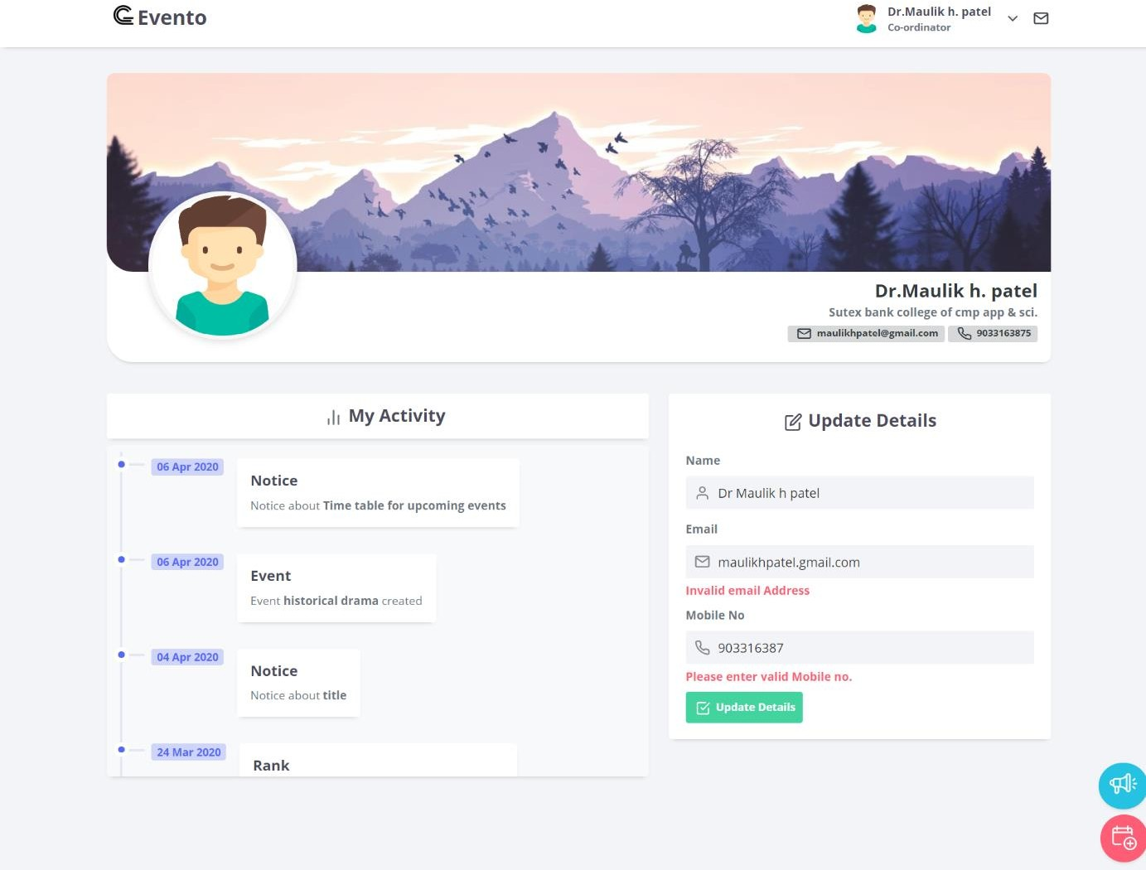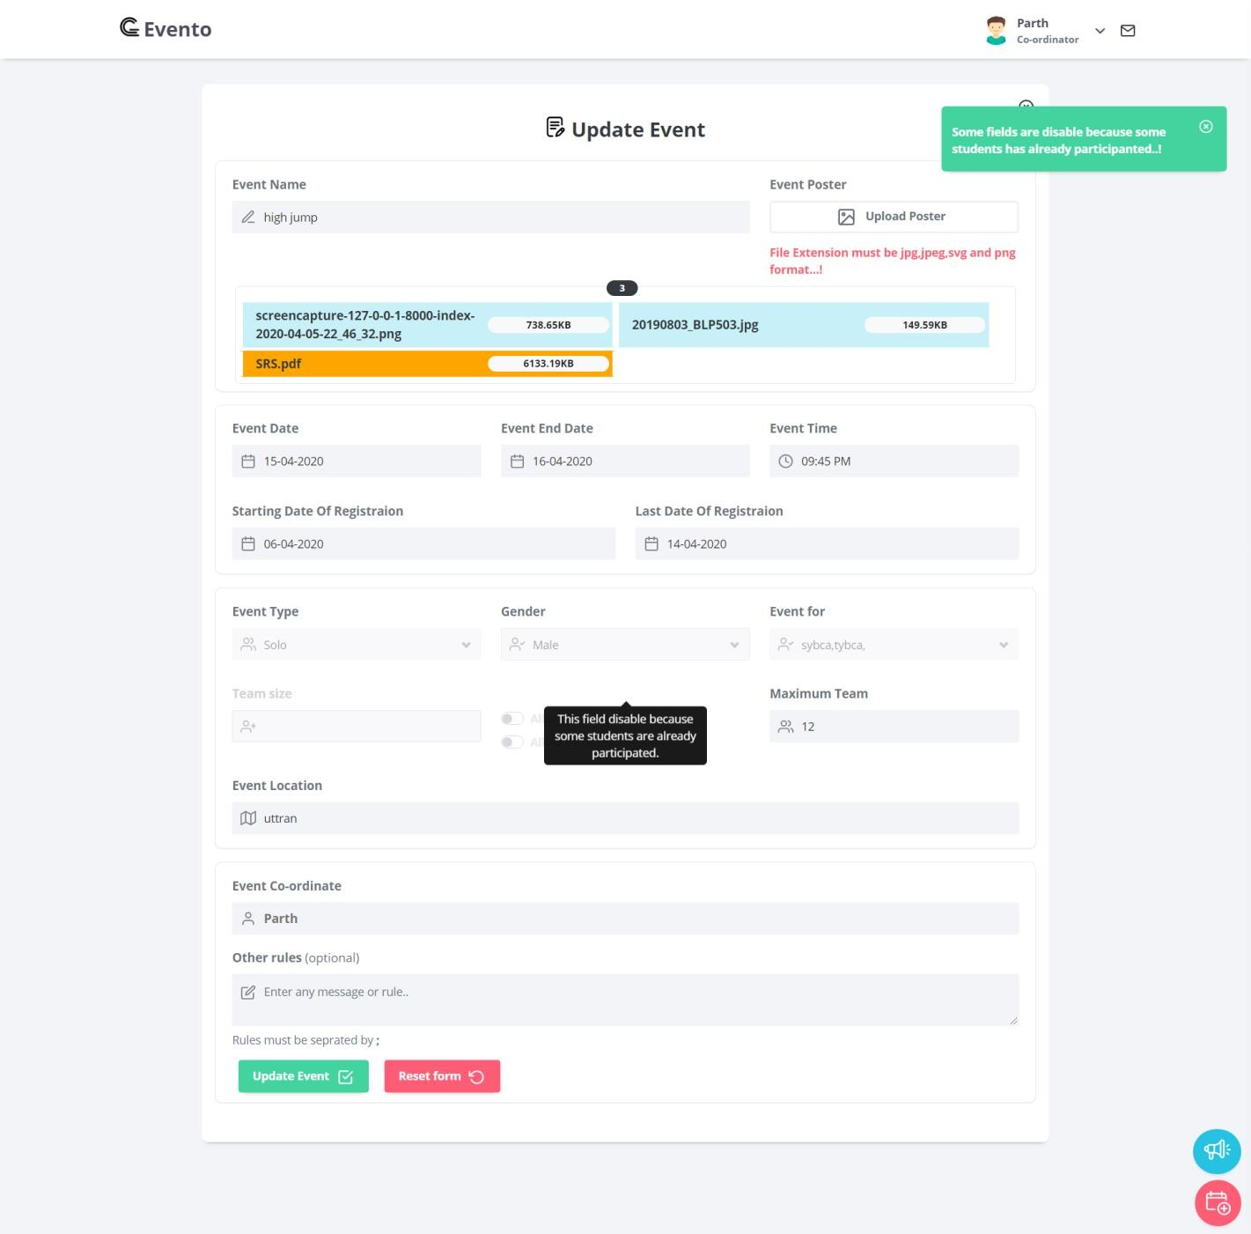

### student side input design

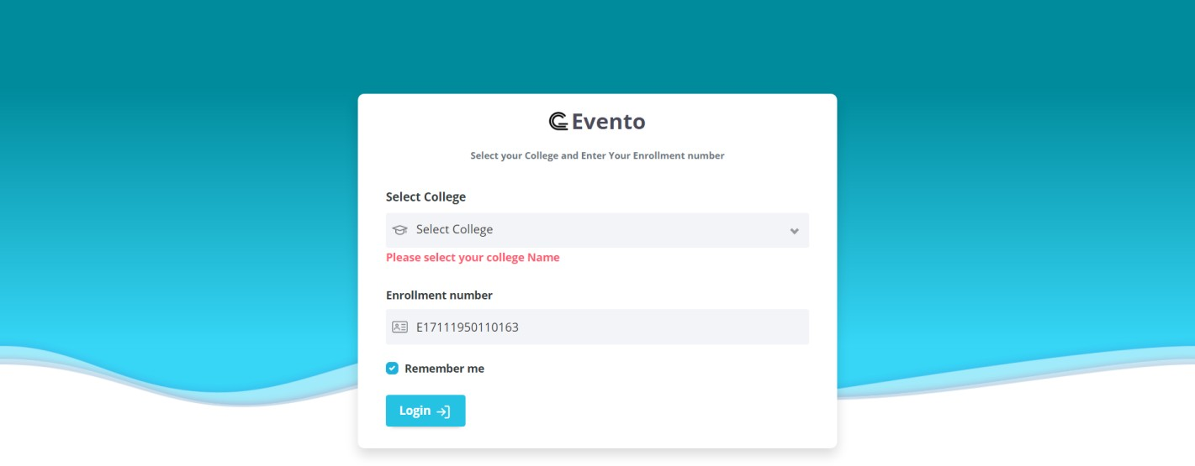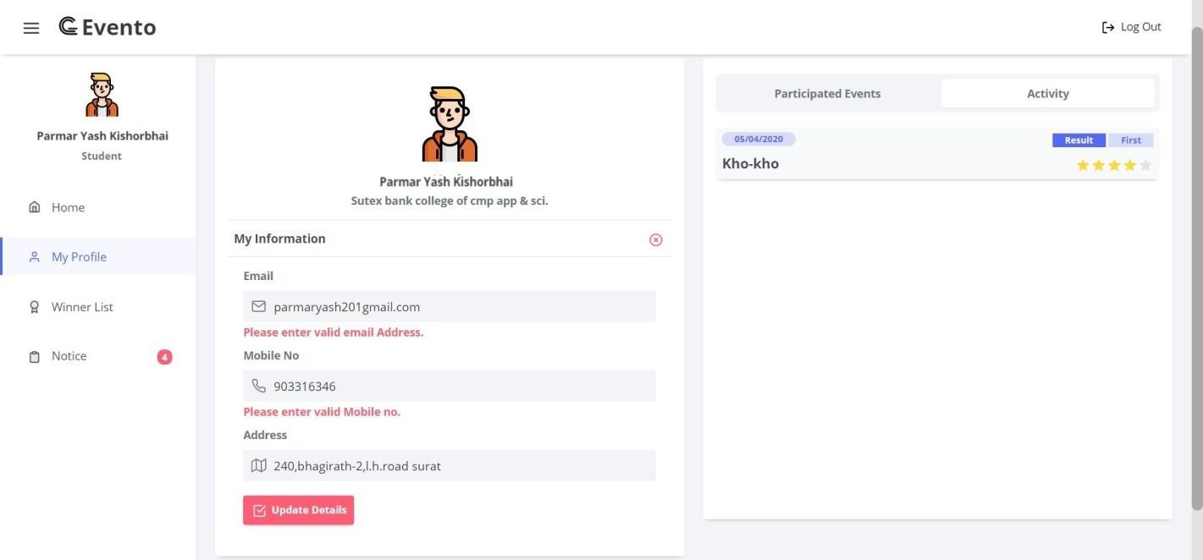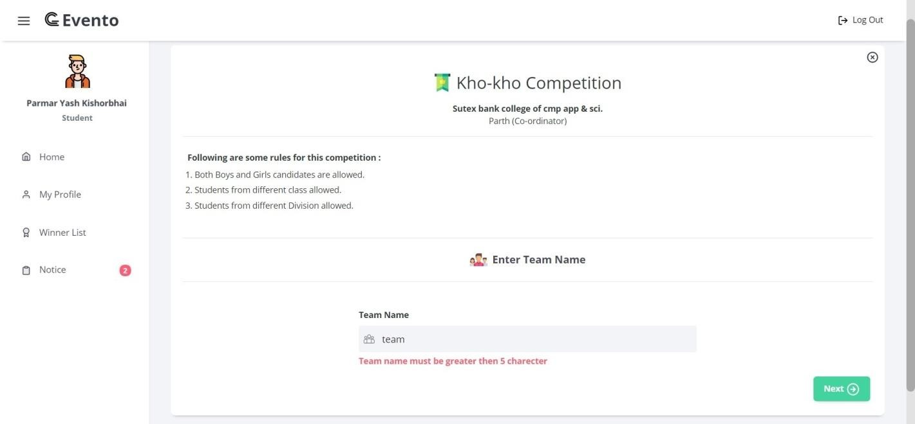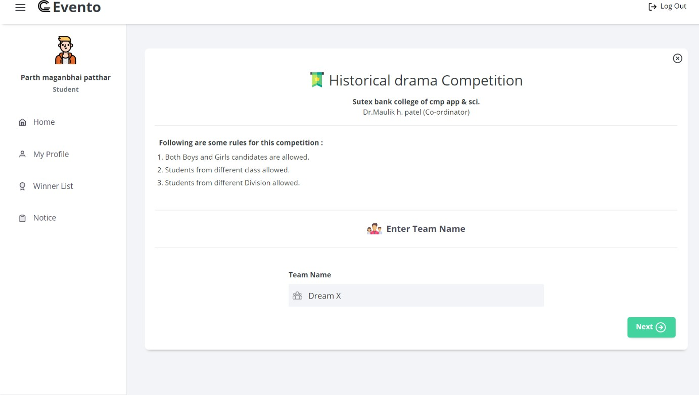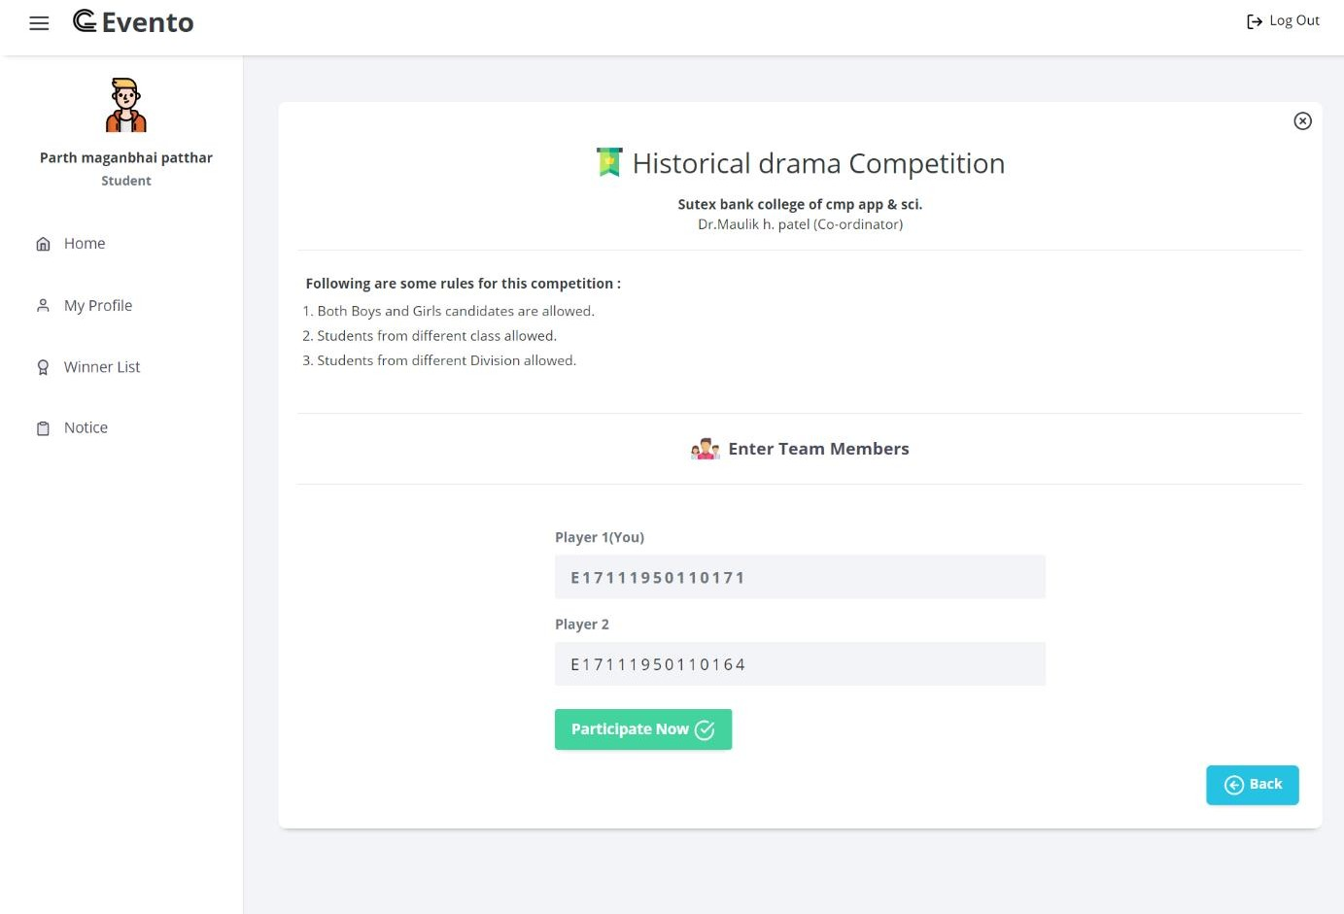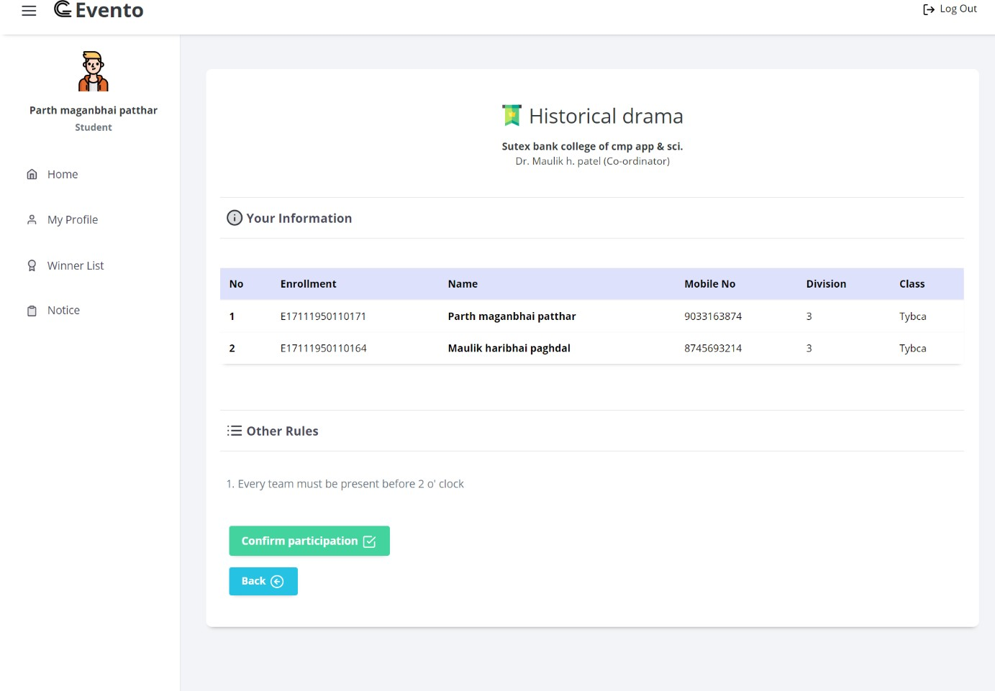

* **System Admin side input design**

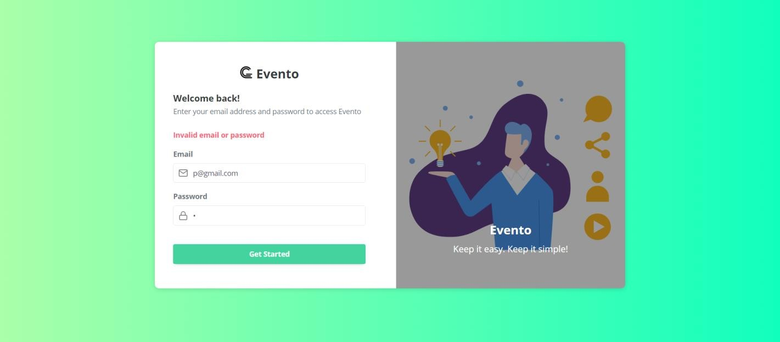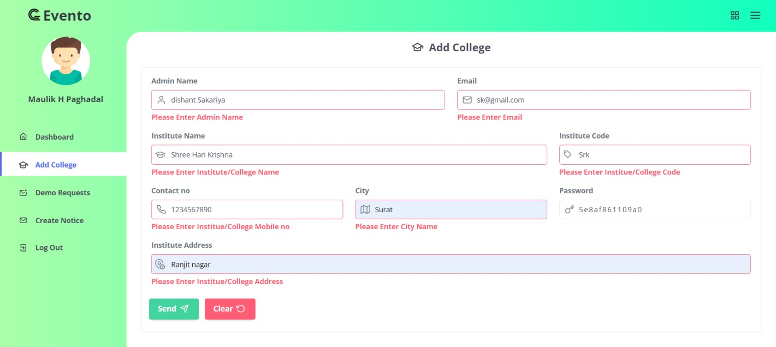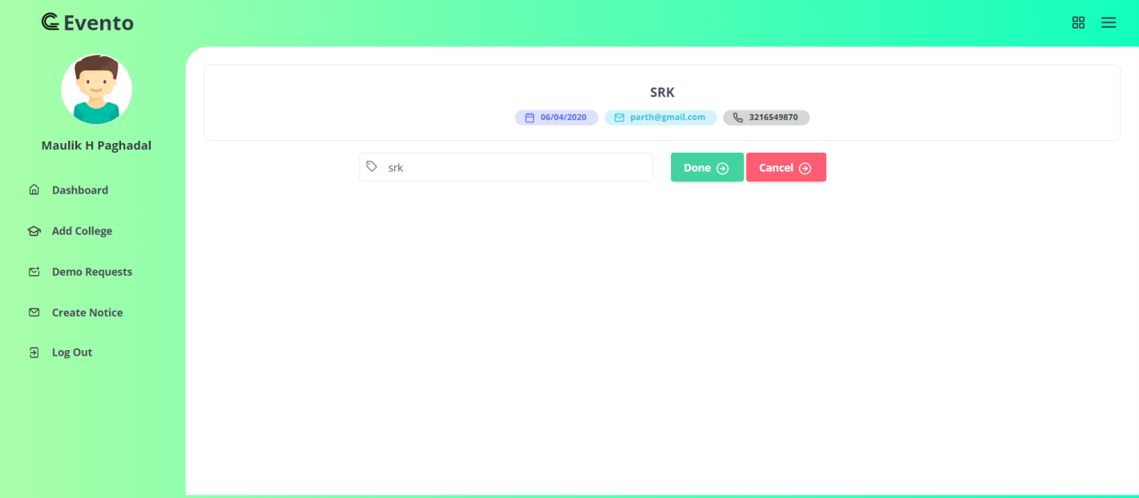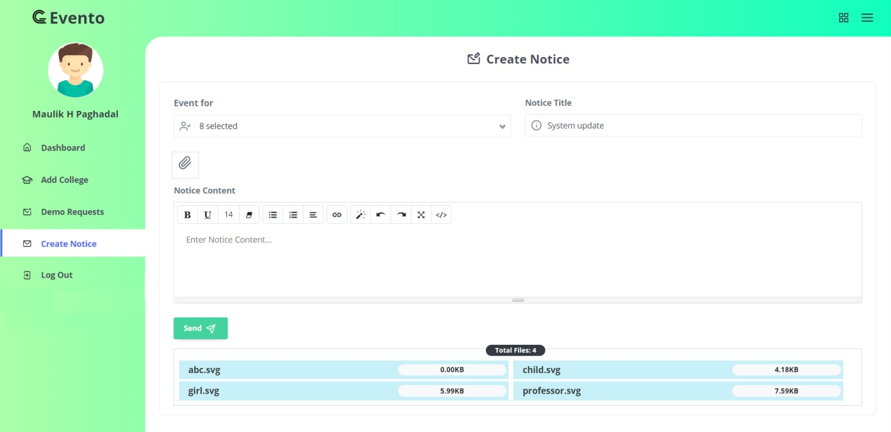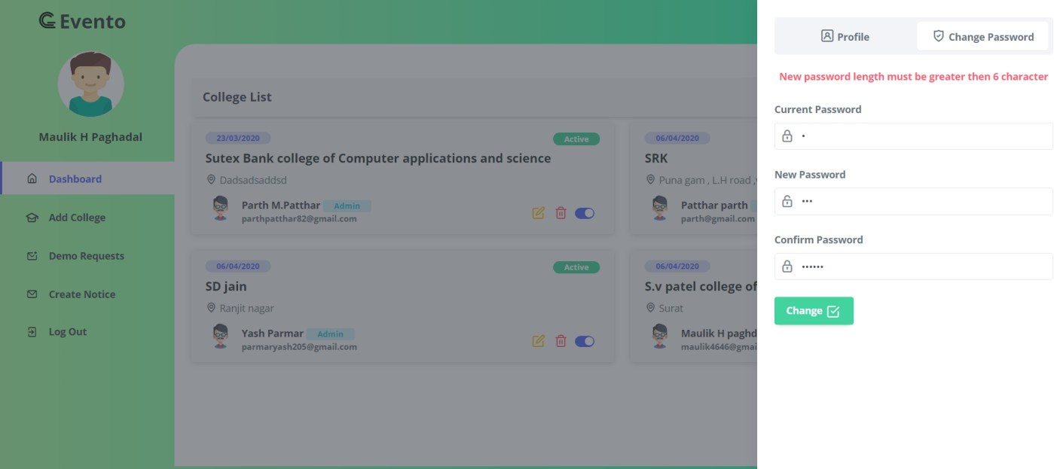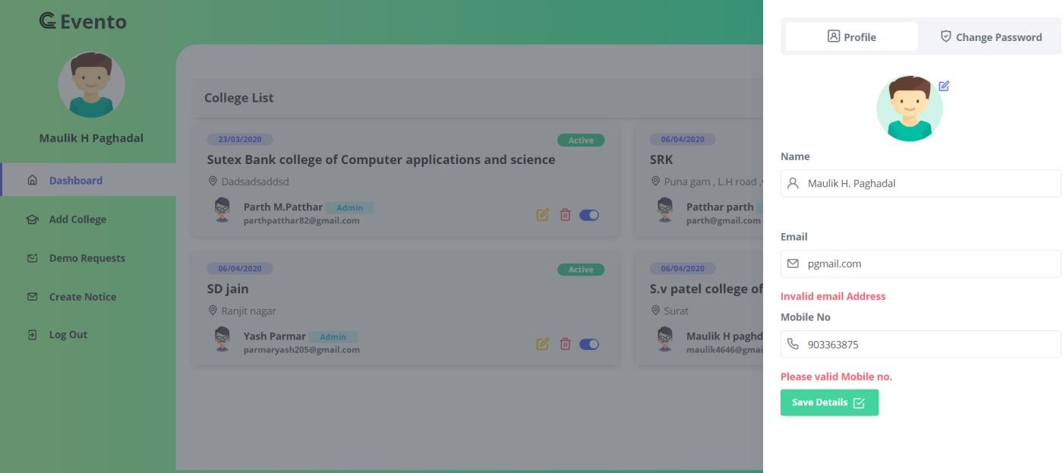

## Output design

### Admin side Output design

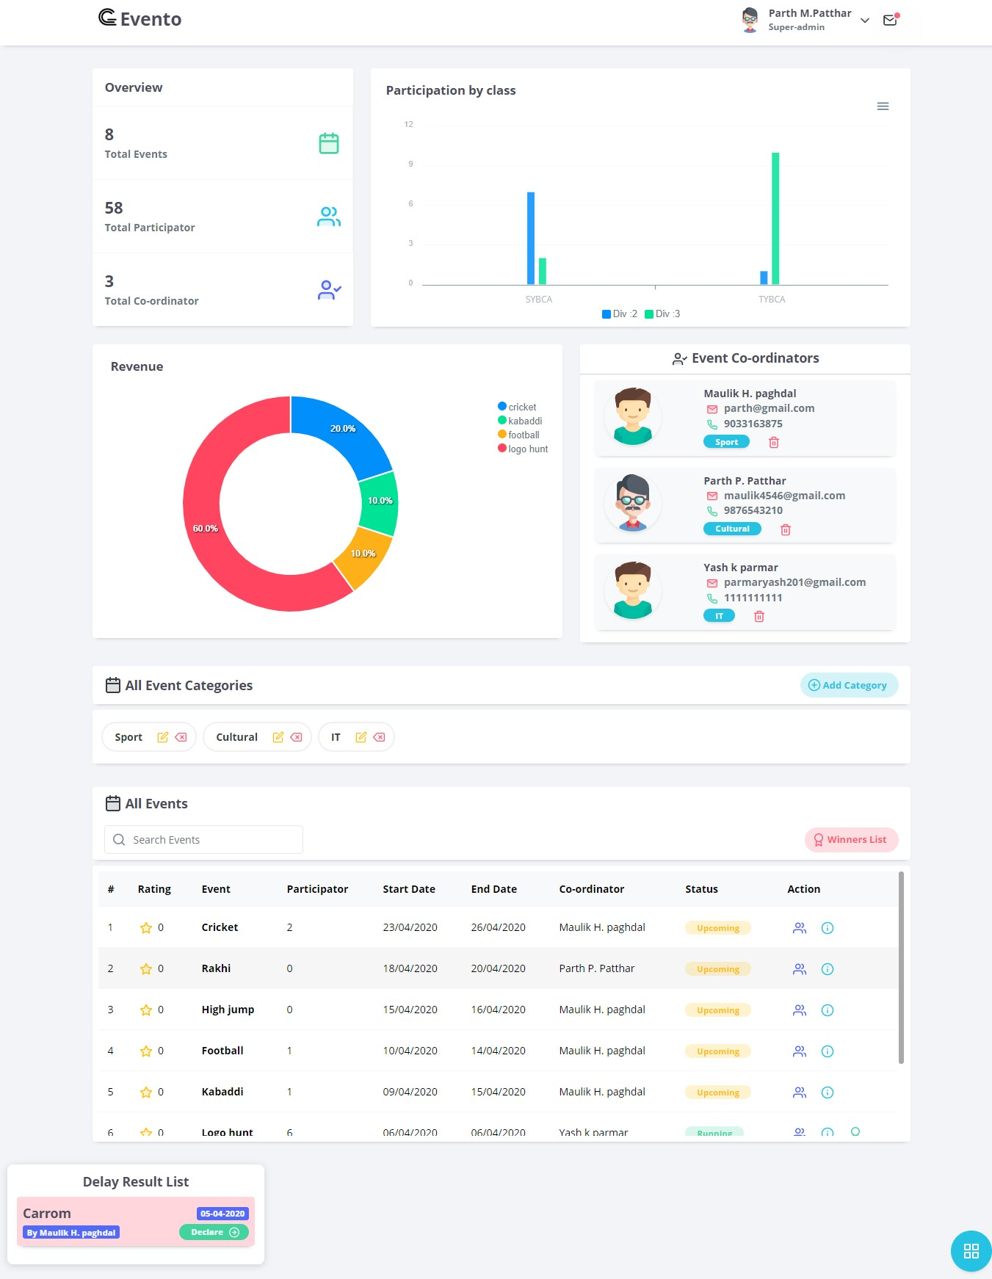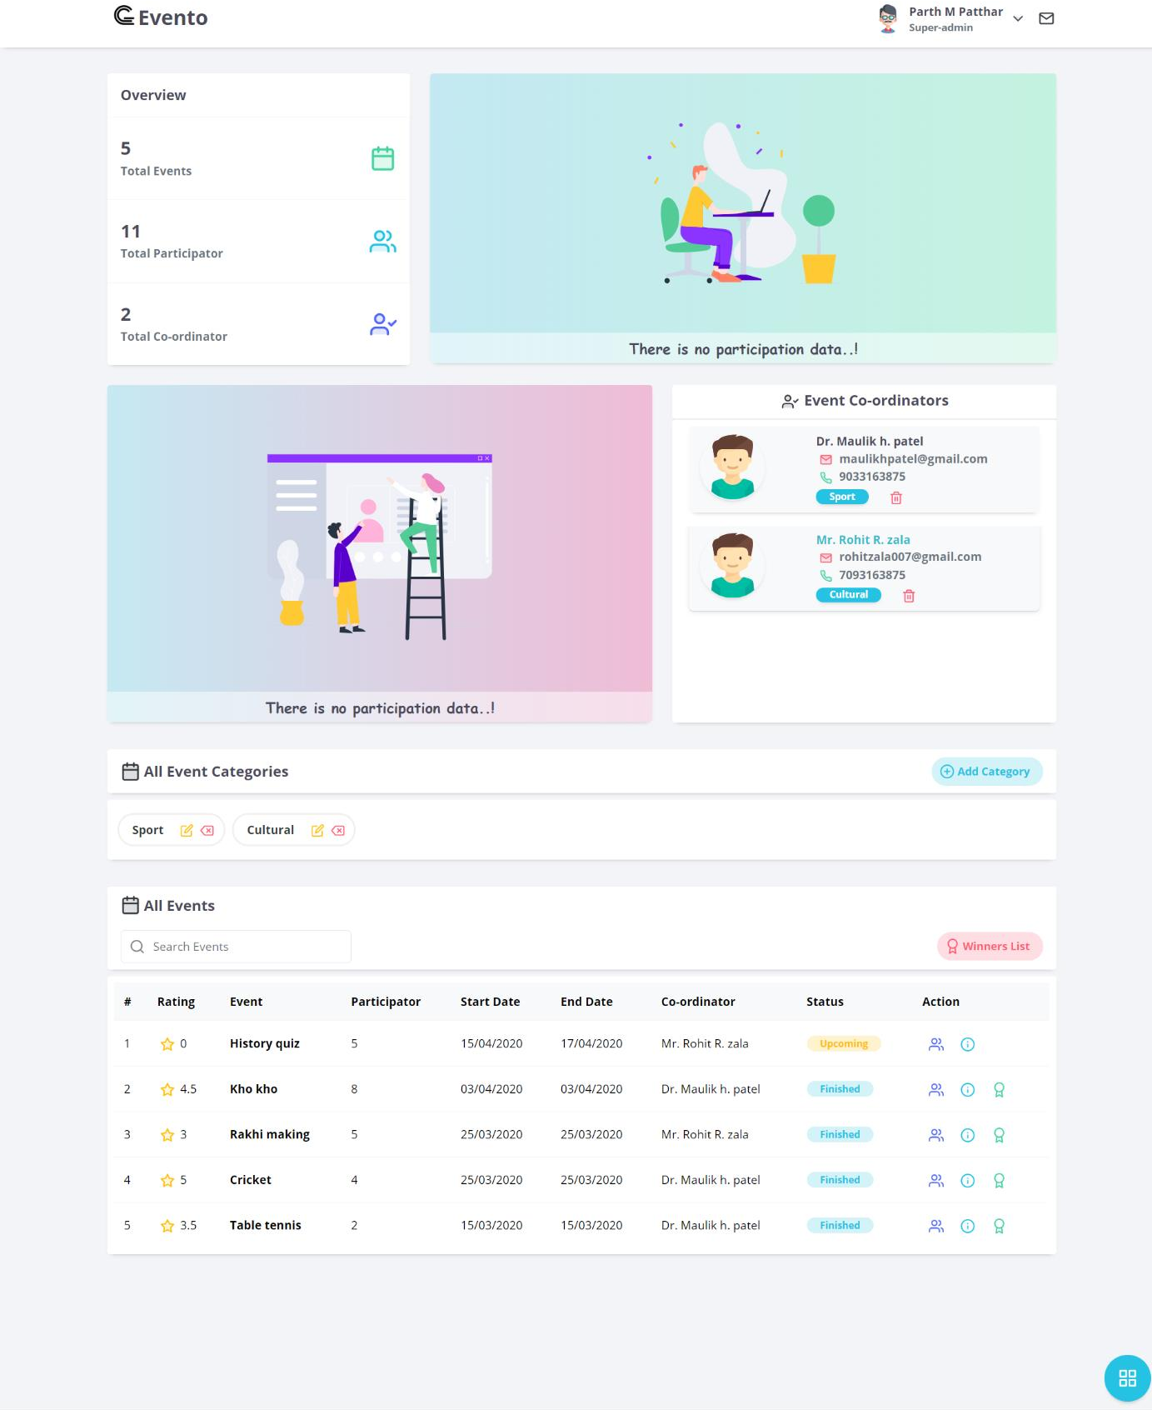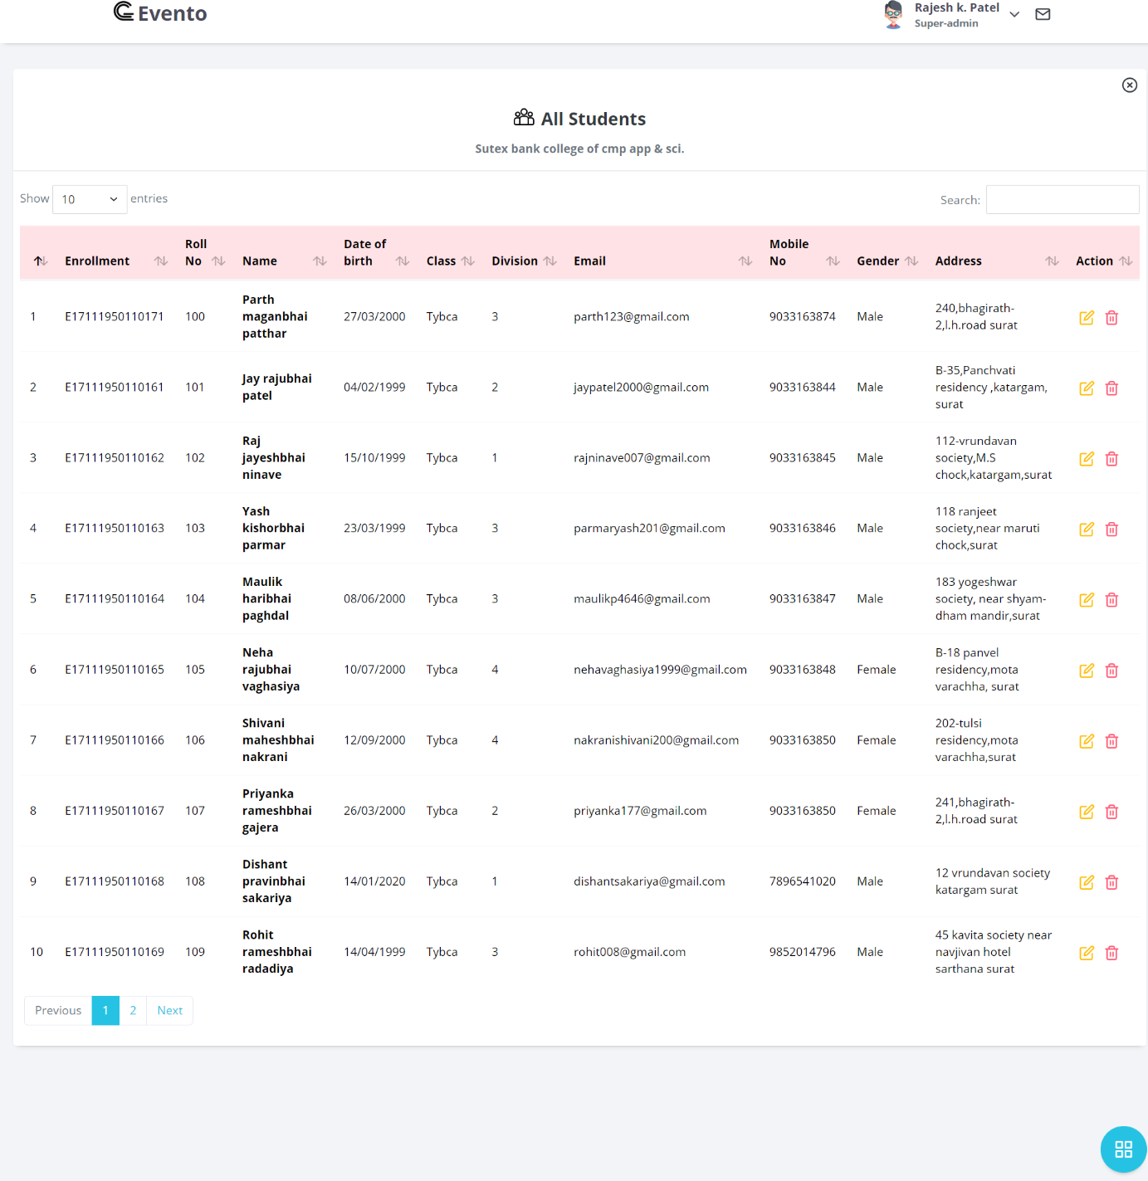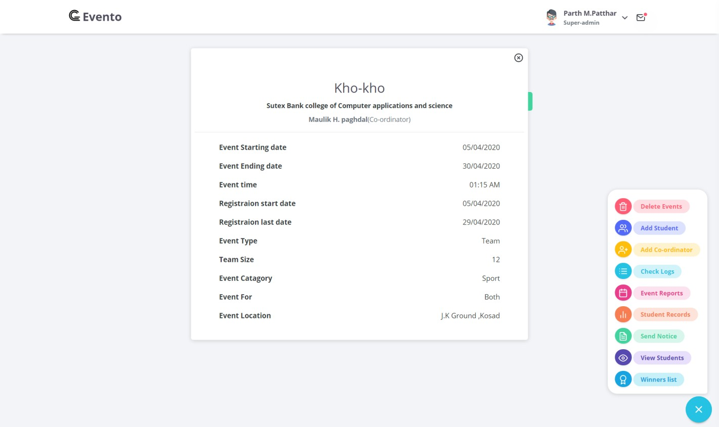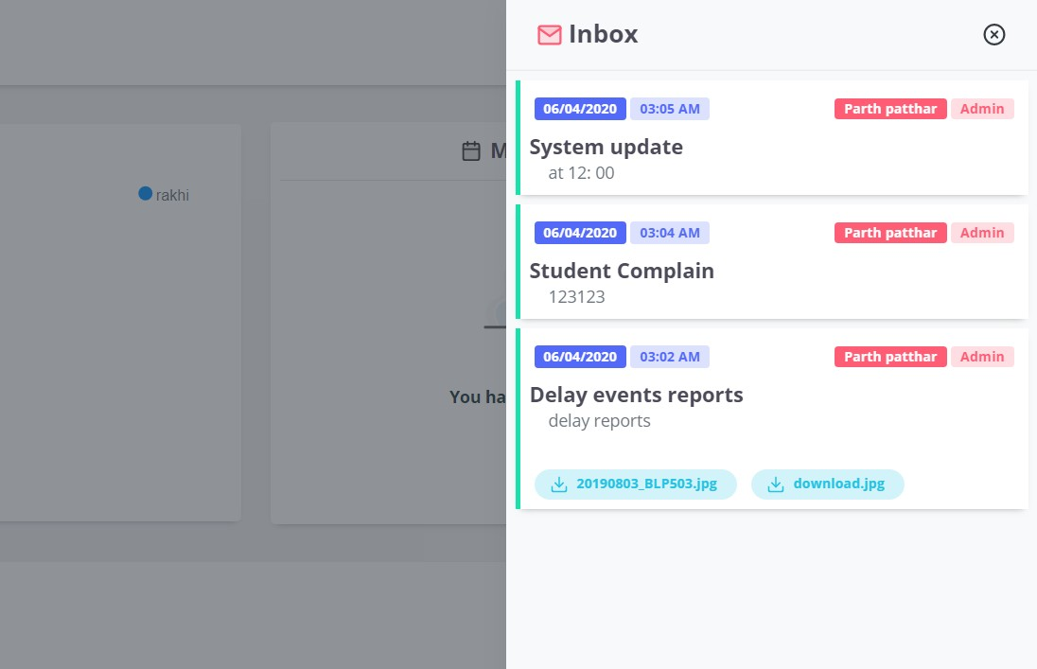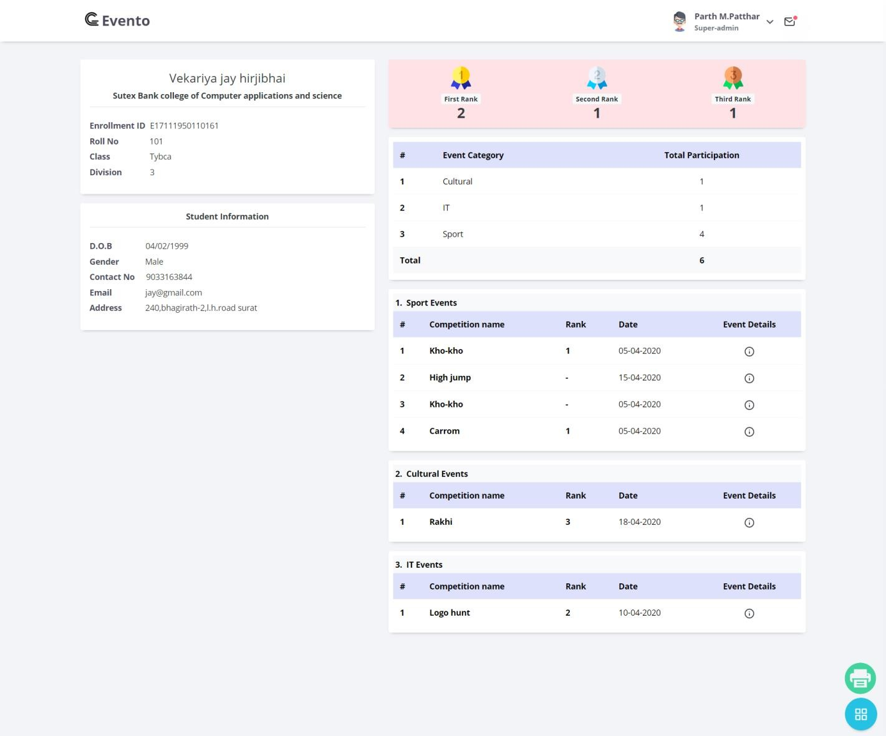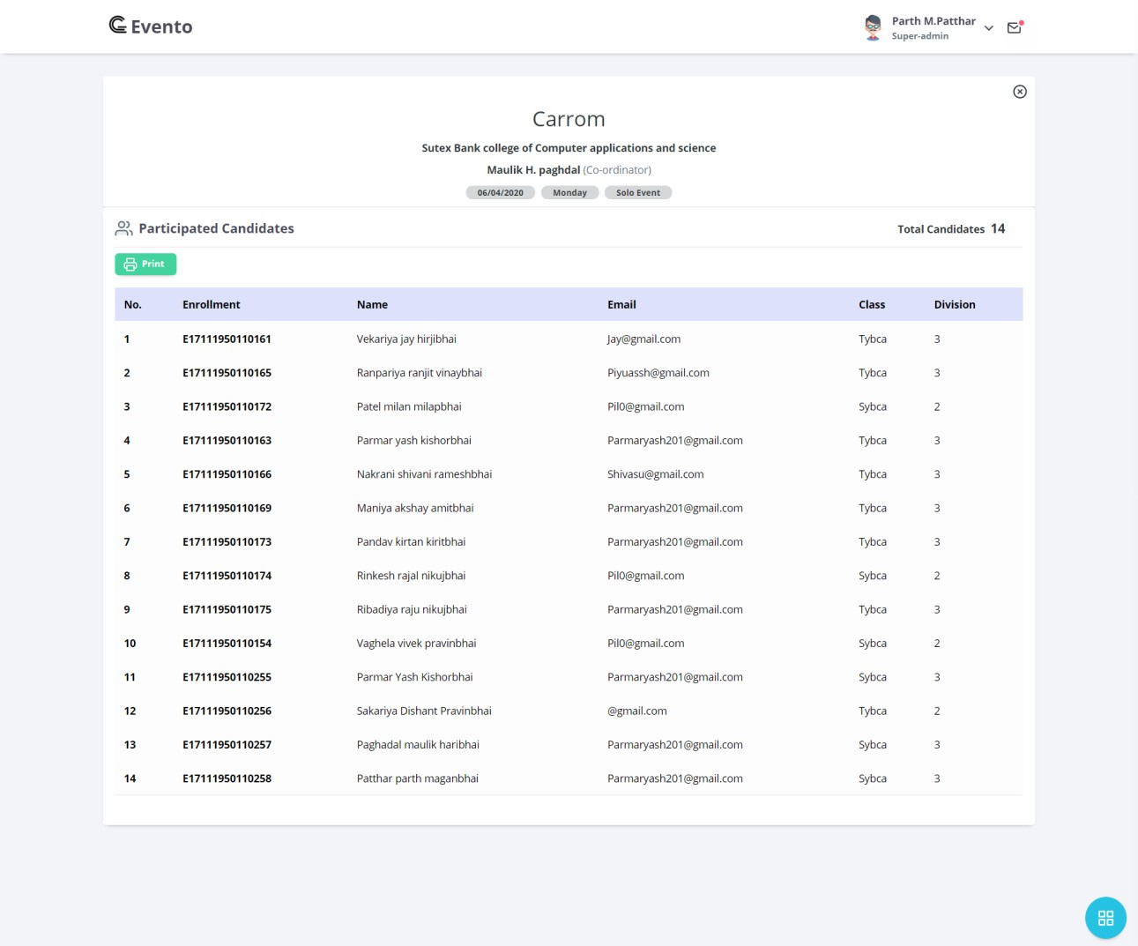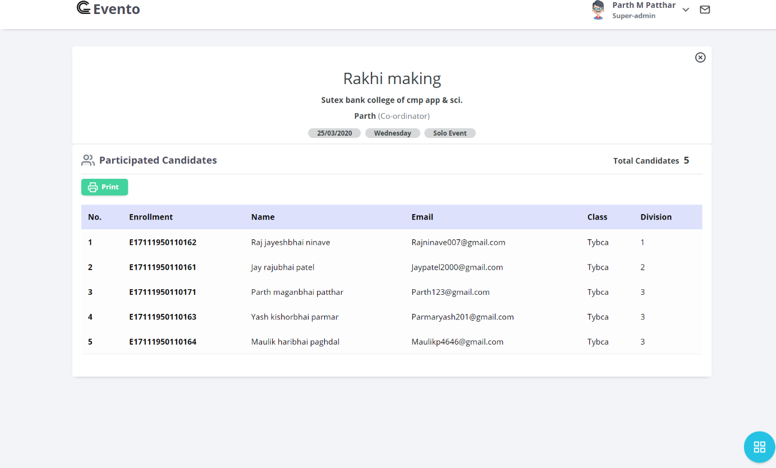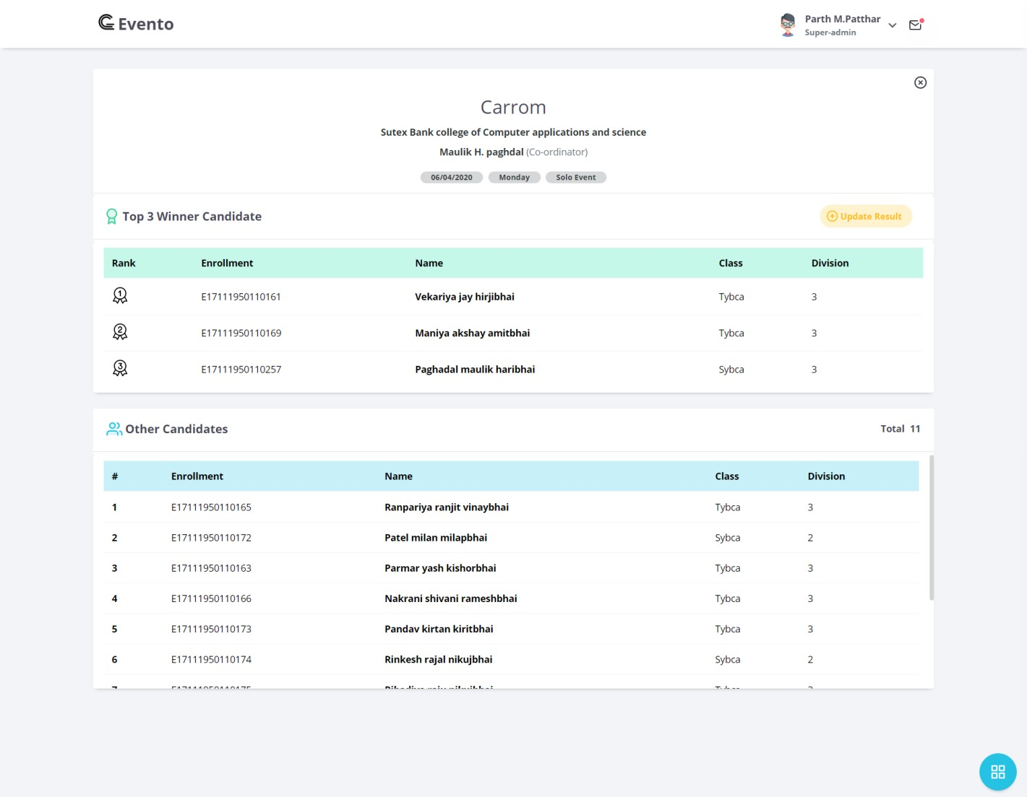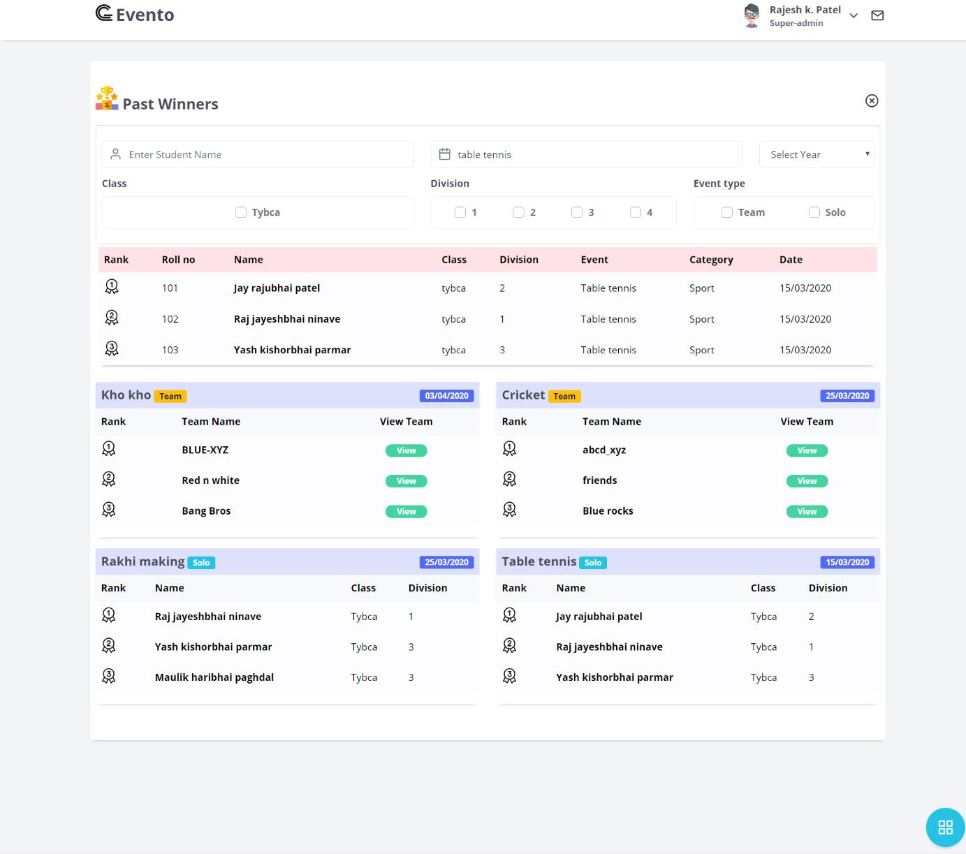

* **Co-ordinator Output design**

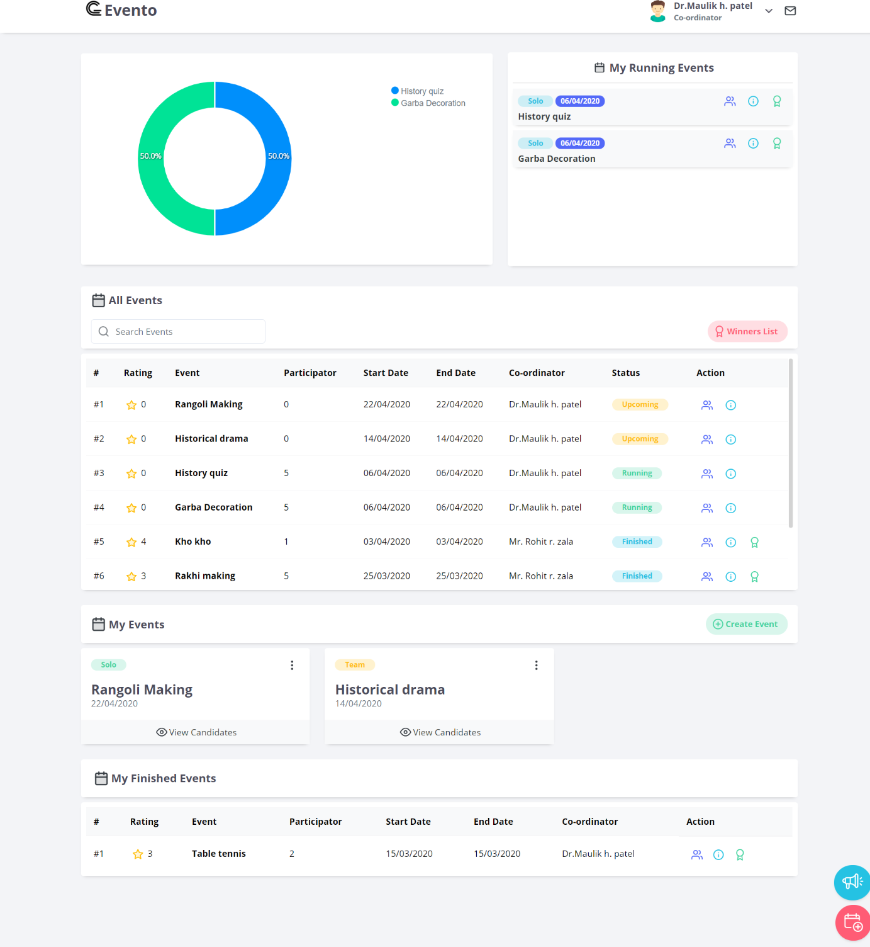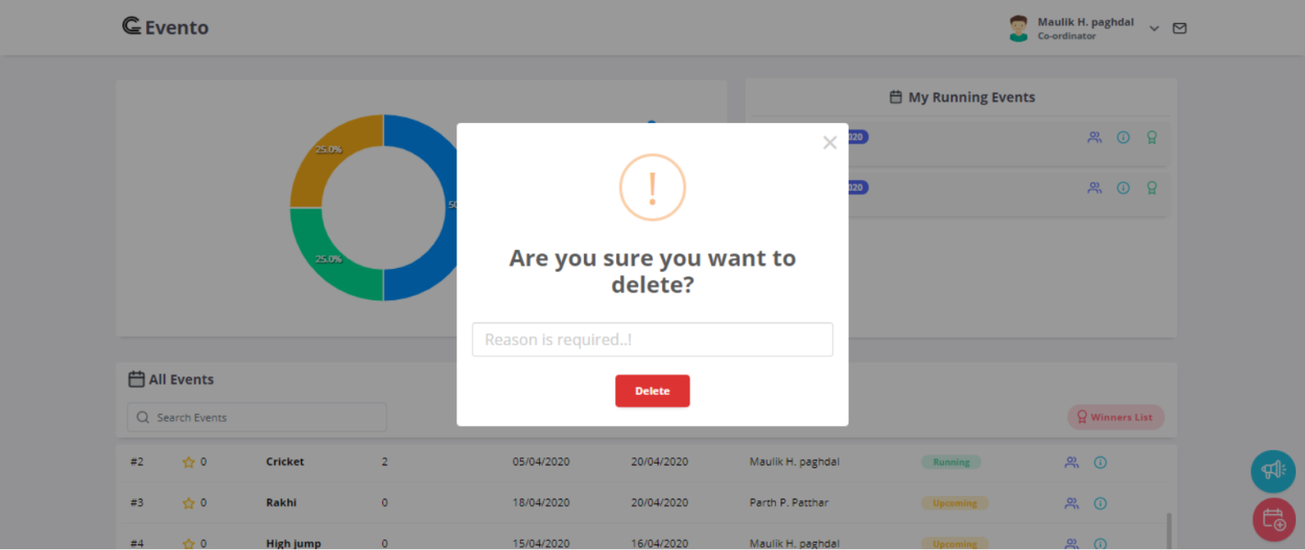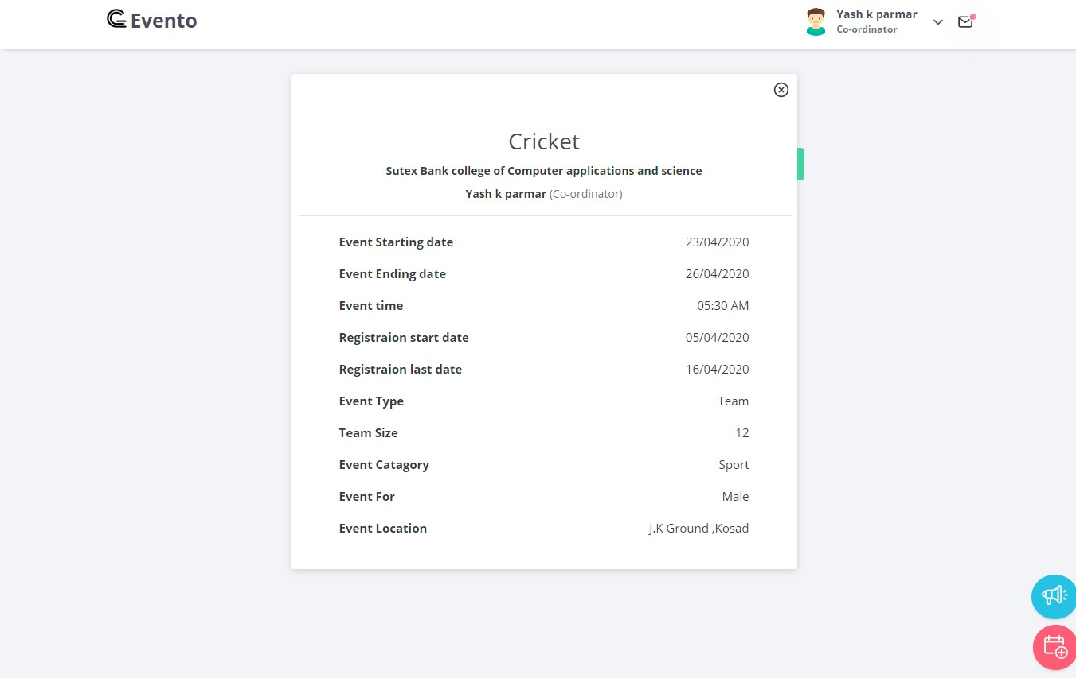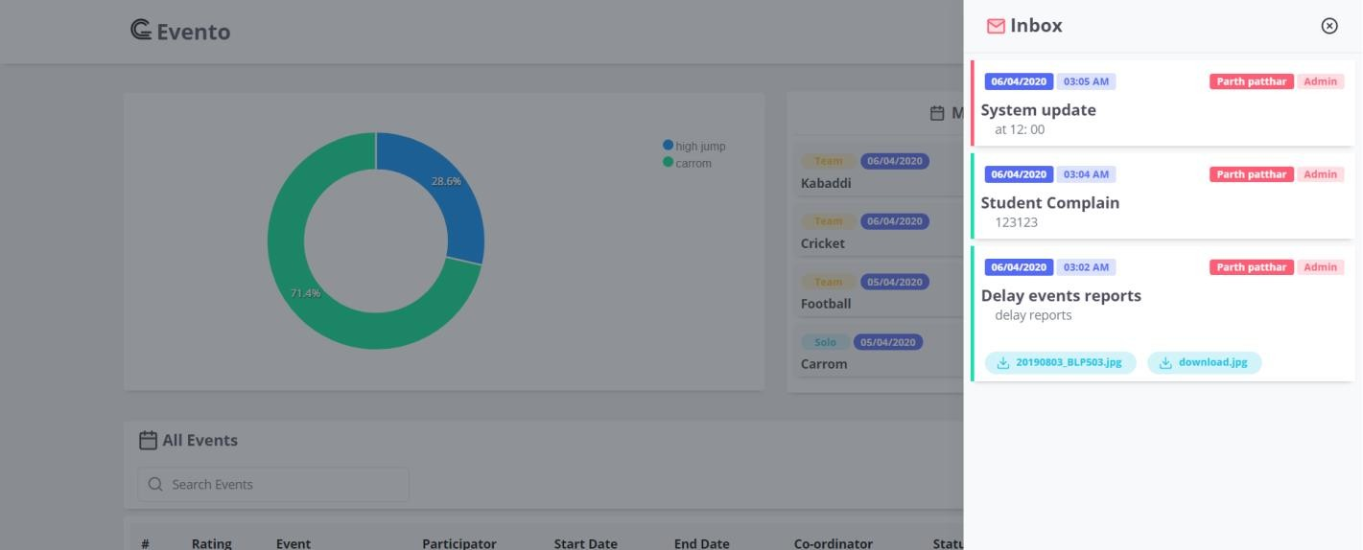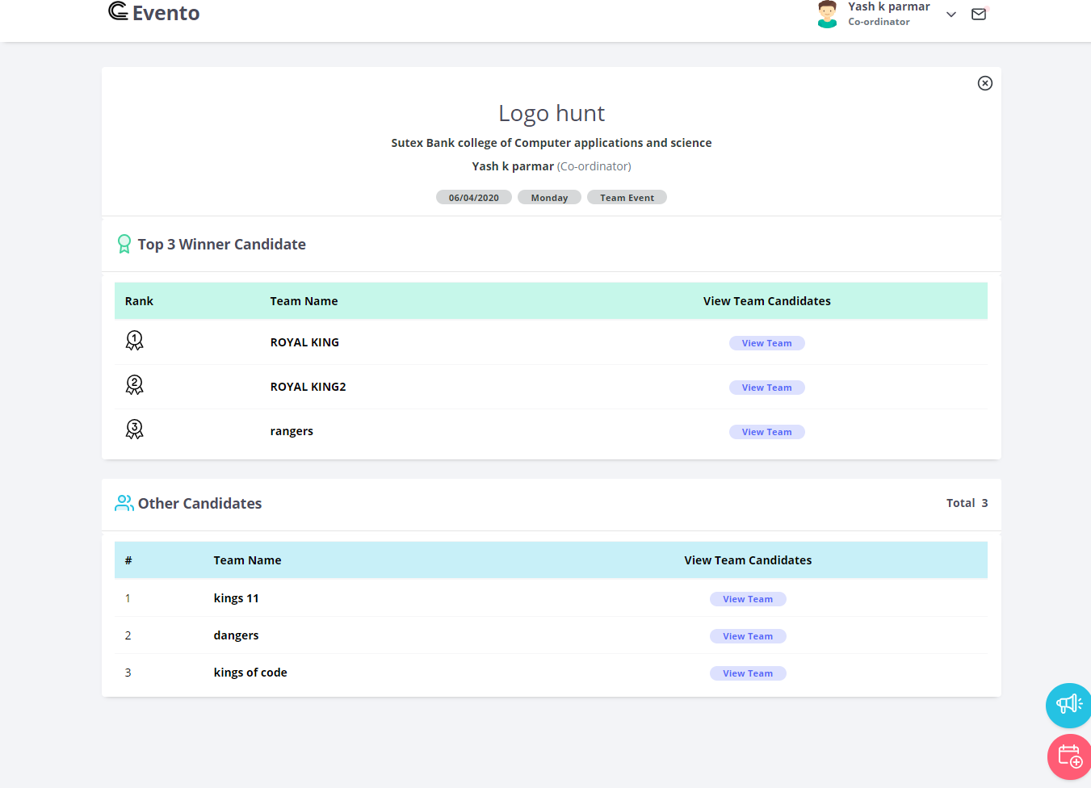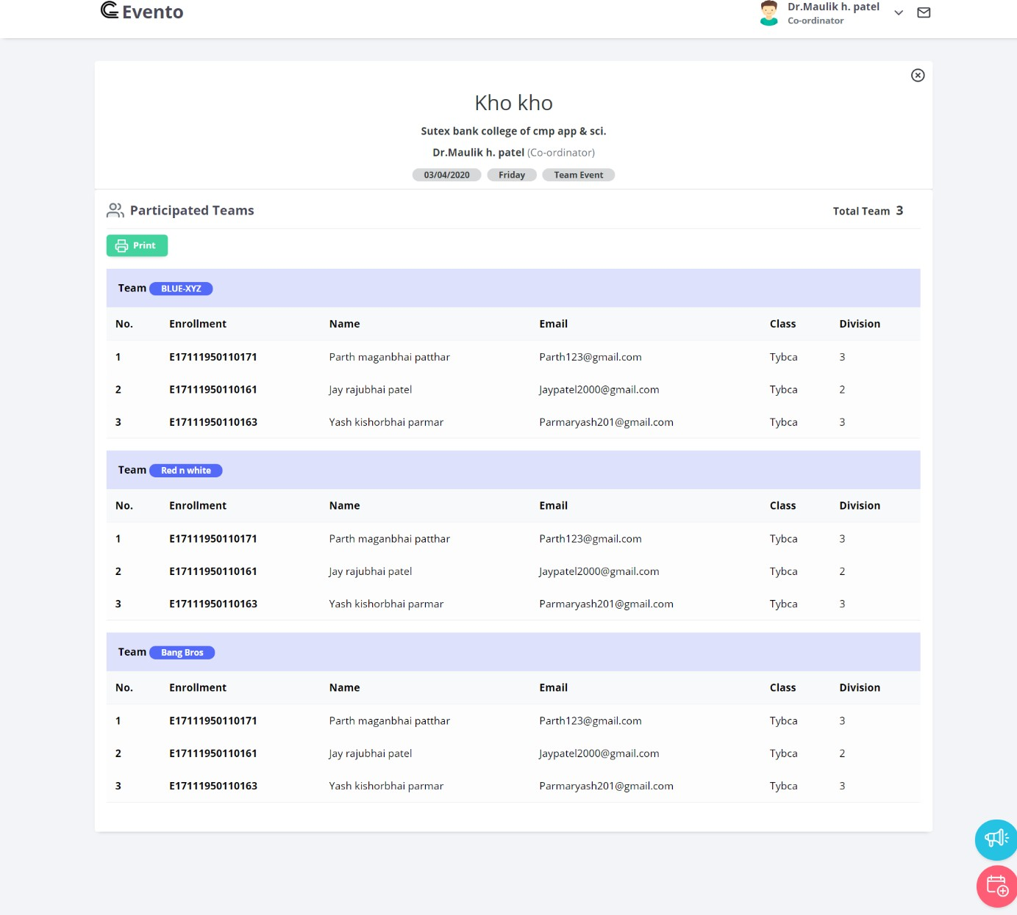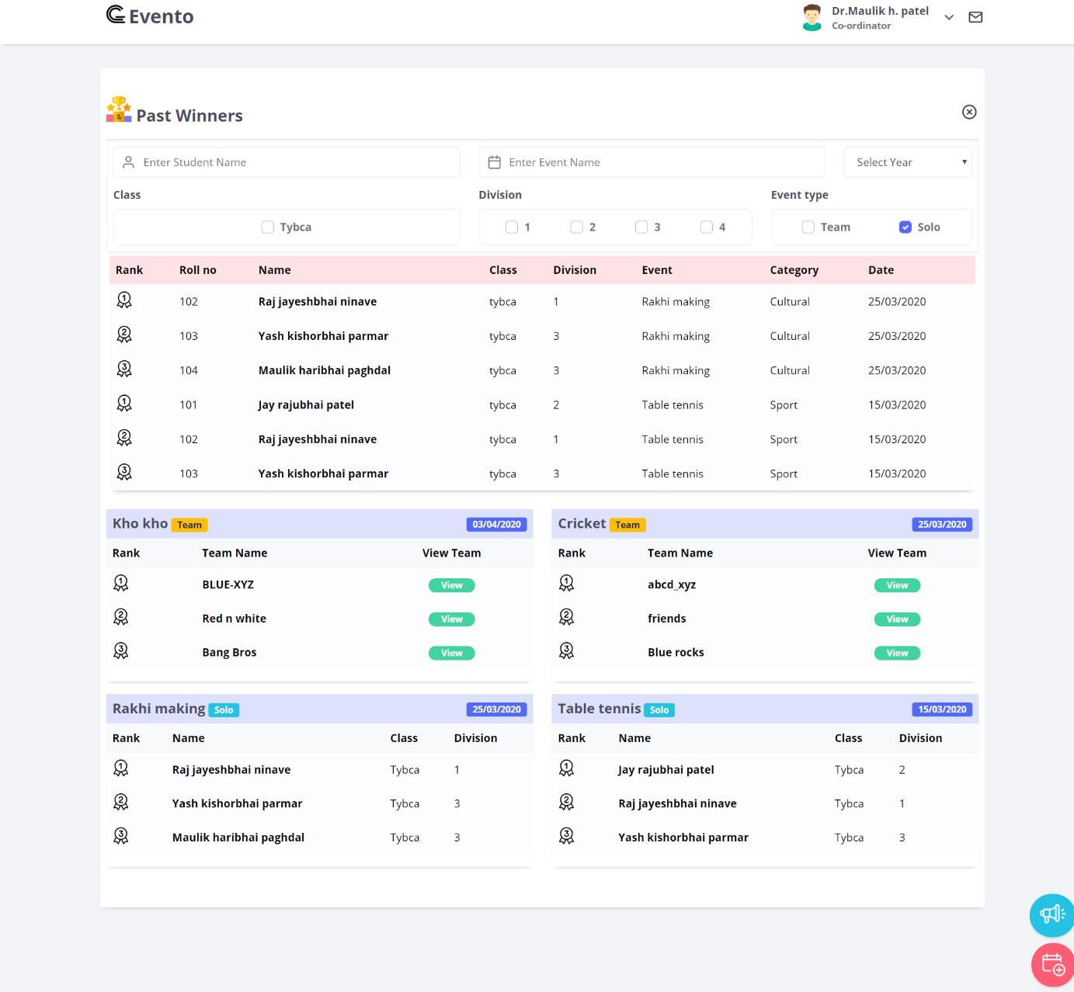

### Student side Output design

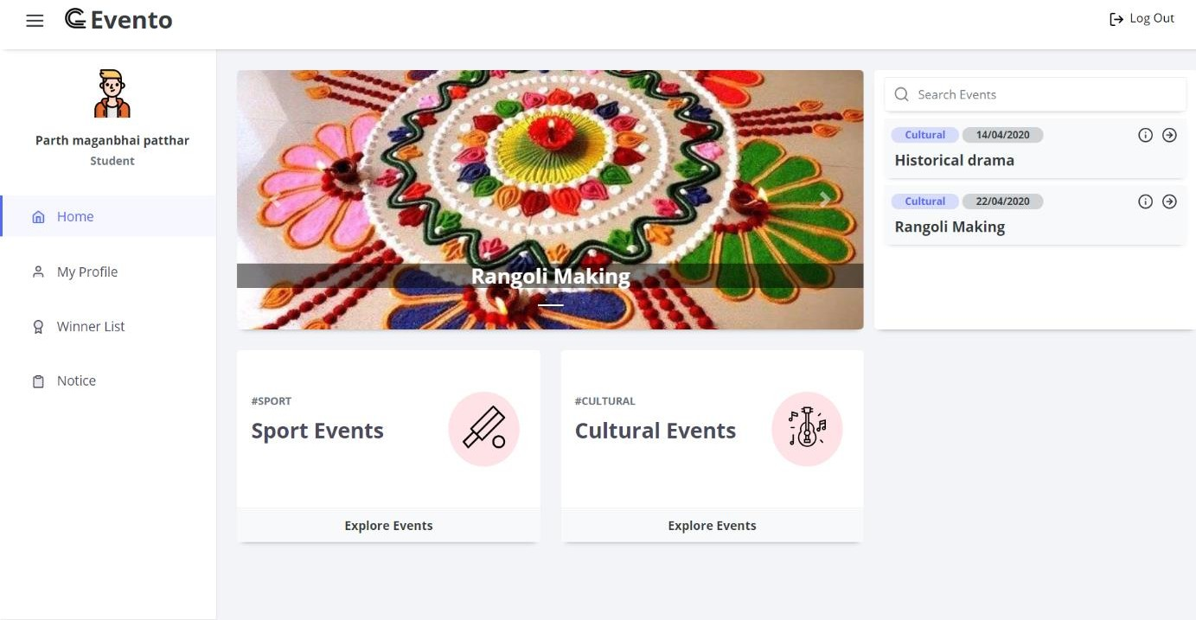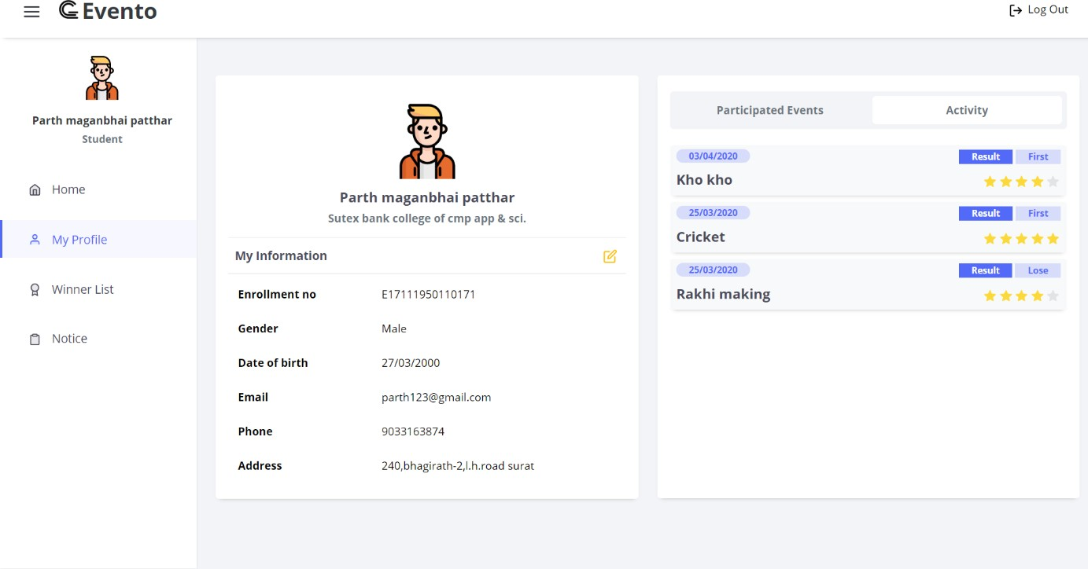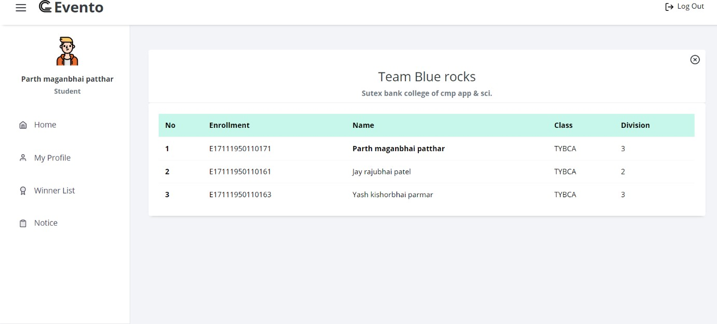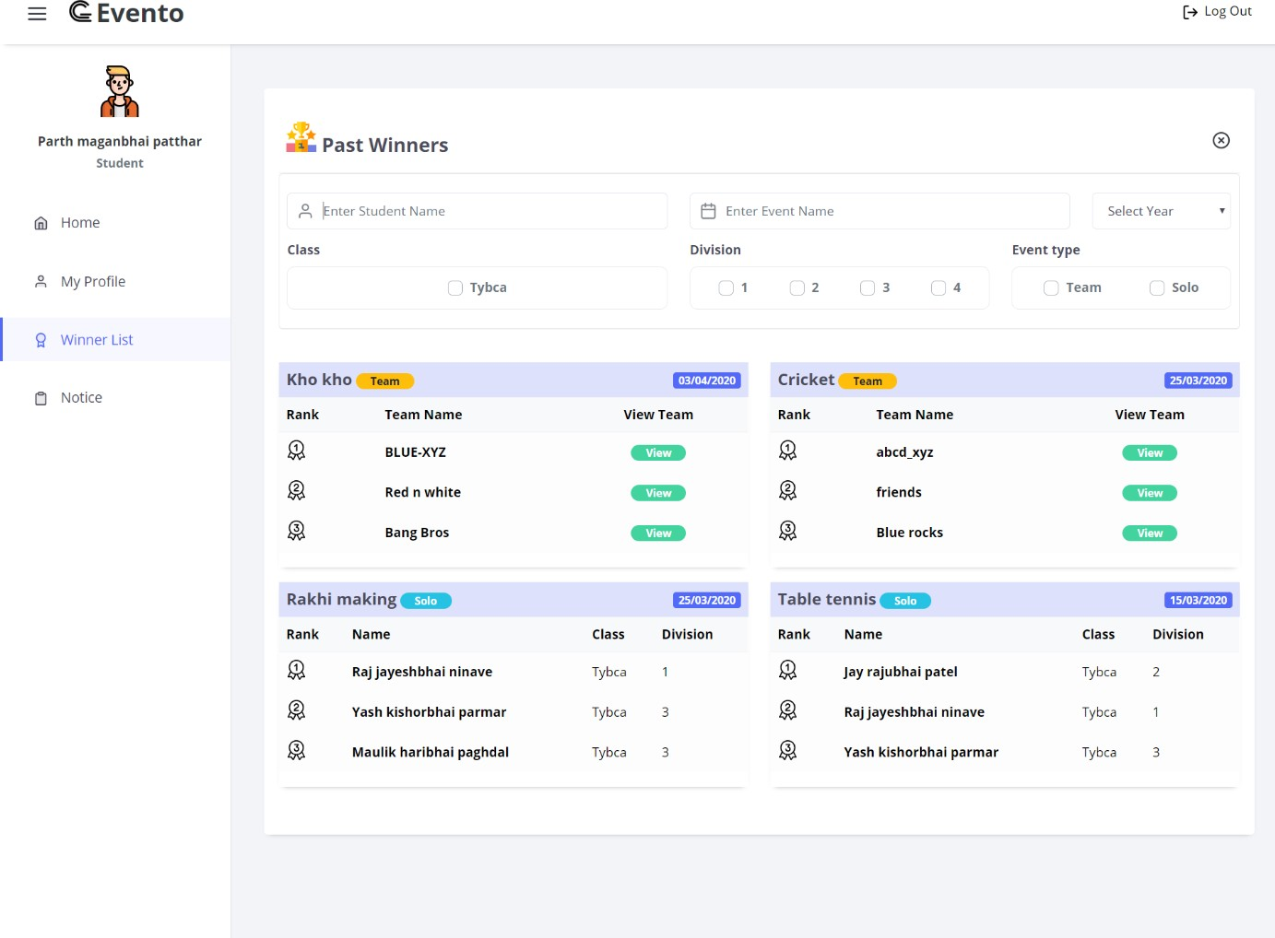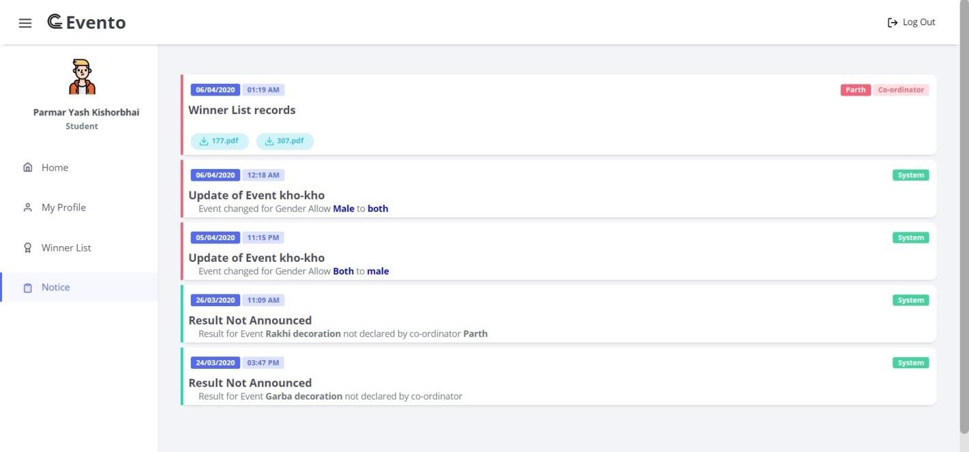

* **System Admin side Output design**

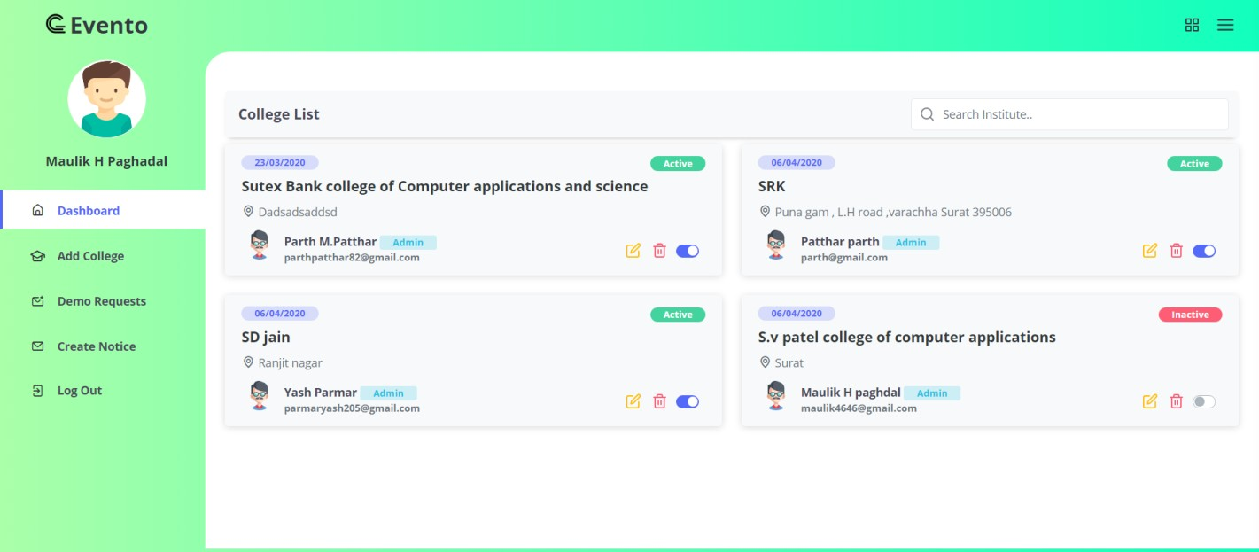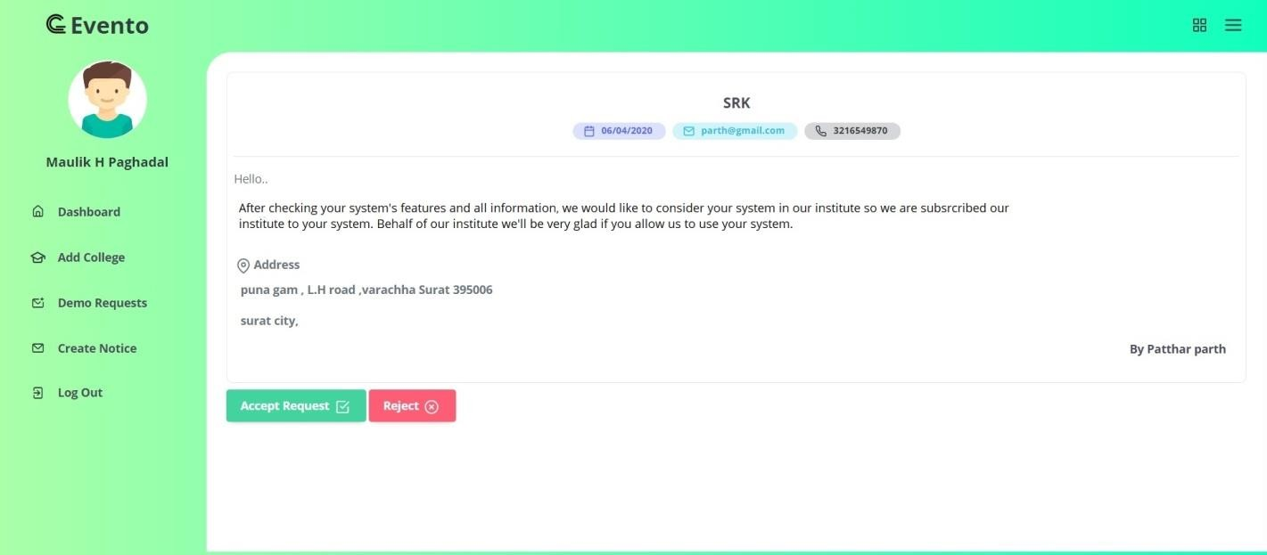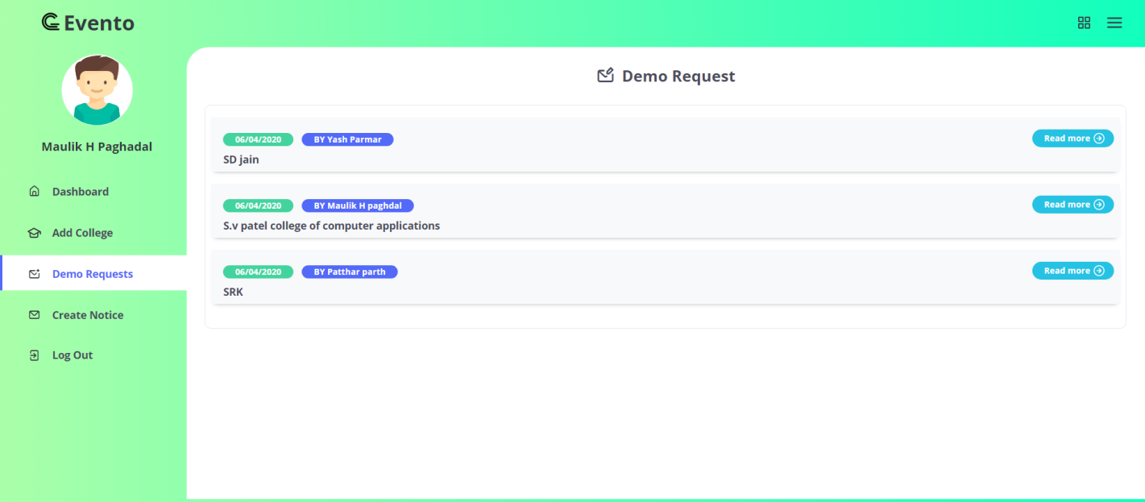

# Software Testing

* + 1. Software Testing
    2. Test Cases
  1. **Software Testing**

### Website testing

Website testing is a critical element of sites quality assurance and represents the ultimate review of specification design and coding. Testing is an exposure of a system to trial input to see whether website meets correct Output. Testing cannot be determined whether website meets user’s needs, only whether it appears to confirm to requirements. Testing can show that a system is free of errors, only that it contains error. Testing finds errors, it does not correct errors. Website success is a quality product, on time and within cost. Through testing can reveal critical mistakes. Testing should therefore,

* + Validate Performance
  + Detects Errors
  + Identify Inconsistencies

### Test Objective: -

* There is strong evidence that effective requirement management leads to overall project cost savings. The three primary reasons for this are,
* Requirement errors typically cost well over 10 times more to repair than other errors.
* Requirement errors typically comprise over 40% of all errors in a software project.
* Small reduction in the number of requirement errors pays big dividend in avoided rework costs and schedule delays.
* System are not designed as entire systems nor are they tested as single systems the analyst must perform both unit and system testing. For this different level testing are use.

### Unit testing

* + In unit testing Module is tested separately and the programmer simultaneously along with the coding of the module performs it.
  + In unit testing the analyst tests the programs making up a system. For this reason, unit testing is sometime called program testing. Unit testing gives stress on modules independently of one another, to find errors. This helps the tester in detecting errors in coding and

logic that are contained within that module alone. The errors resulting from the interaction between modules are initially avoided

* + Unit testing can be performed from the bottom up, Starting with smallest and lowest-level modules and proceeding one at a time., for each module in Bottom-up testing a short program is used to execute the module and provides the needed data, so that the module is asked to perform the way it will when embedded within the larger system

### System testing

* + This is performed after the system is put together. The system *is tested against the system requirement to check if all the requirements are met and if the system performs of specify by the requirements.
  + Testing is an important function to the success of the system. System testing makes a logical assumption that if all the parts of the system are correct, the goal will be successfully activated. Another reason for system testing is its utility as a user-oriented vehicle before implementation.

**System Testing Consists of Following Five Steps:**

### Program Testing:

* A program represents the logical elements of a system. For a program to run satisfactorily, it must compile and test data correctly and tie in properly with other programs. It is the responsibility of a programmer to have an error free program. At the time of testing the system, there exist two types of errors that should be checked. These errors are

1. Syntax Error
2. Logic Error

* A syntax error is a program statement that violates one or more rules of the language in which it is written. An improperly defined field dimension or omitted key words are common syntax errors. These errors are shown through error messages generated by the Computer.
* A logic error, on the other hand, deals with incorrect data fields out of range items, and invalid combinations. Since the logical errors are not detected by compile, the programmer must examine the Output carefully to detect them.
* When program is tested, the actual Output is compared with the expected Output. When there is a discrepancy, the sequence of the instructions, must be traced to determine the problem. Breaking the program down into self- contained portion, each of which can be checked at certain key points, facilitates the process.

## Test cases

### Module 1: Admin

* **Login**

|  |  |  |  |
| --- | --- | --- | --- |
| Test field | Test Data | Valid/Invalid | Test Result |
| **Email Id** | Empty | Invalid | Please enter your  email |
|  | Parthpatthar | Invalid | Invalid email address  or password |
|  | parthpatthar82@gm  ail.com | Valid | Inputted text is  alphabetic |
| **Password** | Empty | Invalid | Please enter  Password |
|  | 123 | Invalid | Invalid email address  or password |
|  | parth@345 | Valid | Given password is  same as exist in database |
| **Login** | Empty | Invalid | Please Enter Email ID  and password |
|  | [parthpatthar77@gm](mailto:parthpatthar77@gmail.com) [ail.com](mailto:parthpatthar77@gmail.com)  12345 | Invalid | Invalid email address or password |
|  | [parthpatthar82@gm](mailto:parthpatthar82@gmail.com) [ail.com](mailto:parthpatthar82@gmail.com)  parth@345 | Valid | Givven mail id and  password is exist in database |

### Add new student

|  |  |  |  |
| --- | --- | --- | --- |
| Test field | Test Data | Valid/Invalid | Test Result |
| **Student**  **name** | Empty | Invalid | Please enter valid  student name |
|  | 123pa | Invalid | Please enter valid  student name |
|  | Yash | Valid |  |
| **Enrollment** | Empty | Invalid | Please enter valid |

|  |  |  |  |
| --- | --- | --- | --- |
| **number** |  |  | enrollment number |
|  | 123456789 | Invalid | Please enter valid  enrollment number |
|  | E1234256 | Invalid | Please enter valid  enrollment number |
|  | E1711195011 0171 | valid |  |
| **Roll number** | Empty | Invalid | Please enter student  roll number |
|  | 177 | valid |  |
| **Class** | Empty | Invalid | Please enter student  class |
|  | 100 | Invalid | Please enter valid  class |
|  | Fybca | Valid |  |
| **Division** | Empty | Invalid | Please enter student  division |
|  | Abc | Invalid | Please enter valid  student division |
|  | 1 | Valid |  |
| **Email** | Empty | Invalid | Please enter student  email address |
|  | Yashparmar | Invalid | Please enter valid  email address |
|  | [yashparmar166@g](mailto:yashparmar166@gmail.com)  [mail.com](mailto:yashparmar166@gmail.com) | Valid |  |
| **Contact No.** | Empty | Invalid | Please enter contact  number |
|  | Abcd | Invalid | Please enter valid  contact number |
|  | 9033163874 | Valid |  |
| **Gender** | Empty | Invalid | Please select gender  of student |
|  | Male | Valid |  |
|  | Female | Valid |  |
| **Date of birth** | Empty | Invalid | Please enter date of  birth |
|  | 16-08-1999 | Valid |  |
| **Address** | Empty | Invalid | Please enter student  address |

* **Add co-ordinators**

|  |  |  |  |
| --- | --- | --- | --- |
| Test field | Test Data | Valid/Invalid | Test Result |
| **Co- ordinator**  **name** | Empty | Invalid | Please enter co- ordinator name |
|  | 123maulik | Invalid | Please enter valid co-  ordinator name |
|  | Yash | Valid |  |
| **Select**  **avatar** | Empty | Invalid | Please select profile  image |
|  | Image1.jpg | Valid |  |
| **Email** | Empty | Invalid | Please enter email  address |
|  | Yashparmar | Invalid | Please enter proper  email address |
|  | [yashparmar166@g](mailto:yashparmar166@gmail.com)  [mail.com](mailto:yashparmar166@gmail.com) | Valid |  |
| **Contact No.** | Empty | Invalid | Please enter contact  number |
|  | Abcd | Invalid | Please enter valid  mobile number |
|  | 9033163874 | Valid |  |
| **Event**  **category** | Empty | Invalid | Please select event  category |
|  | Sport | Valid |  |

### Send notice

|  |  |  |  |
| --- | --- | --- | --- |
| Test field | Test Data | Valid/Invalid | Test Result |
| **Notice title** | Empty | Invalid | Please enter notice  title |
|  | Sport week | Valid |  |
| **Notice for** | Empty | Invalid | Please select receiver |
|  | Co-ordinator | Valid |  |
|  | Student | Valid |  |
| **Notice**  **content** | Empty | Invalid | Please enter your  message |
|  | Next week we | Valid |  |

|  |  |  |  |
| --- | --- | --- | --- |
|  | organize sport week |  |  |
| **Attachment** | Empty | Valid |  |
|  | Notice.pdf | Valid |  |

* **Update profile**

|  |  |  |  |
| --- | --- | --- | --- |
| Test field | Test Data | Valid/Invalid | Test Result |
| **Name** | Empty | Invalid | Please enter valid  name |
|  | 123maulik | Invalid | Please enter valid  name |
|  | Maulik | Valid |  |
| **Email** | Empty | Invalid | Please enter email  address |
|  | Maulik | Invalid | Please enter proper  email address |
|  | [maulikpadhdal@gm](mailto:maulikpadhdal@gmail.com)  [ail.com](mailto:maulikpadhdal@gmail.com) | Valid |  |
| **Mobile no** | Empty | Invalid | Please enter mobile  number |
|  | Abcd | Invalid | Please enter valid  mobile number |
|  | 9512255044 | Valid |  |

### Update password

|  |  |  |  |
| --- | --- | --- | --- |
| Test field | Test Data | Valid/Invalid | Test Result |
| **Current**  **password** | Empty | Invalid | Please enter your  current password |
|  | 1234 | Invalid | Invalid password |
|  | Maulik@345 | Valid |  |
| **New**  **password** | Empty | Invalid | Please enter your  new password |
|  | 1234 | Invalid | New password length  must be greater then 6 character |

|  |  |  |  |
| --- | --- | --- | --- |
|  | maulik@345 | Valid |  |
| **Confirm**  **password** | Empty | Invalid | Please re-enter your  password |
|  | Abcd | Invalid | New password and  confirm password not match |
|  | maulik@345 | Valid |  |

**Module 2: Co-ordinator**

### Login

|  |  |  |  |
| --- | --- | --- | --- |
| Test field | Test Data | Valid/Invalid | Test Result |
| **Co-**  **ordinator email Id** | Empty | Invalid | Please enter your emai |
|  | Yash parmar | Invalid | Invalid email address  or password |
|  | Yashparmar166@g  mail.com | Valid |  |
| **Password** | Empty | Invalid | Please enter your  Password |
|  | 123 | Invalid | Invalid email address  or password |
|  | yash@345 | Valid |  |

* **Create new event**

|  |  |  |  |
| --- | --- | --- | --- |
| Test field | Test Data | Valid/Invalid | Test Result |
| **Event name** | Empty | Invalid | Please enter event  name |
|  | Kho-kho | Valid |  |
| **Event poster** | Empty | Valid |  |
|  | Kho-kho.exe | Invalid | File Extension must be jpg,jpeg,svg and  png format |
|  | Khokho.jpg | Valid |  |
| **Event date** | Empty | Invalid | Please enter event |

|  |  |  |  |
| --- | --- | --- | --- |
|  |  |  | date |
|  | 03-04-2020 | Invalid | Event date is invalid(only allow  after today’s date) |
|  | 09-04-2020 | Valid |  |
| **Event end**  **date** | Empty | Invalid | Please enter event  end date |
|  | 08-04-2020 | Invalid | Event end date must  be after the event start date |
|  | 10-04-2020 | Valid |  |
| **Event time** | Empty | Invalid |  |
|  | 10:15 | Valid |  |
| **Starting date of**  **registration** | Empty | Invalid | Please enter registration start  date |
|  | 17-04-2020 | Invalid | Starting date of registration should be before the event  date and after today |
|  | 05-04-2020 | Valid |  |
| **Last date of**  **registration** | Empty | Invalid | Please enter last date  of registration |
|  | 16-04-2020 | Invalid | End date of registration should be before the event date and after start  date of registration |
|  | 04-04-2020 | Invalid | End date of registration should be before the event date and after start  date of registration |
|  | 07-04-2020 | Valid |  |
| **Event type** | Empty | Invalid | Please select event  type |
|  | Team | Valid |  |
|  | Solo | Valid |  |
| **Gender** | Empty | Invalid | Please select gender |
|  | Male | Valid |  |

|  |  |  |  |
| --- | --- | --- | --- |
|  | Female | Valid |  |
|  | For both | Valid |  |
| **Event for** | Empty | Invalid | Please select class |
|  | Fybca | Valid |  |
| **Team size** | Empty | Invalid | Please enter team  size |
|  | Abc | Invalid | Invalid team size |
|  | 10 | Valid |  |
| **Maximum**  **team** | Empty | Valid |  |
|  | -2 | Invalid | Maximum limit  should be more than one |
|  | 1 | Invalid | Maximum limit  should be more than one |
|  | 10 | Valid |  |
| **Event**  **location** | Empty | Invalid | Please insert event  location |
|  | Maharaja  farm,mota varachha | Valid |  |
| **Other rules** | Empty | Valid |  |
|  | Student need to  physical feet | Valid |  |

### Send notice

|  |  |  |  |
| --- | --- | --- | --- |
| Test field | Test Data | Valid/Invalid | Test Result |
| **Notice title** | Empty | Invalid | Please enter notice  title |
|  | Sport week | Valid |  |
| **Notice**  **content** | Empty | Invalid | Please enter your  message |
|  | Next week we organize sport  week | Valid |  |
| **Attachment** | Empty | Valid |  |
|  | Notice.pdf | Valid |  |

* **Update profile**

|  |  |  |  |
| --- | --- | --- | --- |
| Test field | Test Data | Valid/Invalid | Test Result |
| **Name** | Empty | Invalid | Please enter valid  name |
|  | 123yash | Invalid | Please enter valid  name |
|  | Yash parmar | Valid |  |
| **Email** | Empty | Invalid | Please enter email  address |
|  | Yash | Invalid | Please enter proper  email address |
|  | [yashparmar@gmail](mailto:yashparmar@gmail.com)  [.com](mailto:yashparmar@gmail.com) | Valid |  |
| **Mobile no** | Empty | Invalid | Please enter mobile  number |
|  | Abcd | Invalid | Please enter valid  mobile number |
|  | 9979527696 | Valid |  |

### Update password

|  |  |  |  |
| --- | --- | --- | --- |
| Test field | Test Data | Valid/Invalid | Test Result |
| **Current**  **password** | Empty | Invalid | Please enter your  current password |
|  | 1234 | Invalid | Invalid password |
|  | yash@345 | Valid |  |
| **New**  **password** | Empty | Invalid | Please enter your  new password |
|  | 1234 | Invalid | New password length must be greater  then 6 character |
|  | yashparmar@345 | Valid |  |
| **Confirm**  **password** | Empty | Invalid | Please re-enter your  password |
|  | Abcd | Invalid | New password and  confirm password not match |
|  | yashparmar@345 | Valid |  |

**Module 3: Student**

### Login

|  |  |  |  |
| --- | --- | --- | --- |
| Test field | Test Data | Valid/Invalid | Test Result |
| **Select**  **college** | Empty | Invalid | Please select your  college name |
|  | Sutex bank college of computer application and  science | Valid |  |
| **Enrollment**  **number** | Empty | Invalid | Please enter your  enrollment number |
|  | 12345 | Invalid | Invalid enrollment  number or password |
|  | E17111950110171 | Valid |  |
| **Opt** | Empty | Invalid | Please enter opt |
|  | 711234 | Valid | Same as sent opt by  email |

* **Update profile**

|  |  |  |  |
| --- | --- | --- | --- |
| Test field | Test Data | Valid/Invalid | Test Result |
| **Email** | Empty | Invalid | Please enter email  address |
|  | Yash | Invalid | Please enter proper  email address |
|  | [parthpatthar82@g](mailto:parthpatthar82@gmail.com)  [mail.com](mailto:parthpatthar82@gmail.com) | Valid |  |
| **Mobile no** | Empty | Invalid | Please enter mobile  number |
|  | 903316387 | Invalid | Please enter valid  mobile number |
|  | 9033163874 | Valid |  |
| **Address** | Empty | invalid | Please enter your  address |

### Participation

|  |  |  |  |
| --- | --- | --- | --- |
| Test field | Test Data | Valid/Invalid | Test Result |
| **Team name** | Empty | Invalid | Team name must br greater then 5  character |
|  | Rk | Invalid | Team name must br greater then 5  character |
|  | Royal kings | Valid |  |
| **Player enrollment**  **no** | Empty | Invalid | Please enter this player enrollment  number |
|  | 123456 | Invalid | Invalid enrollment  number |
|  | E17111950110161 | Valid |  |

**Module 4: System Admin**

### Login

|  |  |  |  |
| --- | --- | --- | --- |
| Test field | Test Data | Valid/Invalid | Test Result |
| **Email** | Empty | Invalid | Invalid email or  password |
|  | Maulik | Invalid | Invalid email or  password |
|  | [maulikp4646@gmail](mailto:maulikp4646@gmail.com)  [.com](mailto:maulikp4646@gmail.com) | Valid |  |
| **Password** | Empty | Invalid | Please enter your  Password |
|  | 123 | Invalid | Invalid email or  password |
|  | maulik@46464 | Valid |  |

* **Send notice**

|  |  |  |  |
| --- | --- | --- | --- |
| Test field | Test Data | Valid/Invalid | Test Result |
| **Notice title** | Empty | Invalid | Please enter notice  title |
|  | Your subscription  ended soon | Valid |  |
| **Notice for** | Empty | Invalid | Please select receiver |
|  | Sutex bank college of computer application and  science | Valid |  |
| **Notice**  **content** | Empty | Invalid | Please enter your  message |
|  | Please confirm your  renewal | Valid |  |
| **Attachment** | Empty | Valid |  |
|  | Notice.pdf | Valid |  |

### Add college

|  |  |  |  |
| --- | --- | --- | --- |
| Test field | Test Data | Valid/Invalid | Test Result |
| **Admin name** | Empty | Invalid | Please enter admin  name |
|  | Dishan112 | Invalid | Please enter valid  name |
|  | Dishant sakariya | Valid |  |
| **Email** | Empty | Invalid | Please enter email  address |
|  | Dishant123 | Invalid | Please enter valid  email address |
|  | [dishantsakariya42@](mailto:dishantsakariya42@gmail.com)  [gmail.com](mailto:dishantsakariya42@gmail.com) | Valid |  |
| **Institute name** | Empty | Invalid | Please enter  institute/college name |

|  |  |  |  |
| --- | --- | --- | --- |
|  | S.v patel college | Valid |  |
| **Institute**  **code** | Empty | Invalid | Please enter institute  code |
|  | Svpc | Valid |  |
| **Contact no** | Empty | Invalid | Please enter institute/college  mobile no |
|  | 903316377 | Invalid | Please enter valid  mobile number |
|  | 9033163778 | Valid |  |
| **City** | Empty | Invalid | Please enter city  name |
|  | 123 | Invalid | Please enter valid  city name |
|  | Surat | Valid |  |
| **Institute**  **Address** | Empty | Invalid | Please enter institute  address |
|  | Sumul dairy road. | Valid |  |

* **Update profile**

|  |  |  |  |
| --- | --- | --- | --- |
| Test field | Test Data | Valid/Invalid | Test Result |
| **Name** | Empty | Invalid | Please enter valid  name |
|  | 123maluik | Invalid | Please enter valid  name |
|  | Maulik | Valid |  |
| **Email** | Empty | Invalid | Please enter email  address |
|  | Maulik | Invalid | Please enter proper  email address |
|  | [maulikpadhdal@gm](mailto:maulikpadhdal@gmail.com)  [ail.com](mailto:maulikpadhdal@gmail.com) | Valid |  |
| **Mobile no** | Empty | Invalid | Please enter mobile  number |
|  | Abcd | Invalid | Please enter valid  mobile number |
|  | 9512255044 | Valid |  |

* **Update password**

|  |  |  |  |
| --- | --- | --- | --- |
| Test field | Test Data | Valid/Invalid | Test Result |
| **Current**  **password** | Empty | Invalid | Please enter your  current password |
|  | 1234 | Invalid | Invalid password |
|  | maulik@46464 | Valid |  |
| **New**  **password** | Empty | Invalid | Please enter your  new password |
|  | 1234 | Invalid | New password length  must be greater then 6 character |
|  | Maulik46@345 | Valid |  |
| **Confirm**  **password** | Empty | Invalid | Please re-enter your  password |
|  | Abcd | Invalid | New password and confirm password not  match |
|  | Maulik46@345 | Valid |  |

## Limitations and Future Scope of Enhancements References

* 1. **Limitations of the system**
* The system is made for those colleges which organize events in their college only. So, to manage intercollege competition is not possible through this system.
* The system structure is not suitable for some school
* The system doesn’t include chat system between two users.

Ex. Chat system between system-admin and super-admin

## Future Scope of Enhancements

* Try to provide more facilities for grow up the system
* Some extra Backup features
* Generating match between teams like first round, second round and final round
* Adding chat system between system admin and super admin
* Forum system for students

## References

* <https://stackoverflow.com/>
* <https://laracasts.com/>
* <https://laravel.com/>
* <https://www.w3schools.com/>
* <https://www.youtube.com/>
* <https://github.com/>